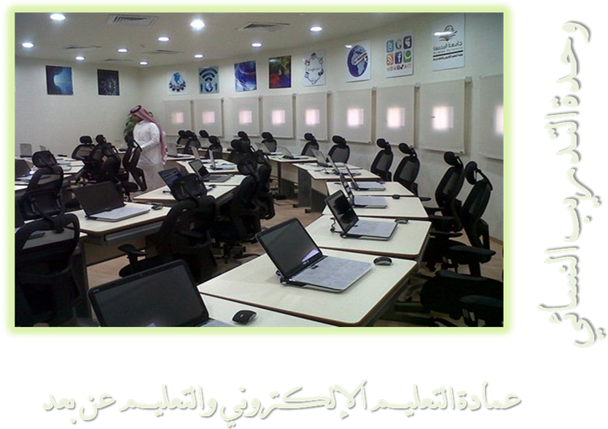

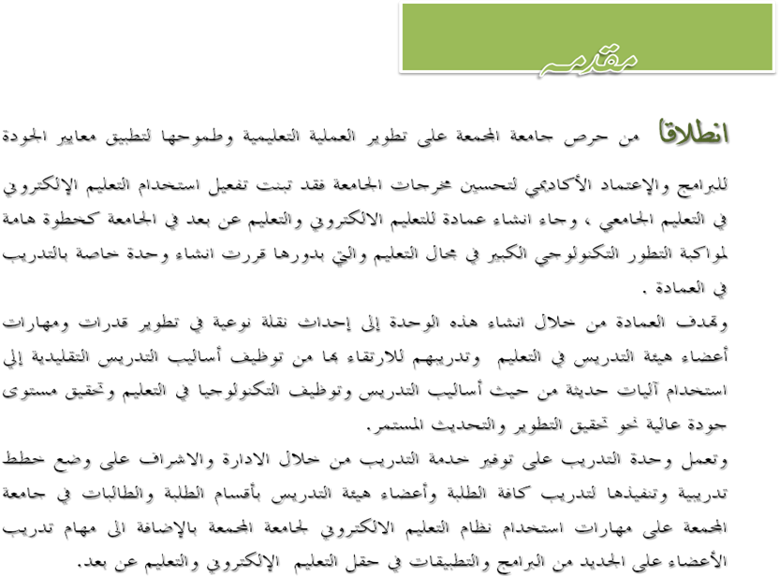

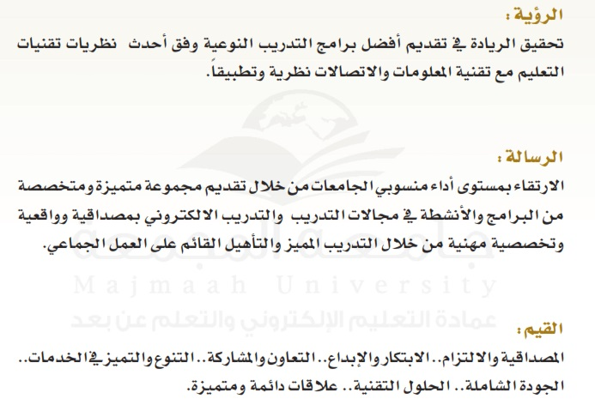

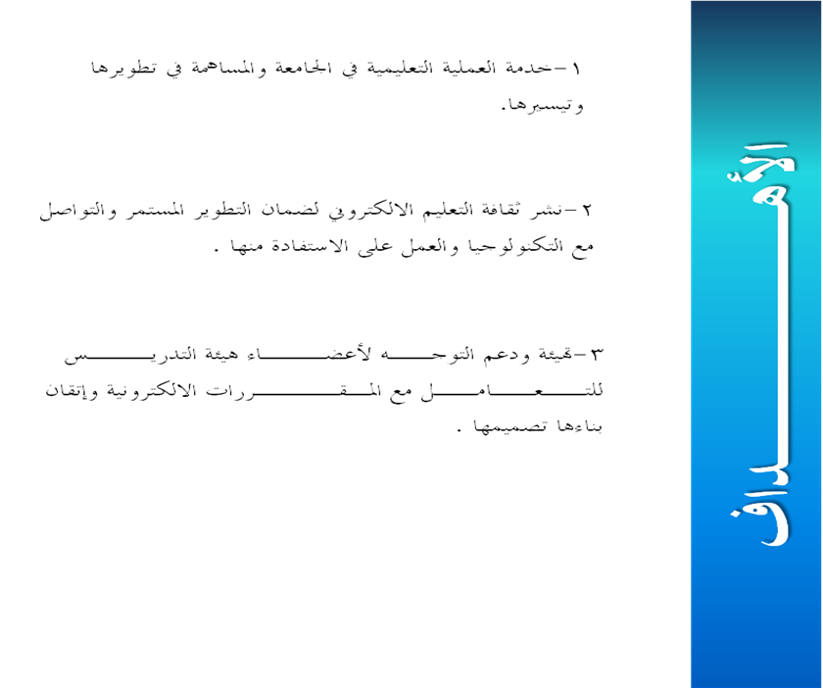
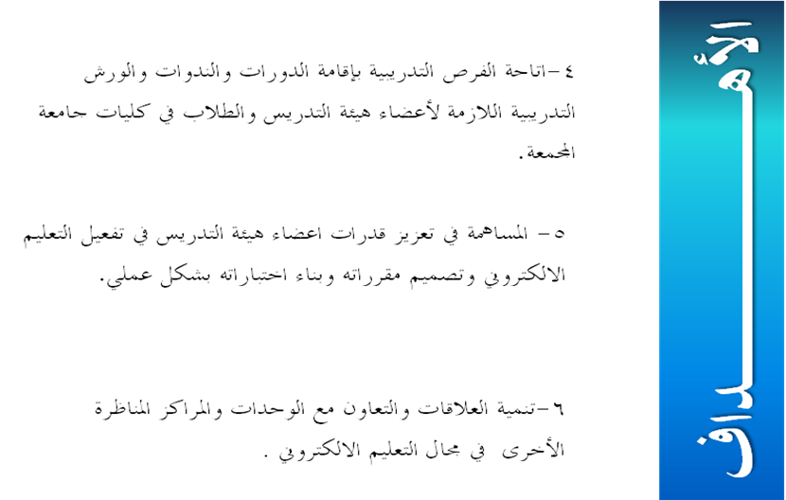

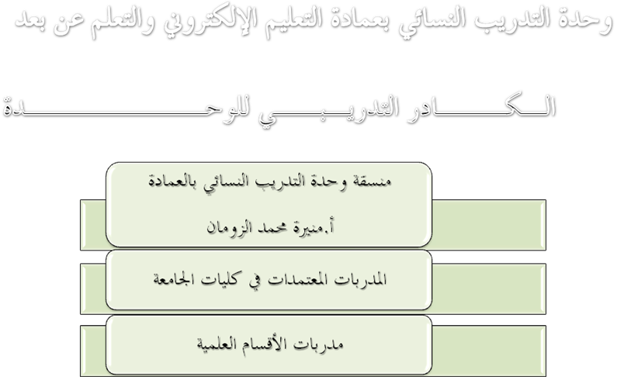

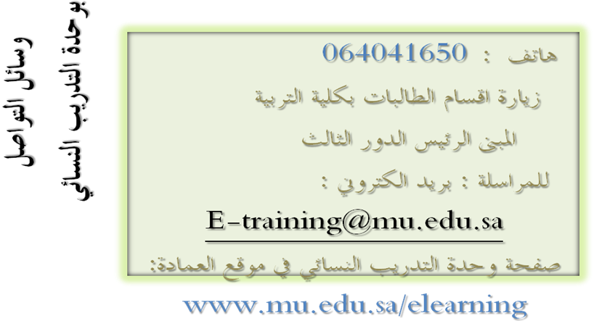

Vision
Achieve leadership in providing the best quality training programs according to the latest theories of learning techniques and the technology of information and communication theoretically and practically.
Message
Raising the performance of universities employees by offering distinct and specialized programs and activities in the fields of training and e-training realistically, credibly and professionally through distinct training and Qualification based on teamwork.
Values
Credibility and commitment... Innovation and creativity... Cooperation and participation... Diversity and excellence in the services... Overall quality... Technical solutions... distinct Lasting relationships.
Coordinator of the females Training Unit: Moneerah Mohammed Al-Zouman

