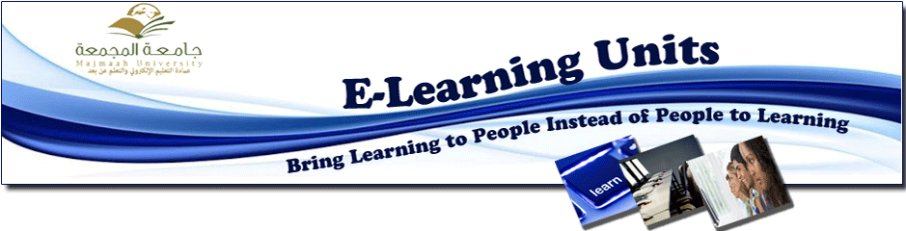
The Women' Training Unit establishes a workshop to teach the interactive whiteboard skills at Majma'ah College of Education

Saturday 20/4/1434
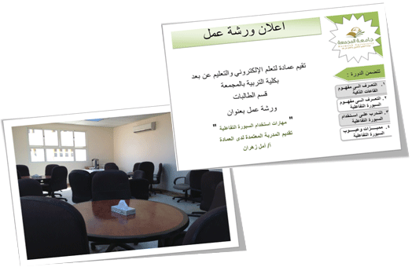
In the framework of activating the training plan programs prepared by the Women's Training Unit at the deanship of e-learning and distance education for the second semester of the academic year 1433-1434, and from the full care of the deanship to increase and develop the awareness of the importance of e-learning; a workshop was held to teach the skills of the interactive whiteboard for faculty members of the university, which was presented by Mrs. Amal Zahran the accredited trainer from the Medical Sciences college in AL-Majma'ah. During the workshop outdated and modern methods of learning were presented and detailed explanation of KalBord program was introduced. The faculty members expressed of their satisfaction with the new technology and their eagerness to apply it for more interactive students in the future.

