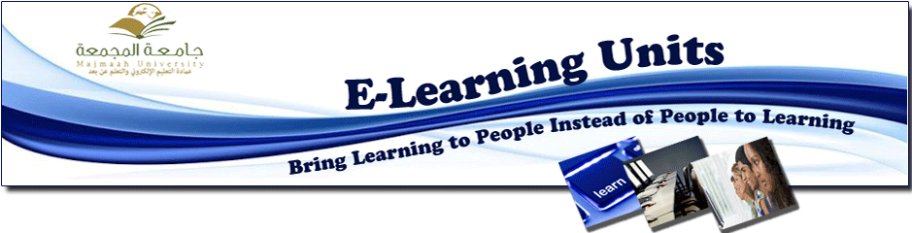
Women's Training Unit concludes its training activities with a workshop entitled "The use of Web 2.0 applications in education"
Tuesday 20/6/1434
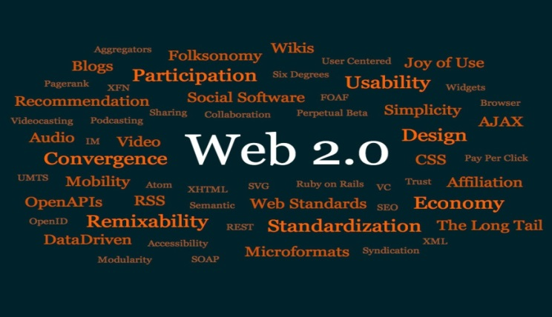
Women's Training Unit concludes its training activities with a workshop entitled "The use of Web 2.0 applications in education" held at the College of education at Al-Majmaah. Produced by Ms. Moneirah Al-Zouman for the faculty members of the university. During the workshop a step by step presentation of the web 2.0 application and registration was given clearly and a model for its use in education was explained. It is noted that web 2.0 is a term which refers to a range of new technologies and web applications that led to change the behavior of the global network "Internet" carrying a number of characteristics that distinguish it, such as: allowing users to use softwares depending on the browser and expressing themselves, their interests and their culture and providing them with interactive systems to allow their social participation and interaction and others.

