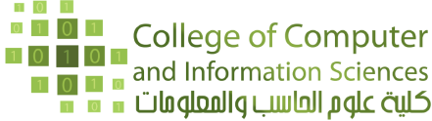 |  | Form 1  Receiving Exam paper  CS & IT Dep’t.  Spring 2017
Form 1
Receiving Exam paper
Faculty Name :
S. No | Course Name & Code | Total Students |  | Exam Day and Date | Number of Answer Sheets | Signature
1
2
3

