College: | Faculty of Education (Girls Branches)
Academic Department: | Mathematics
Program: | Mathematics (Math).
Report Approval Date: |  | 24 / 11 / 1437 H

Annual Program Report
1. Institution: | Majmaah University |  |  | Date of Report: | 24 / 11 / 1437 H
2. College / Department: |  | Faculty of Education (Girls Branches) / Mathematical Department
3. Dean : Dr. Rashid Homood Elthonian
4. List all branches / locations offering this program:
Campus Branch/Location | Approval by | Date
Main Campus | Majmaah University | 32-1433 H
Main building - Zulfi

A. Program Identification and General Information

1. Program title: | Bachelor of Mathematics | Code: | Math.
Name and position of person completing the APR
Dr. Omima Elnour Saeed
Academic year to which this report applies.
1436 / 1437 H

B. Statistical Information
1. Number of students who started the program in the year concerned: |  |  |  |  |  |  |  |  | 22
2. (a) Number of students who completed the program in the year concerned: |  |  |  |  |  |  |  |  |  |  |  | 9
Completed the final year of the program: 9
Completed major tracks within the program (if applicable)
Not applicable |  |  |  |  |  |  | No : None
2. (b) Completed an intermediate award specified as an early exit point (if any) |  |  |  |  |  |  |  |  |  | None
3. Apparent completion rate :
(a) Percentage of students who completed the program,  (Number shown in 2 (a) as a percentage of the number that started the program in that student intake.) |  |  |  |  |  |  |  |  |  |  |  |  | 40.9%
(b) Percentage of students who completed an intermediate award (if any)  (e.g. Associate degree within a bachelor degree program)  (Number shown in 2 (b) as a percentage of the number that started the program leading to that award in that  student intake) |  |  |  |  |  |  |  |  |  |  |  |  | None
Comment on any special or unusual factors that might have affected the apparent completion rates(e.g. Transfers between intermediate and full program, transfers to or from other programs).

Number of graduates is low because it was the second year for starting the program; the program plan was not clear or ready for the students and there were no completed teaching staff in their first 2 years in the beginning, more of them were too late in the program plan..

4. Enrollment Management and Cohort Analysis (Table 1)
Cohort Analysis refers to tracking a specific group of students who begin a given year in a program and following them until they graduate (How many students actually start a program and stay in the program until completion).
A cohort here refers to the total number of students enrolled in the program at the beginning of each academic year, immediately after the preparatory year. No new students may be added or transfer into a given cohort. Any students that withdraw from a cohort may not return or be added again to the cohort.
Cohort Analysis (Illustration): Table 1 provides complete tracking information for the most recent cohort to complete the program, beginning with their first year and tracking them until graduation (students that withdraw are subtracted and no new students are added). Update the years as needed.
Enrollment Management and Cohort Analysis (Table 1)
Student Category | Years
 | *PYP  …… /  …… | 4 Years Ago  32/33 | 3 Years Ago  33 / 34 | 2 Years Ago  34 /35 | 1 Year Ago  35 /36 | Current year  36 /37
- Total cohort enrollment | Not applicable | ــــ | 1st semester = 19  2nd semester = 3 | 22 | 17 | 1st semester = 7  2nd semester = 5
2. Retained till year end |  | ــــ | 15 | 17 | 1st semester = 17  2nd semester = 12 | 5
3. Withdrawn |  | ــــ | 0 | 0 | 1st semester = 1  2nd semester = 0 | 1st semester = 0  2nd semester = 3
4. Cohort Graduated successfully |  | ــــ | 0 | 0 | 0 | 5
5.Total Graduated successfully |  | ــــ | 0 | 0 | 10 | 9
Provide a summary cohort analysis for each of the above cohorts by listing strengths and recommendations for improvement:

The remaining students of the last year will graduated in the next term. The percentage of success will be 54.5% for this year (under study). That is because they were the second cohort entered the program and there was no study plan and low number of teaching staff.
* PYP - Preparatory Year Program

7.Destination of graduates as shown in survey of graduating students (Include this information in years in which a survey of employment outcomes for graduating students is conducted).
Date of Survey | 18 / 11 / 1437
Number Surveyed |  | 9 | Number Responded | 7 |  | Response Rate % |  |  |  |  | 77.7 %
Note : This survey done by sending WatsApp massages :
Destination | Not Available for Employment |  | Available for Employment
 | Further Study | Other Reasons | Employed in Subject Field | Other Employment | Unemployed
Number | None | 9 | None | None | 9
Percent of  Respondents | 0% | 100% | 0% | 0% | 100%
Analysis: List the strengths and recommendations
According to the survey our graduates are strong academically for the scientific data they have , but there is a lack in the sources of learning to make a future sight; because of this only three of them had passed the capacity exam of teachers for employment. Moreover they did not think about the postgraduate now. The program recommended to held training courses for them concerned teaching procedure.

C. Program Context

- 1 - Significant changes within the institution affecting the program (if any) during the past year.

The institution applied the electronic courses and electronic lectures ( D2L) .

Implications for the program

Help students as a different procedure in studying mathematics and solving the associated activities.

- 2 - Significant changes external to the institution affecting the program (if any) during the past year.
None

Implications for the program
None

D. Course Reports Information Summary
- 1. Course Reports Results. Describe and analyze how the individual NCAAA “Course Reports” are utilized to assess the program and to ensure ongoing quality assurance
- (eg. Analysis of course completion rates, grade distributions, and trend studies.)

- (a.) Describe how the individual course reports are used to evaluate the program.

Their future suggestions for :
1.using the electronic sources and facilities to teach,
2.training students to the scientific research procedure ;
are helpful to improve the program

(b.) Analyze the completion rates, grade distributions, and trends to determine strengths and recommendations for improvement.
(i.) Completion rate analysis:

Completion rate is between 55% and 100% in many courses because the standard points for success are clear to both students and teaching staff from the tests internal Commission.

(ii.) Grade distribution analysis:

Grade distribution is suitable ; all courses approximately the rate of success above 60% ( from A+ to D) because the tests internal Commission of the program control the grade distribution when the staff preparing the exam and give them main guides to take care of grade distribution

(iii.) Trend analysis (a study of the differences, changes, or developments over time; normally several years):

This year the program plan was clear to the students, they already know what to do .Also the electronic study and the workshops ( how to learn Math , program outcomes, discussion in training course ) improve their skills to learn Math and increase the rate of success..

2. Analysis of Significant Results or Variations (25 % or more).
List any courses where completion rates, grade distribution, or trends are significantly skewed, high or low results, or departed from policies on grades or assessments. For each course indicate what was done to investigate, the reason for the significant result, and what action has been taken.

There is no course in the program has a significant results or variations

a. Course | None
Significant result or variation | Not exist
Investigation undertaken | ـــ
Reason for significant result or variation | ـــ
Action taken (if required) | ـــ
(Attach additional summaries if necessary)

No significant result or variation in students, results because teaching staff are applying courses specification which are given in the beginning of the term to every student; then they already know what are the related activities to be done and how to pass the exam.

4. Delivery of Planned Courses
(a) List any courses that were planned but not taught during this academic year and indicate the reason and what will need to be done if any compensating action is required.
Course title and code | Explanation | Compensating action if required
None | ـــ | ـــ

(b) Compensating Action Required for Units of Work Not Taught in Courses that were Offered.(Complete only where units not taught were of sufficient importance to require some compensating action)
Course | None
Unit of work | ـــ
Reason | ـــ
Compensating action if required | ـــ

Note : Teaching staff are applying the courses, specifications in teaching their courses because of this there is no a course unit that not taught. Also all courses planed for the program are taught; no course was left.

E. Program Management and Administration
List difficulties (if any)  encountered in management of the program | Impact of difficulties on the achievement of the program objectives | Proposed action to avoid future difficulties in Response
Few members of teaching staff deal with the quality needs and requirements | Certain members prepare the quality documents, this leads to be tired and late in sending what the quality center need | Different directed quality training courses and workshops for all staff
Students did not applied the computer software courses 100% | NO computer laboratory for the program | Specify certain time for our student in computer science Lap
Weakness of students in English and Mathematics as a direct result of the weakness of public education. | Has a severe impact on the level of graduates. | The program going on to publish. Mathematical dictionary

F. Summary Program Evaluation
1. Graduating Students Evaluation (To be reported on in years when surveys are undertaken)
Date of Survey | 24 / 4 / 1437 --- 3 / 2 / 2016
Attach : survey report ( see page 27 )
a. List most important recommendations for improvement, strengths and suggestions | Analysis  (e.g. Assessment, action already taken, other considerations, strengths and recommendation for improvement.)
To be interested on :  1. Learning resources and library.  2. Reviewing courses specifications continuously. | 1. For learning resources and library ; the library capacity is not suitable for all students  2.About reviewing courses specifications continuously most courses information are repeated every year without refreshment
b. Changes proposed in the program (if any) in response to this analysis and feedback.
1. For learning resources and library the program established library which contain the references of all courses till level 8.
2. About reviewing courses specifications continuously this due to the institution plan of improvement.

2. Other Evaluation (e.g. Evaluations by employers or other stakeholders, external review)
Describe evaluation process .

Attach review/survey report : ( see page 29 )

a. List most important recommendations for improvement, strengths and suggestions for improvement. |  |  |  | e.g. Analysis of recommendations for improvement: ( Are recommendations valid and what action will be taken, action already taken, or other considerations?)
1. Modify the form of the program objectives and mission.  2. Change the form of the English Self Study. |  |  |  | 1.The program mission is so long comparing with King Saud University  2.The form of the English self study is changed to a new one as showed by Science College / Majmaah University
b. Changes proposed in the program (if any) in response to this feedback.

1.We held on many committees to modify the form of the program mission.
2. We prepare the English Self Study in the new forms.
3. Ratings on Sub-Standards of Standard 4 by program faculty and teaching staff; 4.1 to 4.10.
(a) Standard 4 Sub-Standards. Are the “Best Practices” followed; Yes or No? Provide a revised rating for each sub-standard. Indicate action proposed to improve performance (if any).
Sub-Standards | Best Practices  Followed  ( Y / N ) | 5 Star Rating | List priorities for  improvement.
4.1 | Y | *** | 1Meet the National Qualifications Framework Requirements after counting them and awareness.  2. Satisfy the requirements of professional practice in the relevant fields ,
4.2 | Y | *** | 1. Form a committee of teaching staff from all disciplines to study the content of the program , and ways to implement them more effectively  2. form an advisory committees to monitor the academic areas and / or professional - which prepares students - continuously , and taking the necessary adjustments in programs
4.3 | Y | **** | 1. Establish comprehensive records on completion rates of students of all courses and for the program, and placed them within the quality indicators.  2. Activate cooperation between the departments in comparisons to the quality indicators of various programs and to benefit from mutual experiences
4.4 | Y | **** | 1. Find appropriate mechanisms to verify the academic progress of the students in the programs  2. Provide methods for feedback for students and training teaching staff to activate them
4.5 | Y | **** | Provide a package of mechanisms to monitor student progress and provide treatment programs if necessary
4.6 | Y | **** | Clarify the results of the assessment decisions to the  teaching staff and emphasized the need to provide a report on what has been achieved in the light of courses reports .
4.7 | Y | **** | The continuation of the formal recognition and appreciation for outstanding performance in teaching procedures, and encouraging creativity and innovation.
4.8 | Y | *** | ease the burden of teaching to encourage teaching staff to participate in scientific and research activities of faculty members
4.9 | Y | *** | 1.To be Attention on the training course activities and interested on developing them ,increases the efficiency of the graduate.  ,2.The visit of students and supervisors to training appropriate place ensure the nature of their work and provide modern strategies in it
4.10 | N | ** | Establish partnership agreements with the local society and counterpart institutions in Saudi Arabia and international universities
Analysis of Sub-standards. List the strengths and recommendations for improvement of the program’s self-evaluation of following best practices.
The strengths :
1.The academic progress of the students in the programs is found.
2. Few members of teaching staff participate scientific research activities of faculty members.
3. Few partnership agreements with the local society are made
Recommendations :
1. Find appropriate mechanisms to verify the academic progress of the students in the programs
2. ease the burden of teaching to encourage teaching staff to participate scientific research activities of faculty members
3. Establish partnership agreements with the local society and counterpart institutions in Saudi Arabia and international universities

G. Program Course Evaluation
1. List courses taught during the year. Indicate for each course whether student evaluations were undertaken and/or other evaluations made of quality of teaching.
For each course indicate if action is planned to improve teaching.
Course Title / Course Code | Student Evaluations |  | Other Evaluation  ( specify ) | Action  Planned
 | Yes | No |  | Yes | No
Analytic Geometry - Math 124 | √ |  | None | √
Calculus (2) - Math 121 | √ |  | None | √
Calculus in Several Variables- Math212 | √ |  | None | √
Complex Analysis- Math413 | √ |  | None | √
Differential Geometry- Math 421 | √ |  | None | √
Introduction in Functional Analysis- Math423 | √ |  | None | √
Introduction to Partial Differential Equations- Math415 | √ |  | None | √
Introduction to statistical inference- Stat 421 | √ |  | None | √
Mathematical Applications - Math 313 | √ |  | None | √
Numerical Analysis – Math311 | √ |  | None | √
Principles of Probability Distribution Theory Stat 223 | √ |  | None | √
Principles of Statistics and Probability – Stat 123 | √ |  | None | √
Real Analysis (1) – Math312 | √ |  | None | √
Rings and Fields – Math414 | √ |  | None | √
Vector Analysis – Math213 | √ |  | None | √
(Add items or attach list if necessary)
Note : Students Evaluation is made for all courses in the program.

2. List courses taught by this program this year and for this program that are in other programs.
Level | Course  Code | Course Title | Number of sections | Credit  Hours | University / College or  Department
Level 1 | SALM 101 | Introduction to Islamic Culture | 1 | 2 | University
 | ARAB 101 | Arabic language skills | 1 | 2 | University
 | SOCI101 | Contemporary Social Issues  ( elective ) | 1 | 2 | University
 | EDU 116 | Teaching techniques and Communication skills | 1 | 2 | College
 | EDU 117 | Fundamentals of Islamic Education | 1 | 2 | College
 | EDU 118 | The System and Policy of Education in KSA | 1 | 2 | College
 | MATH 111 | Calculus (1) | 1 | 2 (1+2) | Department
 | PHYS 111 | General physics(1) | 1 | 2 (1+2) | Department
 | Chem111 | General chemistry (1) | 1 | 2 (1+2) | Department
Level 2 | SALM102 | Islam and Society  (elective) | 1 | 2 | University
 | EDU126 | Developmental Psychology | 1 | 2 | College
 | MATH 121 | Calculus (2) | 1 | 4(3+2) | Department
 | MATH 124 | Analytic Geometry | 1 | 4(3+2) | Department
 | MATH 122 | The Foundations of Mathematics | 1 | 3(2+2) | Department
 | STAT 123 | Principles of Statistics and Probability | 1 | 3(2+2) | Department
Level 3 | LHR101 | Voluntary Work  (elective) | 1 | 2 | University
 | EDU216 | Psychological Health | 1 | 2 | College
 | EDU217 | Principles of Educational Research | 1 | 2 | College
 | MATH 212 | Calculus in Several Variables | 1 | 4(3+2) | Department
 | MATH 214 | Linear Algebra | 1 | 3(2+2) | Department
 | Math213 | Vector Analysis | 1 | 4(3+2) | Department
Level 4 | SALM 103 | Economic System in Islam  (elective) | 1 | 2 | University
 | EDU226 | Educational Psychology | 1 | 2 | College
 | STAT 223 | Principles of Probability -Distribution Theory | 1 | 3(2+2) | Department
 | MATH 224 | Introduction to ordinary Differential Equations | 1 | 4(3+2) | Department
 | MATH 225 | Statics | 1 | 4(3+2) | Department
 | MATH 222 | Number Theory | 1 | 3(2+2) | Department
Level 5 | EDU316 | Administration and Educational Planning | 1 | 2 | College
 | EDU317 | Production of E-learning resources | 1 | 2 | College
 | MATH 311 | Numerical Analysis | 1 | 4(3+2) | Department
 | MATH 313 | Mathematical Applications | 1 | 4(3+2) | Department
 | MATH 312 | Real Analysis (1) | 1 | 4(3+2) | Department
 | MATH 314 | Mathematics Lab | 1 | 2(1+2) | Department
Level 6 | EDU326 | Teaching Strategies | 1 | 2 | College
 | EDU327 | Curricula | 1 | 2 | College
 | MATH324 | Mathematical Methods | 1 | 4(3+2) | Department
 | MATH 327 | Mathematical Applications on the Computer | 1 | 3(2+2) | Department
 | MATH 322 | Group Theory | 1 | 3(2+2) | Department
 | MATH 323 | Introduction to Topology | 1 | 4(3+2) | Department
Level 7 | EDU416 | Modern Trends in Teaching Strategies | 1 | 2 | College
 | EDU417 | Educational Evaluation | 1 | 2 | College
 | MATH413 | Complex Analysis | 1 | 3(2+2) | Department
 | MATH 414 | Rings and Fields | 1 | 3(2+2) | Department
 | MATH 415 | Introduction to Partial Differential Equations | 1 | 4(3+2) | Department
 | MATH 412 | Real Analysis (2) | 1 | 4(3+2) | Department
Level 8 | EDU 428 | Training course (Math) | 2 | 6(0+6) | College
 | MATH 421 | Differential Geometry | 1 | 4(3+2) | Department
 | MATH 422 | Introduction in Functional Analysis | 1 | 3(2+2) | Department
 | MATH 425 | Research project | 1 | 2(0+2) | Department
 | STAT 421 | Introduction to statistical inference | 1 | 3(2+2) | Department
Include additional Levels if needed
Note : University courses are 13 courses ; student select 6 of them to complete the program total load (144 hours).

3. Program Learning Outcome Assessment:
Provide a report on the program learning outcomes assessment plan using an assessment cycle (a four to six-year cycle is recommended). All program learning outcomes are to be directly assessed at least once during the cycle. By the end of the cycle each program learning outcome will be assessed and recorded using a separate KPI Assessment Table (see below);
KPI  # | NQF Learning Domains  and Learning Outcomes | Method of  Assessment for LOs | Date of Assessment
A | Knowledge
a.1 | The ability to understand fundamentals of mathematics in different fields | Lectures and collaborative work. | All over the term
a.2 | Whole knowledge about the latest developments in mathematic by overviewing modern scientific researches, which interested in issues and solutions | discussions and tutorial
a.3 | Preparation of students in the professional practice programs so that graduates are aware of the regulations , regulations of the profession , its technical requirements and how to improve it over time in response to changes in surrounded conditions | Training course (Math).
B | Cognitive Skills
b.1 | Giving students the ability to solve exercises, tutorials and mathematical issues. | 1.written or oral Tests,  2. Courses related research and research projects in the final year.  3.Home works | - Mid term, final exam and quizzes.
b.2 | The student can use logical and creative thinking and has the ability to face and solve problems
b.3 | Making survey, understand and evaluation of the information , concepts and new evidence from different sources
C | Interpersonal Skills & Responsibility
c.1 | The student is responsible for her self-learning by using books, references, and scientific journals. | .1. Discussions and dialogues in tutorial lectures  2. Ask a hypothetical issues and note how the student deal with it | All over the term
c.2 | Practice of group's leadership in different situations which requiring innovative responses
c.3 | The ability of students to configure communication skills with others
D | Communication, Information Technology, Numerical
d.1 | Determination of the relevant statistical and mathematical methods when examining issues and problems, and applying them creatively in interpretation of information and suggesting solutions | - discussions  - homework  - questions with long answers
d.2 | Preparing students to participate in seminars and workshops related to the specialization to exchange information with others |  | All over the term
d.3 | Effective communication : verbally and in writing and presentation of different issues for different cautious properly
5.0 | Psychomotor
5.1 | N.A | N.A | N.A
Provide an analysis of the Program Learning Outcome Assessment Cycle (List strengths and
recommendations for improvement).

Note : When the student has the ability to understand fundamentals of mathematics in different fields , the ability to use technology in data analysis and presentation of results and participate seminars and workshops related to the specialization to exchange information with others she will be very qualified and the program will satisfy the institution mission .

Provide “direct assessments” for the current year’s program learning outcomes, according to the dates provided above (G.3). A key performance indicator (KPI) table is provided below. Each learning outcome should utilize a separate KPI table. Over the four (five/six) year cycle, all program learning outcomes are to be assessed and reported in the Annual Program Report(s).

Note: Programs are to provide their own KPIs for directly measuring student performance.

The KPI Assessment Table is used to document directly assessed program learning outcomes. Each program learning outcome should use a separate table. Direct assessments methods may include: national or international standardized test results, rubrics, exams and learning outcome grade analysis, or learning achievement using an alternative scientific assessment system (copy the KPI Assessment Table and paste to
make additional tables as needed).

KPI Assessment Table
KPI # : KPI 4 |  | Program KPI :  Beneficiaries Evaluation to the IT services (availability -security -technical support maintenance - software and hardware)
Assessment Year : 1436 / 1437 |  | Program Learning Outcome :  Whole knowledge about the latest developments in mathematic by overviewing modern scientific researches, which interested in issues and solutions
NQF Learning Domain | Knowledge ( a.2 )
Target Benchmark | 100%
KPI Actual Benchmark | 100%
Internal Benchmark | 100%
External Benchmark | 100%
Analysis: (List strengths and recommendations)
Whole knowledge about the latest developments in mathematic leads to continuous revision of curriculum and its progression because of this this KPI is 100% interested
New Target Benchmark | 100%

KPI #: KPI 5 |  | Program KPI:  Ratio of students to teaching staff( full time staff or equivalent members )
Assessment Year : 1436 / 1437 |  | Program Learning Outcome :  Participation of students in seminars and workshops related to the specialization to exchange information  with others
NQF Learning Domain | Communication, Information Technology, Numerical ( d1)
Target Benchmark | 11:1
KPI Actual Benchmark | 11:1
Internal Benchmark | 11:1
External Benchmark | 12:1
Analysis: (List strengths and recommendations)
When students Participate in seminars and workshops related to the specialization to exchange information
with others we guarantee a qualified graduate for jobs or postgraduate

New Target Benchmark | 17:1

KPI # : KPI 7 |  | Program KPI :  Proportion of teaching staff with verified doctoral qualifications
Assessment Year: 1436 / 1437 |  | Program Learning Outcome:  The ability to understand fundamentals of mathematics in different fields
NQF Learning Domain | Knowledge ( a.1)
Target Benchmark | 60%
KPI Actual Benchmark | 50%
Internal Benchmark | 78%
External Benchmark | 93%
Analysis: (List strengths and recommendations)
Qualified staff give quality and success , we recommended that other members have the Ph.D certificate
New Target Benchmark | 64%

KPI # : KPI 12 |  | Program KPI :  Students evaluation to the professional and academic supervision (average estimates of how appropriate psychological and vocational guidance on an annual estimated five-point scale for students in the final year.
Assessment Year : 1436 / 1437 |  | Program Learning Outcome :  Preparation of students in the professional practice programs so that graduates are aware of the regulations , regulations of the profession , its technical requirements and how to improve it over time in response to changes in surrounded conditions
NQF Learning Domain | Knowledge ( a.3 )
Target Benchmark | 100%
KPI Actual Benchmark | 100%
Internal Benchmark | 100%
External Benchmark | 100%
Analysis: (List strengths and recommendations)
Academic supervision is in focus of learning and teaching process it has 100% of interest

New Target Benchmark | 100%

KPI # : KPI 14 |  | Program KPI :  Beneficiaries Evaluation to the IT services (availability -security -technical support maintenance - software and hardware)
Assessment Year : 1436 / 1437 |  | Program Learning Outcome:  The student is responsible for her self-learning by using books, references, and scientific journals
NQF Learning Domain | Interpersonal Skills & Responsibility ( c1 )
Target Benchmark | 85%
KPI Actual Benchmark | 80%
Internal Benchmark | 100%
External Benchmark | 100%
Analysis: (List strengths and recommendations)
Students can using books, references, and scientific journals from net but the library capacity is not enough ; the program establish their own library contains books and references for all courses till 8 level

New Target Benchmark | 85%

KPI # : KPI 15 |  | Program KPI :  Proportion of teaching staff participating in professional development activities last year
Assessment Year : 1436 / 1437 |  | Program Learning Outcome :  Giving students the ability to solve exercises, tutorials and mathematical issues.
NQF Learning Domain | Cognitive Skills ( b1)
Target Benchmark | 100%
KPI Actual Benchmark | 100%
Internal Benchmark | 100%
External Benchmark | ـــ
Analysis: (List strengths and recommendations)
Teaching process cores are teaching staff, student and curricula. This KPI is 100% important for quality of learning.
New Target Benchmark | 100%

KPI # : KPI 19 |  | Program KPI :  Proportion of teaching staff and other employees who provided activities to the society service
Assessment Year : 1436 / 1437 |  | Program Learning Outcome:  The ability of students to configure communication skills with others
NQF Learning Domain | Interpersonal Skills & Responsibility ( c3 )
Target Benchmark | 60%
KPI Actual Benchmark | 50%
Internal Benchmark | 100%
External Benchmark | ـــ
Analysis: (List strengths and recommendations)
Although there is no clear plan from the unit of society service in the college to attend activities, 50% of teaching staff attend activities as a personally effort.

New Target Benchmark | 50%

4. Orientation programs for new teaching staff
Orientation programs provided ? | Yes | √ | NO | ………..
If offered how many participated ? | 3
a. Brief Description
Orientation programs provided for new teaching staff are D2L programs, teaching procedures and techniques all staff of the program participate but the new ones are 4, then 3 out of 4 were attended.
b. List recommendations for improvement by teaching staff.
1.Be strong at the scientific knowledge mainly the current related topics of their specification.
2.Make confidence with the students to understand the subject.

c. If orientation programs were not provided, give reasons.
The orientation programs were provided mainly D2L training courses and teaching techniques .

5. Professional Development Activities for Faculty, Teaching and Other Staff
a. Activities Provided | How many Participated
 | Teaching  Staff | Other Staff
How to learn mathematic | 3 | 3
Mathematics seminars | 3 | 4
scientific research seminars | 4 | 20
D2L training courses and workshops | 8 | All faculties
Quality training courses and workshops | 6 | All faculties
Intelligent board training course | 6 | All faculties
b. Summary analysis on usefulness of activities based on participant’s evaluations or other evaluation methods.

- All activities in D2L and Quality are available for the staff experience.
- Seminars and academic research papers were very important and available.

H. Independent Opinion on Quality of the Program
(e.g. head of another similar department/ program offering comment on evidence received and conclusions reached)
1. Matters Raised by Evaluator Giving Opinion | Comment by Program Coordinator
1.The program mission is not known by the beneficiaries  2.Low interest about the scientific research  3. Few activities geared to local society services. | 1. We distributed questionnaires of mission , goals and objectives.  2.Teaching staff have full work load ; there is no time for them to publish papers.  3.Three members associated local society activities
2. Implications for Planning for the Program

1. Employer will ignore our graduate or refuse her if he did not know about the program mission and objectives.
2.Any shortage in scientific research and local society activities will affect on the staff growing and actually on the objectives of the academic research unit.

Program KPI and Assessment Table
Note : All program PKIs in attachments ( see page 30 )
KPI  # | KPIS | KPI Target Benchmark | KPI Actual Benchmark | KPI Internal Benchmarks | KPI External Benchmark s | KPI Analysis | KPI New Target Benchmark
KPI  4 | Proportion of courses in which student evaluations were conducted during the year. | 100 % | 100 % | 100 % | 100 % | It leads to continuous revision of curriculum and its progression | 100 %
KPI  5 | Ratio of students to teaching staff( full time staff or equivalent members ) | 11 : 1 | 11 : 1 | 1 : 11 | 1 : 12 | Number of students will increase | 17 : 1
KPI  7 | Proportion of teaching staff with verified doctoral qualifications | 60 % | 50 % | 78 % | 93 % | Qualified staff give quality and knowledge | 64 %
KPI 12 | Students evaluation to the professional and academic supervision (average estimates of how appropriate psychological and vocational guidance on an annual estimated five-point scale for students in the final year | 100 % | 95 % | 100 % | ــــ | Academic supervision is the focus of the teaching process | 100 %
KPI 14 | Beneficiaries Evaluation to the IT services (availability -security -technical support maintenance - software and hardware) | 85 % | 80 % | 100 % | 100 % | Our rate is low because we have no computer lap to apply math software programs, besides the internet services is weak in Zulfi  22 | 85 %
KPI 15 | Proportion of teaching staff participating in professional development activities last year | 100 % | 100 % | 100 % | ــــ | improvement is very important in teaching process | 100 %
KPI 19 | Proportion of teaching staff and other employees who provided activities to the society service | 60 % | 50 % | 100 % | ــــ | No clear plan from the unit of the  society service in the college to attend activities | 50 %
Whole Program Analysis of KPIs and Benchmarks: (list strengths and recommendations)
The program plan is interested on the three cores of teaching process and this is good, but there is a lack in the scientific research and scientific papers. We recommended that :
1. Continuous revision for courses specification 2. Existence of postgraduate programs 3. Activation of the academic
supervision 4. Increasing the library capacity 5. Encourage new staff to attend professional practice programs
6. Held a price for the excellent activity in society services.
NOTE The following definitions are provided to guide the completion of the above table for Program KPI and Assessment.

KPI refers to the key performance indicators the program used in its SSRP. This includes both the NCAAA suggested KPIs chosen and all additional
KPIs determined by the program (including 50% of the NCAAA suggested KPIs and all others).
Target Benchmark refers to the anticipated or desired outcome (goal or aim) for each KPI.
Finding Benchmark refers to the actual outcome determined when the KPI is measured or calculated.
Internal Benchmarks refer to comparable benchmarks (actual findings) from inside the program (like data results from previous years or data results from other departments within the same college).
External Benchmarks refer to comparable benchmarks (actual findings) from similar programs that are outside the program (like from similar programs that are national or international).
KPI Analysis refers to a comparison and contrast of the benchmarks to determine strengths and recommendations for improvement.
New Target Benchmark refers to the establishment of a new anticipated or desired outcome for the KPI that is based on the KPI analysis.
23
Program Action Plan Table
Directions: Based on the “Analysis of KPIs and Benchmarks” provided in the above Program KPI and Assessment Table, list the
recommendations identified and proceed to establish a continuous improvement action plan.
No. | Recommendations | Actions | Assessment Mechanism  or Criteria | Responsible  Person | Start  Date | Completion  Date
1 | Continuous revision for courses specification | 1.Courses evaluation questionnaire  2.Courses annual reports | 1. The questionnaire  2.Courses annual  reports | Quality coordinator | 14th week | 15th week
2 | Existence of postgraduate programs | Link with the responsible university | Record in a postgraduate program | Scholarship coordinator | All over the term | The end of the year
3 | Activation of the academic  supervision | Determine the academic  Supervision table time | Academic  supervision questionnaire | Academic  supervision coordinator | 14th week | 15th week
4 | Increasing the library capacity( books, building, tools) | 1.Establish the program library  2.Have credit hours in Computer Science program lap | 1. the program library  2.the program student time table | Academic  supervision coordinator | 2nd week | 15th week
5 | Encourage new staff to attend professional practice programs | Registration in professional practice programs | Appreciation certificates | Teaching staff  affairs coordinator | 1st week | 16th week
6 | Held a price for the excellent activity in society services | 1.Prepare researches  2. Society services activities | 1. researches or paper  2. activities photos | Society services coordinator | 3rd week | 13th week  24
Action Plan Analysis (List the strengths and recommendations for improvement of the Program Action Plan).

1Increasing the capacity of the library or establish the program library leads to variety of using text books and reference and help the continuous evaluation of the curriculum.
2. Registration in postgraduate program increase qualified Ph.D. holders ,this leads to focusing their researches in the society services.
3. Registration of teaching staff in professional practice programs help them to know the requirements of the profession mainly the academic supervision and her role as a divisor to increase the student scale.
By these three cores the program certainly applied the institution mission.

I. Action Plan Progress Report
1. Progress on Implementation of Previous Year’s Action Plans
Actions Planned | Planned  Completion Date | Person Responsible | Completed | If Not Complete,  Give Reasons
a. Renovation of the program plans in light of its objectives and mission | 4th week | Plans unit coordinator | Yes | ……………………..
b. Illustration of the importance of the target learning outcomes, courses contents and strategies of teaching and assessment for the students | 2nd week | Teaching staff | Yes | ……………………..
c. Activation of Academic supervision | All over the term | Academic supervision coordinator | Yes | ……………………..  25
d. activation of the students participation in scientific and research activities | Monthly all over the term | Academic supervision coordinator | Yes | ……………………..
e. study of the shortage and the extent of the needs of books and references in the program | 2nd week | Program coordinator | Yes

Program Chair/ Coordinator Name : |  | Dr. Nadia Ali Soultan
Signature : | Nadia |  | Date Report Completed: |  | 24 / 11 / 1437 H
Received by: | Quality Centre |  | Dean/Department Head
Signature: | …………………………….…….. |  | Date: | 24 / 11 / 1437 H
26

Attachments:

- Graduates Evaluation :
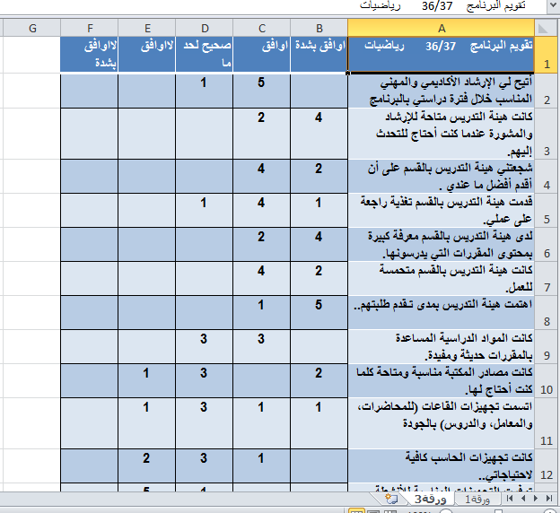
27
19
18
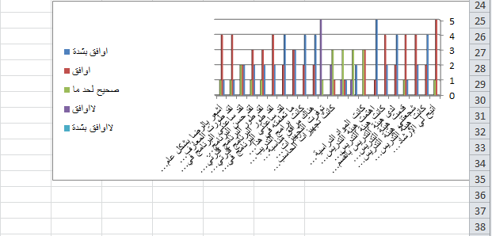
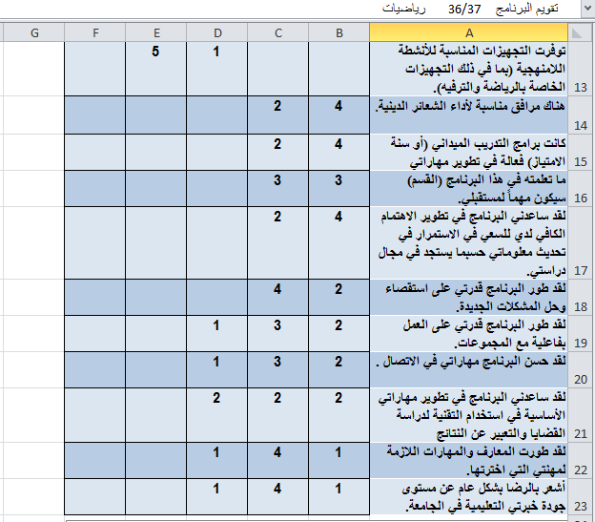

28

- Another evaluation process ( review) :
a.
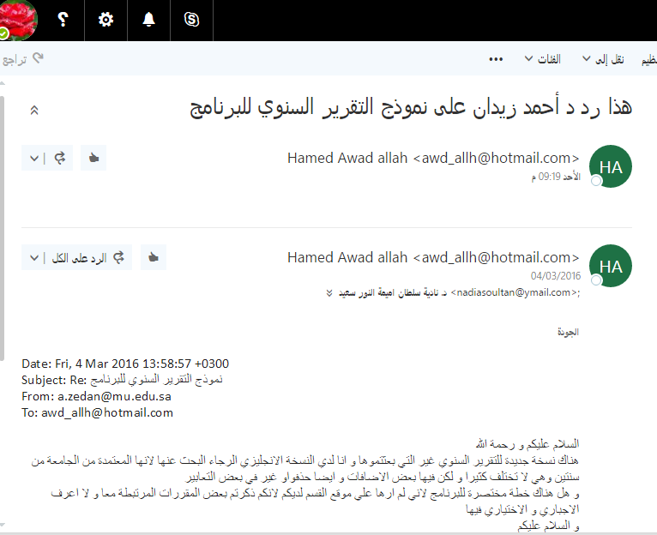

29
b.
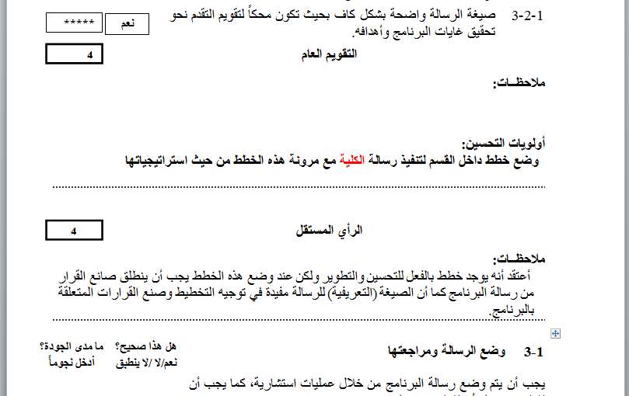

3. All key performance indicator (KPI) of Math program :
30
29
مؤشر  # | مؤشر الاداء | القيمة المستهدفة | القيمة الحالية | قيمة المقارنة  المرجعية الداخلية | قيمة المقارنة المرجعية الخارجية | تحليل مؤشر الأداء | المستهدف الجديد
KPI1 | Evaluation of the knowledge of beneficiaries about the program mission and objectives | 90 % | 80 % | 100 % | 100 % | The program did not distribute the questionnaire to the employment field | 90 %
KPI 2 | Employees and teaching staff evaluation to the polices indicator of the program organizational structure and job descriptions. | 85 % | 80 % | - | - | No handbook for polices indicator | 85 %
KPI 3 | Students overall evaluation on the quality of their learning experiences. | 100 % | 100 % | 100% | - | Questionnaire survey is all student of the program | 100 %
KPI 4 | Proportion of courses in which student evaluations were conducted during the year. | 100 % | 100 % | 100% | 100% | It leads to continuous revision of curriculum and its progression | 100 %
KPI5 | Ratio of students to teaching staff( full time staff or equivalent members ) | 11 : 1 | 11 : 1 | 11 : 1 | 12 : 1 | Number of students will increase | 17 : 1
KPI 6 | Students overall rating on the quality of their courses. | 98 % | 95 % | ــ | ــ | Not all students know the quality standards | 98 %
KPI 7 | Proportion of teaching staff with verified doctoral qualifications | 60 % | 50 % | 78 % | 93 % | Qualified staff give quality and knowledge | 64 %
KPI  8 | Percentage of students entering the program and successfully complete first year. | 97 % | 94 % |  | - | Full academic supervision | 100 %
KPI  9 | Proportion of students entering the program undergraduate and complete in minimum time. | 42 % | 33 % |  |  | First cohort in the program the plan of math courses was not clear in the beginning they have many math courses in one term ; more of them fail | 50 %
KPI  10 | Proportion of postgraduates who complete in the certain time | ــ | ـــ | ــ | - | Not applicable
KPI  11 | Proportion of graduates from undergraduate programs who within six months of graduation are:  (a) employed  (b) enrolled in further study  (c) not seeking employment or further study. | 100 %  أ- 20 %  ب- 20 %  ج- 60 % | 100 %  أ- 0 %  ب- 20%  ج-80% | 88 %  1%  -  - | - | 1.Approximately more of them fail in the teaching exam  2.No postgraduate program is open | 100 %  أ- 30 %  ب- 40%  ج-30%
KPI  12 | Students evaluation to the professional and academic supervision (average estimates of how appropriate psychological and vocational guidance on an annual estimated five-point scale for students in the final year) | 100 % | 95 % | 100 % | - | Academic supervision is the focus of the teaching process | 100 %
KPI  13 | Beneficiaries evaluation to the library services and documentation center. | 80 % | 75 % | - | - | library capacity is small for all student | 85 %
KPI  14 | Beneficiaries Evaluation to the IT services (availability -security -technical support maintenance - software and hardware) | 85 % | 80 % | 100 % | 100 % | Our rate is low because we have no computer lap to apply math software programs, besides the internet services is weak in Zulfi | 85 %
KPI  15 | Proportion of teaching staff participating in professional development activities last year | 100 % | 100 % | 100 % | - | improvement is very important in teaching process | 100 %
KPI  16 | Number of papers published in the scientific journals in the previous year for each teaching staff (full-time or equivalent member) | 4 | 1 | - | - | Only 4 member concerned on papers , publishing and reports submitted | 6
KPI  17 | Proportion of teaching staff (full-time) who have at least one scientific research in the previous year | 50 % | 50 % | - | - |  | 66 %
KPI  18 | Number of scientific papers or reports submitted to conferences for teaching staff ( full-time or equivalent members ) last year | 5 | 1 | - | - |  | 4
KPI  19 | Proportion of teaching staff and other employees who provided activities to the society service | 60 % | 50 % | 100 % | - | No clear plan from the unit of the  society service in the college to attend activities | 50 %
اعتماد التقرير السنوي بمجلس القسم |  |  | يعتمد مشرفة القسم ،،،،  الاسم: د. أميمة النور سعيد  التوقيع: أميمة
رقم الجلسة : | ( الثانية )
تاريخ الجلسة : | 27 / 2 / 1438 هـ

32

