|  |
| --- |
| C:\Users\win7\Desktop\جامعة المجمعة\الشعار111...jpgKingdom of Saudi Arabia  Ministry of Education  Majmaah University  College of Education - Zulfi  Department of Chemisty |

**Study plan of Chemistry program**

**Table 1 : Percentages' Courses**

|  |  |  |
| --- | --- | --- |
| Percentage | Module | No. |
| 18.05% | **Education Skills** | **1** |
| 10.41% | **General Sciences** | **2** |
| 59.02% | **Chemical Sciences** | **3** |
| 8.33% | **Compulsory(University elective studies)** | **4** |
| 4.16% | **Practical Training** | **5** |

**The portion of elective studies is 8.33 %. The student may include any courses taught at MU in the elective studies.**

**Table 2: Courses Requirement**

|  |  |  |  |  |
| --- | --- | --- | --- | --- |
| ECST | Percentage | Total Credit Hours | Type | Requirement |
| 20.4 | **8.33%** | **12** | **Compulsory** | **University** |
|  | **-** | **26** | **Optional** |
| 54.4 | **22.22%** | **32** | **Compulsory** | **College** |
|  | **-** | **-** | **Optional** |
| 170 | **69.44%** | **100\*** | **Compulsory** | **Department** |
|  | **-** | **-** | **Optional** |
|  | **-** | **-** | **Free Courses** | |
| 244 | **100%** | **144** | **Total hours and percentage** | |

|  |
| --- |
| **Table 3: University Requisite** |

|  |  |  |  |  |  |
| --- | --- | --- | --- | --- | --- |
| No. | Code | Course | Credit Hours | Prerequisite | Observations |
| 1 | **SALM 101**  **SALM 102** | **Introduction to Islamic Culture** | **(2+0+0) 2** | **-----------** | **6 Hours**  **Selecting 3 from 4** |
| 2 | **Islam and Society** | **(2+0+0) 2** | **-----------** |
| 3 | **SALM 103** | **Economic System in Islam** | **(2+0+0) 2** | **-----------** |
| 4 | **SALM 104** | **The Basics of the Political System in Islam** | **(2+0+0) 2** | **-----------** |
| 5 | **AR AB 101** | **Arabic Language Skills** | **(2+0+0) 2** | **-----------** | **2 Hours Selecting 1 from2** |
| 6 | **AR AB 103** | **Arabic Editing** | **(2+0+0) 2** | **-----------** |
| 7 | **SOCI 101** | **Contemporary Social Issues** | **(2+0+0) 2** | **-----------** | **4 Hours**  **Selecting 2 from 7** |
| 8 | **ENT 101** | **Business Leadership** | **(2+0+0) 2** | **-----------** |
| 9 | **FCH 101** | **Family and Childhood.** | **(2+0+0) 2** | **-----------** |
| 10 | **HAF 101**  **LHR 101** | **The basics of Health and Fitness**  **Laws and Human Rights** | **(2+0+0) 2** | **-----------** |
| 11 | **(2+0+0) 2** | **-----------** |
| 12 | **VOW 101** | **Voluntary Work** | **(2+0+0) 2** | **-----------** |
| 13 | **ENG 101** | **English Language** | **(2+0+0) 2** | **-----------** |
| Total Number of Credit hours | | | **26** |  |  |

|  |
| --- |
| **Table 4: Compulsory College Requisites** |
|  |

|  |  |  |  |  |
| --- | --- | --- | --- | --- |
| NO. | CODE | SUBJECT | CREDIT HOURS | Prerequisite |
| 1 | **EDU 116** | **Teaching Techniques and Communication Skills** | **(2+0+0) 2** |  |
| 2 | **EDU 117** | **Fundamentals of Islamic Education** | **(2+0+0) 2** |  |
| 3 | **EDU 118** | **The System and Policy of Education in KSA** | **(2+0+0) 2** |  |
| 4 | **EDU 126** | **Developmental Psychology** | **(2+0+0) 2** |  |
| 5 | **EDU 216** | **Psychological Health** | **(2+0+0) 2** | **EDU 126** |
| 6 | **EDU 217** | **Principles of Educational Research** | **(2+0+0) 2** |  |
| 7 | **EDU 226** | **Educational Psychology** | **(2+0+0) 2** | **EDU 126** |
| 8 | **EDU316** | **Administration and Educational Planning** | **(2+0+0) 2** |  |
| 9 | **EDU317** | **Production of E-learning** | **(2+0+0) 2** | **EDU 116** |
| 10 | **EDU 326** | **Teaching Strategies** | **(2+0+0) 2** |  |
| 11 | **EDU 327** | **Curricula** | **(2+0+0) 2** |  |
| 12 | **EDU 416** | **Modern Trends in Teaching Strategies** | **(2+0+0) 2** | **EDU 326** |
| 13 | **EDU 417** | **Educational Evaluation** | **(2+0+0) 2** |  |
| 14 | **EDU426** | **Practicum** | **(0+0+6) 6** | **120 Successful Hours.**  **EDU 416**  **EDU 326** |
| Total Number of Credit hours | | | **32** |  |

**Table 5 : Compulsory Department Requisites**

|  |  |  |  |  |  |
| --- | --- | --- | --- | --- | --- |
| No. | Code | Course | Semester  F=First  S= Second | Credits hours | Prerequisite |
| 1 | **CHEM111** | **General chemistry (1)** | **F** | |  | | --- | | **(1+1+0)2** | |  | |  |
| 2 | **MATH 111** | **Calculus(1)** | **F** | |  | | --- | | **(1+1+0)2** | |  | |  |
| 3 | **PHYS 111** | **General Physics (1)** | **F** | **(1+1+0)2** |  |
| 4 | **CHEM121** | **Organic Chemistry (1)** | **S** | **(3+1+0)4** |  |
| 5 | **CHEM122** | **Inorganic Chemistry ( Main Group Elements)** | **S** | **(2+0+0)2** |  |
| 6 | **COMP125** | **Introduction to Computer** | **S** | **(2+1+0)3** |  |
| 7 | **MATH123** | **Introduction to Differential Equations** | **S** | **(2+1+0)3** | **MATH 111** |
| 8 | **STAT 101** | **Biostatistics** | **S** | **(1+1+0)2** |  |
| 9 | **CHEM211** | **Organic Chemistry (2)** | **F** | **(3+1+0)4** | **CHEM121** |
| 10 | **CHEM212** | **Physical Chemistry- Phase Rule** | **F** | **(1+1+0)2** |  |
| 11 | **CHEM213** | **General Chemistry (2)** | **F** | **(2+1+0)3** | **CHEM111** |
| 12 | **PHYS 123** | **General Physics( 2)** | **F** | **(2+1+0)3** | **PHYS 111** |
| 13 | **CHEM221** | **Heterocyclic Compounds Chemistry** | **S** | **(2+2+0)4** | **CHEM211** |
| 14 | **CHEM222** | **Quantum Chemistry (1)** | **S** | **(2+0+0)2** | **MATH123** |
| 15 | **CHEM223** | **Physical Organic Chemistry** | **S** | **(2+0+0)2** | **CHEM ،211** |
| 16 | **CHEM224** | **Descriptive Analytical Chemistry** | **S** | **(2+1+0)3** |  |
| 17 | **CHEM225** | **Electro-Reversible Chemistry (1)** | **S** | **(2+1+0)3** |  |
| 18 | **CHEM311** | **Quantum Chemistry (2)** | **F** | **(2+0+0)2** | **CHEM222** |
| 19 | **CHEM312** | **Thermodynamic Chemistry** | **F** | **(2+1+0)3** |  |
| 20 | **CHEM314** | **Organic Chemistry (Polymers and patrol)** | **F** | **(2+1+0)3** | **CHEM 211** |
| 21 | **CHEM315** | **Quantitative Analytical Chemistry** | **F** | **(2+1+0)3** | **CHEM224** |
| 22 | **CHEM316** | **Physical Chemistry ( Surfaces, Colloid s & Catalysis)** | **F** | **(2+1+0)3** |  |
| 23 | **CHEM321** | **Biochemistry (1)** | **S** | **(2+1+0)3** |  |
| 24 | **CHEM322** | **Inorganic Chemistry( Transition Elements)** | **S** | **(4+0+0)4** | **CHEM 122** |
| 25 | **CHEM323** | **Electro-Reversible Chemistry (2)** | **S** | **(3+1+0)4** | **CHEM 225** |
| 26 | **CHEM324** | **Coordination Chemistry** | **S** | **(2+1+0)3** | **CHEM 122** |
| 27 | **CHEM411** | **Instrumental Analysis Chemistry** | **F** | **(3+1+0)4** |  |
| 28 | **CHEM412** | **Kinetic Chemistry** | **F** | **(2+1+0)3** | **CHEM 312** |
| 29 | **CHEM413** | **Organic Chemistry (Organic Compounds Spectra)** | **F** | **(3+1+0)4** |  |
| 30 | **CHEM414** | **Biochemistry (2)** | **F** | **(2+1+0)3** | **CHEM 321** |
| 31 | **CHEM421** | **Natural Products Chemistry** | **S** | **(2+1+0)3** | **CHEM221** |
| 32 | **CHEM 422** | **Chemistry of Organic Reactions Mechanisms** | **S** | **(2+0+0)2** | **CHEM211** |
| 33 | **CHEM 423** | **Research Project** | **S** | **(1+3+0)4** |  |
| 34 | **CHEM 424** | **Nuclear and Radiation Chemistry** | **S** | **(3+0+0)3** |  |
| Total Number of EUC Credits hours | | | | **100 Credits hours** |  |

|  |
| --- |
| **Table 6: Suggested distribution of courses on levels** |

|  |  |  |  |  |  |
| --- | --- | --- | --- | --- | --- |
| Level | Course  Code | Course Title | Credit  Hours | Prerequisite | College or  Department |
| Level 1 | **EDU 116** | **General Chemistry (1)** | **(1+1+0)2** |  | **Department** |
| **EDU 117** | **Teaching Techniques and Communication Skills** | **(2+0+0)2** |  | **College** |
| **EDU 118** | **Fundamentals of Islamic Education** | **(2+0+0)2** |  | **College** |
| **MATH 111** | **The System and Policy of Education in KSA** | **(2+0+0)2** |  | **College** |
| **PHYS 111** | **Calculus(1)** | **(1+1+0)2** |  | **Department** |
| **EDU 116** | **General Physics (1)** | **(1+1+0)2** |  | **Department** |
|  | **University Requirement** | **(2+0+0)2** |  | **University** |
|  | **University Requirement** | **(2+0+0)2** |  | **University** |
|  | **University Requirement** | **(2+0+0)2** |  | **University** |
| Level 2 | **CHEM121** | **Organic Chemistry (1)** | **(3+1+0)4** |  | **Department** |
| **CHEM122** | **Inorganic Chemistry ( Main Group Elements)** | **(2+0+0)2** |  | **Department** |
| **COMP125** | **Introduction to Computer** | **(2+1+0)3** |  | **Department** |
| **EDU 126** | **Developmental Psychology** | **(2+0+0)2** |  | **College** |
| **MATH123** | **Introduction to Differential Equations** | **(2+1+0)3** | **MATH111** | **College** |
| **STAT 101** | **Biostatistics** | **(1+1+0)2** |  | **Department** |
|  | **University Requirement** | **(2+0+0)2** |  | **University** |
| Level 3 | **CHEM211** | **Organic Chemistry (2)** | **(3+1+0)4** | **CHEM121** | **Department** |
| **CHEM212** | **Physical Chemistry- Phase Rule** | **(1+1+0)2** |  | **Department** |
| **CHEM213** | **General chemistry (2)** | **(2+1+0)3** | **CHEM111** | **Department** |
| **EDU 216** | **Psychological Health** | **(2+0+0)2** | **EDU 126** | **College** |
| **EDU 217** | **Principles of Educational Research** | **(2+0+0)2** |  | **College** |
| **PHYS 123** | **General Physics (2)** | **(2+1+0) 3** | **PHYS 111** | **Department** |
|  | **University Requirement** | **(2+0+0)2** |  | **University** |
| Level 4 | **CHEM221** | **Heterocyclic Compounds Chemistry** | **(2+2+0)4** | **CHEM211** | **Department** |
| **CHEM222** | **Quantum Chemistry (1)** | **(2+0+0)2** | **MATH 123** | **Department** |
| **CHEM223** | **Physical Organic Chemistry** | **(2+0+0)2** | **CHEM ،211** | **Department** |
| **CHEM224** | **Descriptive Analytical Chemistry** | **(2+1+0)3** |  | **Department** |
| **CHEM225** | **Electro-Reversible Chemistry (1)** | **(2+1+0)3** |  | **Department** |
| **EDU 226** | **Educational Psychology** | **(2+0+0)2** | **EDU126** | **College** |
|  | **University Requirement** | **(2+0+0)2** |  | **University** |
| Level 5 | **CHEM311** | **Quantum Chemistry (2)** | **(2+0+))2** | **CHEM 22** | **Department** |
| **CHEM312** | **Thermodynamic Chemistry** | **(2+1+0)3** |  | **Department** |
| **CHEM314** | **Organic Chemistry (polymers and patrol)** | **(2+1+0)3** | **CHEM211** | **Department** |
| **CHEM315** | **Quantitative Analytical Chemistry** | **(2+1+0)3** | **CHEM224** | **Department** |
| **CHEM316** | **Physical Chemistry ( Surfaces, Colloid s & Catalysis)** | **(2+1+0)3** |  | **Department** |
| **EDU316** | **Administration and Educational Planning** | **(2+0+0)2** |  | **College** |
| **EDU317** | **Production of E-learning** | **(2+0+0)2** |  | **College** |
| Level 6 | **CHEM321** | **Biochemistry (1)** | **(2+1+0)3** |  | **Department** |
| **CHEM322** | **Inorganic Chemistry( Transition Elements)** | **(4+0+0)4** | **CHEM122** | **Department** |
| **CHEM323** | **Electro-Reversible Chemistry( 2 )** | **(3+1+0)4** | **CHEM 225** | **Department** |
| **CHEM324** | **Coordination Chemistry** | **(2+1+0)3** | **CHEM 122** | **Department** |
| **EDU 326** | **Teaching Strategies** | **(2+0+0)2** |  | **Department** |
| **EDU 327** | **Curricula** | **(2+0+0)2** |  | **Department** |
| Level 7 | **CHEM411** | **Instrumental Analysis Chemistry** | **(3+1+0)4** |  | **Department** |
| **CHEM412** | **Kinetic Chemistry** | **(2+1+0)3** | **CHEM 312** | **Department** |
| **CHEM413** | **Organic Chemistry (Organic Compounds Spectra)** | **(3+1+0)4** |  | **Department** |
| **CHEM414** | **Biochemistry ( 2)** | **(2+1+0)3** | **CHEM 321** | **Department** |
| **EDU 416** | **Modern Trends in Teaching Strategies** | **(2+0+0)2** | **EDU 326** | **College** |
| **EDU 417** | **Educational Evaluation** | **(2+0+0)2** |  | **College** |
| Level 8 | **CHEM421** | **Natural Products Chemistry** | **(2+1+0)3** | **CHEM221** | **Department** |
| **CHEM 422** | **Chemistry of Organic Reactions Mechanisms** | **(2+0+0)2** | **CHEM211** | **Department** |
| **CHEM423** | **Research Project** | **(1+3+0)4** |  | **Department** |
| **CHEM 424** | **Nuclear and Radiation Chemistry** | **(3+0+0)3** |  | **Department** |
| **EDU426** | **Practicum** | **(0+0+6)6** | **EDU326،**  **EDU 416** | **College** |

**Study Plan of Chemistry Program**

**Department Requirement**

**Pre-requisite**

**College Requirement**

***Forth Year***

**2nd**

**2nd**

**1st**

***Third Year***

**2nd**

**1 st**

**1st**

**2**

**1st**

**2nd**

***First Year***

***Second Year***

**3**

**EDU 327 Curricula**

E

**2**

**STAT 101 Biostatistics**

**E**

**2**

**EDU426 Field education**

**E**

**6**

**2**

**University requirement**

E

**2**

**CHEM211 Organic chemistry 2**

E

**4**

**EDU 216 Psychological Health**

**E**

**2**

**CHEM121 Organic chemistry (1)**

**E**

**4**

**2**

**2**

**2**

**University Requirement**

**EDU 326 Teaching Strategies**

**E**

**2**

**2**

**2**

**2**

**MATH 111 Calculus(1)**

**CHEM 111**

general chemistry (1)**.** general chemistry (1)



**Course Name**

**Course Code**

**Credit hours**

4

**CHEM423**

**Research Project**

**E**

**4**

**CHEM322**

**Transition Elements**

**CHEM413**

**Organic Compounds Spectra**

**E**

**4**

**CHEM 424 Nuclear and Radiation Chemistry**

**E**

**3**

**CHEM312 Thermodynamic chemistry**

**lec. Course1**

**E**

**3**

**2**

**EDU 217 Principles of Educational Research**

**E**

**PHYS 111 General physics (1)**

**CHEM411 Instrumental Analysis Chemistry**

**E**

**4**

**CHEM414 Biochemistry 2**

E

**3**

**2**

**EDU317 Production of E-learning**

**E**

CHEM311 Quantum Chemistry (2)

ating System

E

**2**

**CHEM321 Biochemistry 1**

**E**

**3**

**CHEM315 Quantitative Analytical Chemistry**

**E**

**3**

**CHEM322 transition elements**

**E**

**4**

**CHEM323 Electro-Reversible Chemistry 2**

**E**

**4**

**CHEM324 Coordination chemistry**

**Cr. & Inf. Security**

**E**

**3**

**COMP125 Introduction to computer**

**E**

**3**

**CHEM122 main group elements**

**Calculus 1**

**E**

**2**

**2**

**University requirement**

E

**EDU 226 Educational Psychology**

**E**

**2**

**2**

**PHYS 123 General physics 2**

**E**

**3**

**CHEM213 General chemistry 2**

**E**

**3**

**University requirement**

E

**2**

**CHEM225 Electro-Reversible Chemistry 1**

**E**

**3**

**MATH123 Introduction to differential equations**

**E**

**3**

**EDU 118 The System and Policy of Education in KSA**

**The System and Policy of Education in KSA**

**The System and Policy of Education in KSA**

**The System and Policy of Education in KSA**

**The System and Policy of Education in KSA**

**E**

**EDU 116 Teaching techniques and Communication skills**

**CHEM 422 Chemistry of organic reactions mechanisms**

**E**

**2**

**CHEM421 Natural Products Chemistry**

**E**

**3**

**EDU 417 Educational Evaluation**

**E**

**2**

**EDU 416 Modern Trends in Teaching Strategies**

**CHEM412 Kinetic Chemistry**

**E**

**3**

**EDU316 Administration and Educational Planning**

**E**

**2**

**CHEM316 Surfaces, Colloid s & Catalysis**

**E**

**CHEM314**

**(polymers and patrol)**

**Artificial Int.**

**E**

**3**

**CHEM222 Quantum Chemistry1**

**E**

**2**

**1st**

**2nd**

**CHEM224 Descriptive Analytical Chemistry**

**E**

**3**

**CHEM223 Physical organic chemistry**

**E**

**CHEM221 Heterocyclic Compounds chemistry**

**E**

**4**

**EDU 126 Developmental Psychology**

**E**

**2**

**CHEM212 Physical chemistry- Phase Rule**

**E**

**2**

**2**

**University requirement**

**University requirement.**

**2**

**University requirement**

***First Year***

**EDU 117 Fundamentals of Islamic Education**

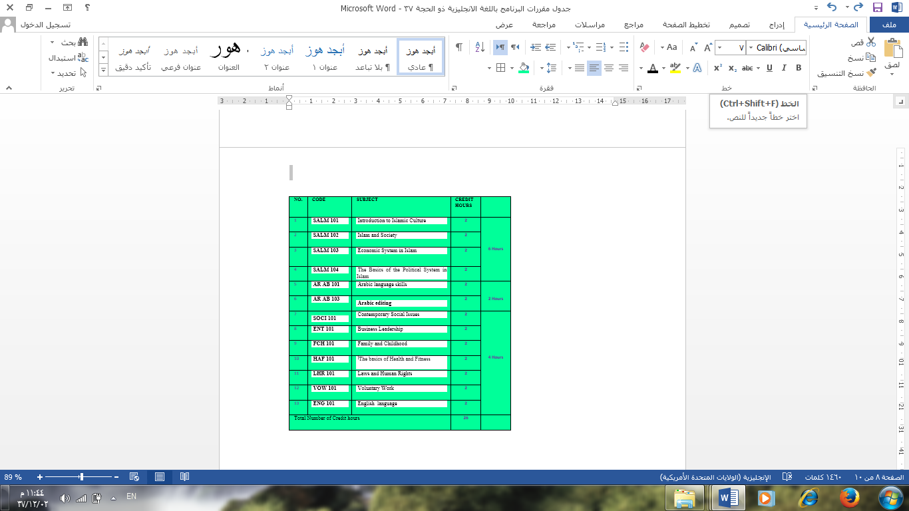

University Requisite

Compulsory 12 Credit hours

**ZULFI COLLEGE OF EDUCATION CHMISTRY PROGRAME**

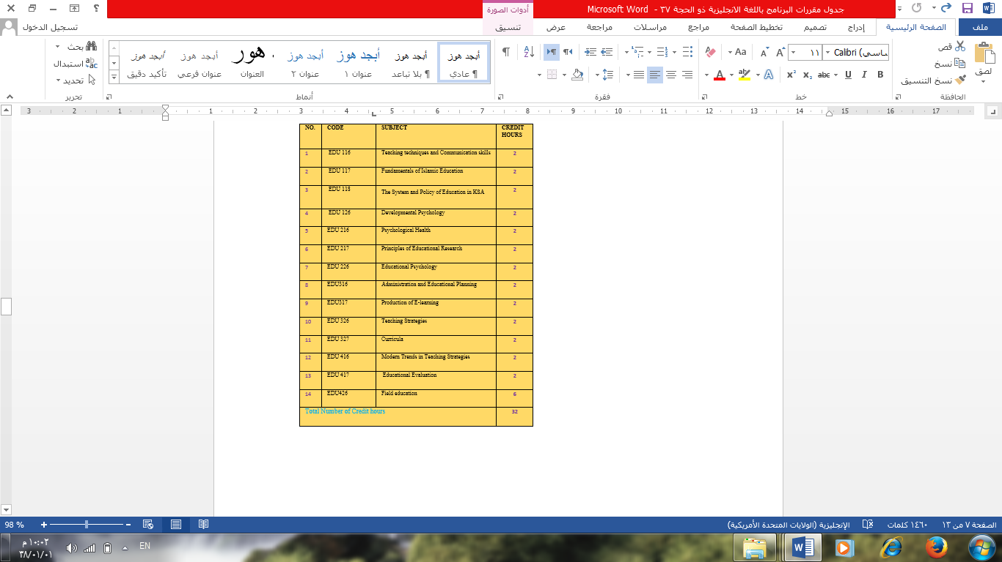

Mathematics and Science Requirements 15 Credit hours

College Requisite

Chemistry Compulsory 85 Credit hours

Compulsory 32 Credit hours

Department Requisite

