Dr. Bakheet Al-Rasheedi a Director for the Innovations & Students’ Outstanding Ideas Center

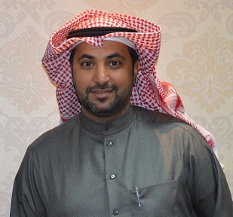
A decree was issued by His Excellency the Rector, Dr. Khalid S. Al-Mugren to appoint Dr. Bakheet Bin Awad Al-Rasheedi as a director for the Innovations & Students’ Outstanding Ideas Center.
Dr. Bakheet extended his thanks and appreciations to the Rector for his trust and promised to be committed to the new appointment and to exert more efforts.
Congratulations were also expressed by the staff of the Rector-ship for Postgraduate Studies & Scientific Research for Dr. Al-Rasheedi on the new position.

