## [His Excellency University Rector Dr. Khaled Saad Almuqrin opened the Second Forum for Educational Affairs that was organized by University vice presidency for Educational Affairs on Tuesday 2/4/1434 in Altashreefat Hall, under the title: "Educational Affa](http://www.mu.edu.sa/en/news/%D9%88%D9%83%D8%A7%D9%84%D8%A9-%D8%A7%D9%84%D8%AC%D8%A7%D9%85%D8%B9%D8%A9-%D9%84%D9%84%D8%B4%D8%A4%D9%88%D9%86-%D8%A7%D9%84%D8%AA%D8%B9%D9%84%D9%8A%D9%85%D9%8A%D8%A9/his-excellency-university-rector-dr-khaled-saad-almuqrin-opened)

With the presence of His Excellency the Vice President for Graduate Studies and Scientific Research and the supervisor of Vice Presidency for Academic Affairs Dr. Mohammed Abdullah Al Shayea, all deans of Deanships, colleges' vice Deans for Educational Affairs, heads of departments, heads of quality centers and a group of faculty members. The forum sought to achieve the following objectives:

1. Familiarizing the participants with the plans prepared by the Vice President for Academic Affairs for the development of the educational process at the university.

2. Inaugurating the website of vice Presidency for Educational Affairs.

 3. Inaugurating the Strategic Plan of vice Presidency for Educational Affairs.

4. Exchanging experiences and points of view between administration of Vice Presidency for Educational Affairs and all university employees including university leaders and faculty members about the axes of the Forum.

**The forum revolved around the following axes:**

 1. Strategic planning for tertiary education.

2. Mechanisms of preparing and developing academic plans at universities.

3. Quality of the assessment processes in the tertiary education.

4. The reality of external cooperation and over-time in academic programs.

5. Mechanisms of dealing with student cases.

6. Mechanisms of updating academic programs.

The forum's activities included a presentation of the accomplishments of University vice presidency for Educational Affairs given by his Excellency Dr. Mohammad Abdullah Alshayea, and it included the following proofs:

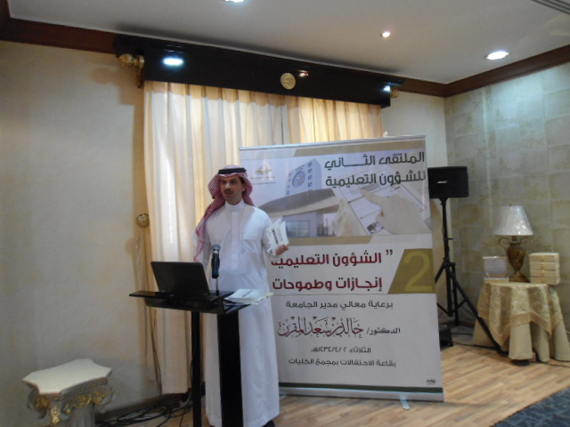

1. The strategic plan of University vice presidency for Educational Affairs 33/1436

2. A guide of preparation and approval of academic plans

3. A guide of examinations quality

4. A guide of organization structure and specializations

5. A procedural guide for implementing academic programs

6. A procedural guide for external cooperation in teaching

7. A procedural guide for over-time request

8. A request of updating an academic program

9. Establishing a new department section

10. A technical report on academic plans

The forum included inauguration of university vice Deanship for Academic Affairs' website and its strategic plan by his Excellency University Rector. It also included an accompanying program of two sessions that encompassed seven agendas over two topics:

First: The first Session (Educational Affairs: Plans and Mechanisms), and it included three agendas as the following:

1_ Strategic planning for Tertiary education, The speaker: Prof. Dr. Mostafa Alfarmawi

2_ Mechanisms of preparing and developing teaching in academic programs, The speaker: dr. Abdulrahman Alqawasmi

3. The status of external cooperation of teaching in academic programs, the speaker: Dr. Fahad Almajdoua

Second: The second session ( Quality of evaluation and academic programs ), and it included four agendas as the following:

1. Quality of assessment processes in tertiary education, the speaker: Prof. Dr. Mostafa Alfarmawi

2. Procedures of over-time request, the speaker: Mr. Fares Saleh Alfares

3. Mechanisms of updating academic programs, the speaker: Dr. Abdulrahman Alqawasmi

4. Work procedures in the regulations of disciplining Almajmaah university students, the speaker: Dr. Hamad Abdullah Alghemeizi

His Excellency University Rector expressed his happiness with these scientific accomplishments that were achieved by the teamwork in vice presidency during the past five months. He also appreciated excellent organization of the forum and teamwork that the university leaders are excellent at in different fields. This has been reflected in the rapid developments the university achieves in all fields. The Rector hoped that the forum, through the agendas discussed and discussions,  concluded with effective recommendations that aim to develop educational affairs in the university. He also expressed his happiness with what has been presented by vice presidency for constant development. His Excellency University Rector honored the participants in the forum and wished everybody progress and prosperity.

The student Abdullah Alsaeed (from Faculty of Education in Almajmaah) presented the forum's activities; the student Abdullah Altuweijri (from Faculty of Business Administration)recited the Holy Quraan.