The E-system of Committees and Councils
(User Guide)

System of Committees

and Councils

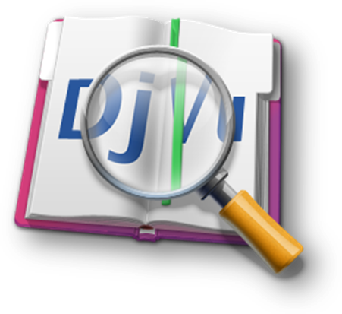

Majmaah University seeks to keep up with the quantitative and qualitative expansion of its vocational processes and systems to find out solutions and applications that facilitate work pursuance and achievement. From this standpoint came the Rector’s guidance to create the system of "committees and councils" as one of the e-system dealings at the university, which aims to standardize work procedures, accelerate the mechanism of decision-making and facilitate work pursuance and archiving in an electronic integrated way that pursues the principle of (paperless) in all its processes. The “system of committees and councils" in its initial version which is adopted by the deanship of e-learning in coordination with the "Permanent Committee"; for monitoring committees distributes roles to the committees and councils members according to the their authorities of the longitudinal system; beginning from the establishment of a new session and ending with the approval of the minutes from the authorized member; Including procedures such as adding agenda, inviting members, adding files and comments, and establishing and signing minutes before being approved by the head of the Committee / Council and then send it to the authorized member. In addition, it makes statistical reports about committees and it archives all minutes in a (PDF) format, which facilitates the process of reference. Based on the adoption of this implementation at the university and the developmental notes that will be received, updated copies of the system will be issued in a periodical package. The technical support team is pleased to receive your comments and inquiries through technical support from within the system.


A brief introduction about the system:
The system was established under the guidance of the Rector in the second consultative meeting of 1432-1433 in order to facilitate and standardize the procedures for dealing with minutes of committees and councils.
- The system is an automation of the current procedures in establishing and preparing minutes.
- The system facilitates the mechanism of committee members work through:
    - Providing a clear schedule for the meetings of the Committee and its subjects.
    - Providing materials and documents electronically.
    - Solving the problem of geographical gap.
    - Electronic signature.
- The system provides multiple data for the decision-maker on the minutes sum achievement through attached reports:
    - The Total of sessions, attendance, topics, apologizes and absence...
    - Chronological age of minutes since its establishment and until approved...

Committee members’ roles and distribution of tasks:
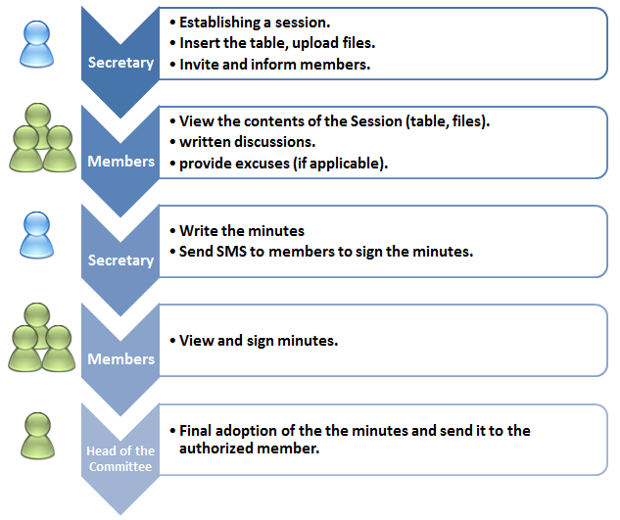

- Program Name: E-system of committees and councils
- Link: http://comt.mu.edu.sa/
- Access: You can access the system through the university portal and then "faculty members" link.
- User rights in the program are as follows:
Permissions of the system usage and its procedures are distributed into four levels:
- Member of the Committee.
- Secretary of the Committee.
- Head of the Committee.
- Authorized member.
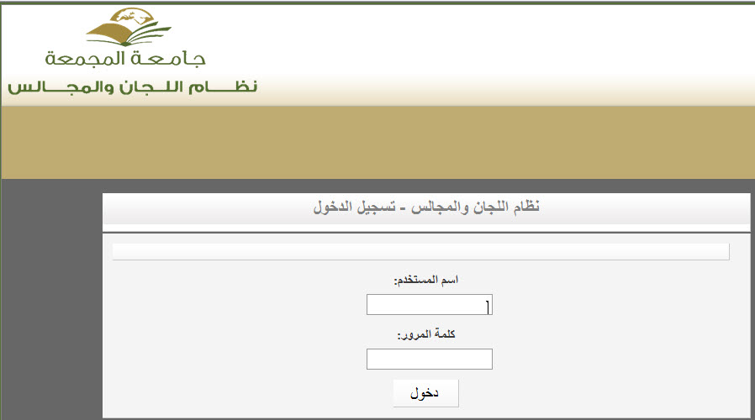
- Login Screen of the System:

- Committee Member Services:
The committee member can do the number of procedures related to the role required of him within the Committee:
- My Account (user data): In case of system login the new user must update and complete data of communication through My Account icon at the top of the screen.
(My Account screen)
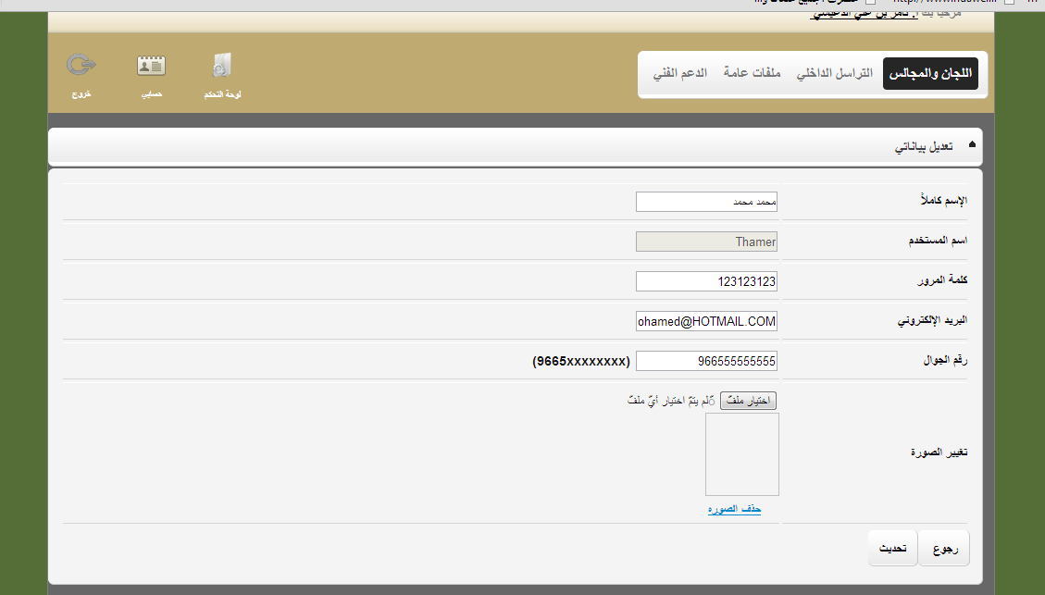

- The following must be noted:
- If correct data were not inserted you’ll be prevented from notification messages access as well as mobile text messages.
- Also it must be noted that the mobile number format should be as follows: 9665XXXXXXXX

- Review of Committees Information: a member is able to acknowledge the committees to which he/she belongs through the tree of committees to the right of the screen, new sessions appear in each committee. Also, the member can access the committee Information Link to view the details of the committee, member and its minute’s files of previous sessions.

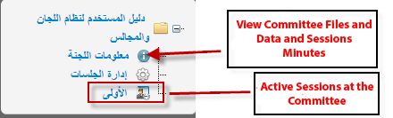

First: About Committee:
When you click on about Committee link the following details appears:
- General Information about Committee (Title, type, description, start and end date of the committee establishment).
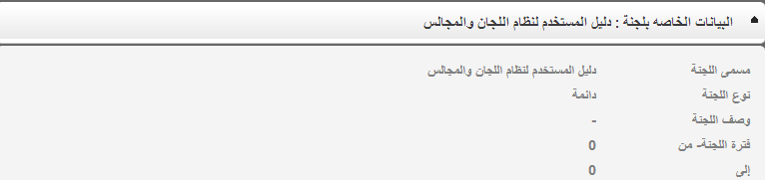

Second: Add a sub-committee:
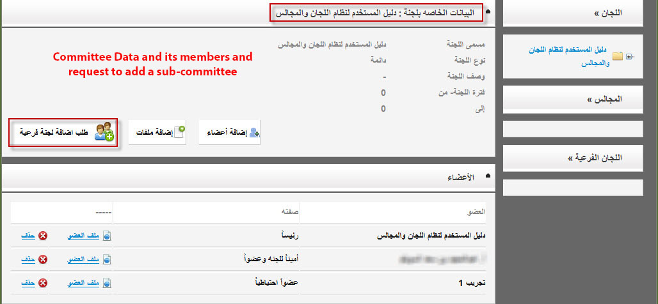
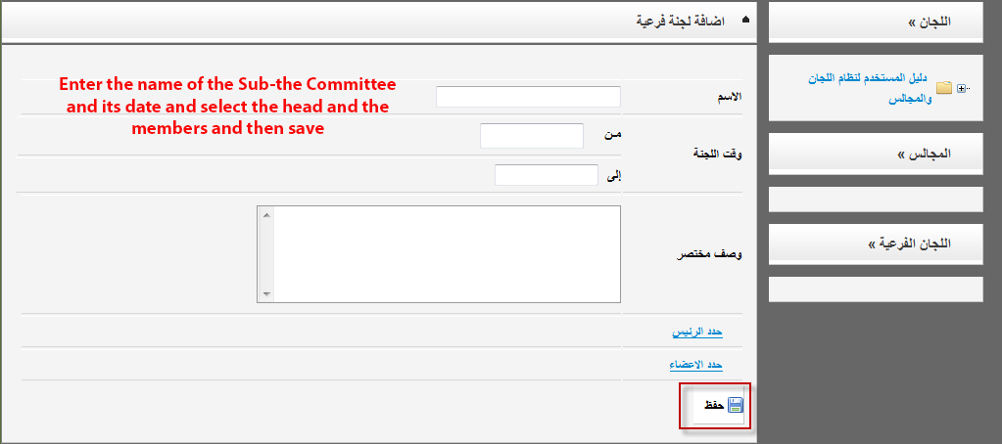
This service is available for the head of the Committee to add a committee or sub-committees, through access to about Committee link and ask to add a sub-committee and then choose the head and members of the committee the request is sent to system administration for activation in the case of approval of the authorized member.

- Members of the Committee: The names of the members and their Titles appear in each committee with the possibility of access to any file member and the possibility of contact them.
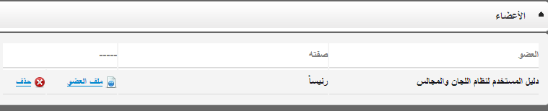

- Committee special files (head of the Committee uploads them), which contain all the rules and executive regulations related to committee.
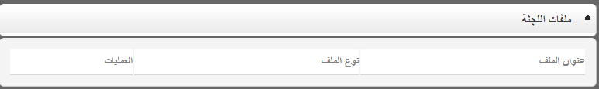
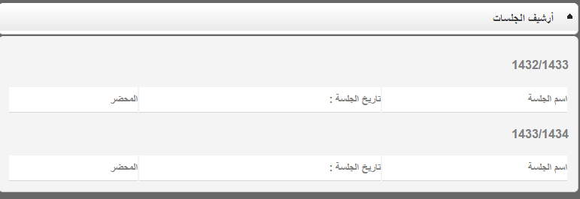
- Previous session minutes Archive which are accredited and arranged according to the year with the possibility of access to the minutes.

Third: session’s Link
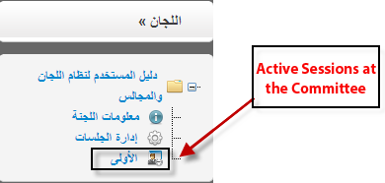

Through the session’s active sessions’ titles can be viewed and you can access the session page through which you can do and view:
- Information about session.
- The agenda (Session topics).
- Participate in discussions and pre-comments on the agenda.
- Download files of sessions.
- Apply for an Excuse for not attending the session.
- View the minutes and express any opinion either by approve or disapprove, and sign.

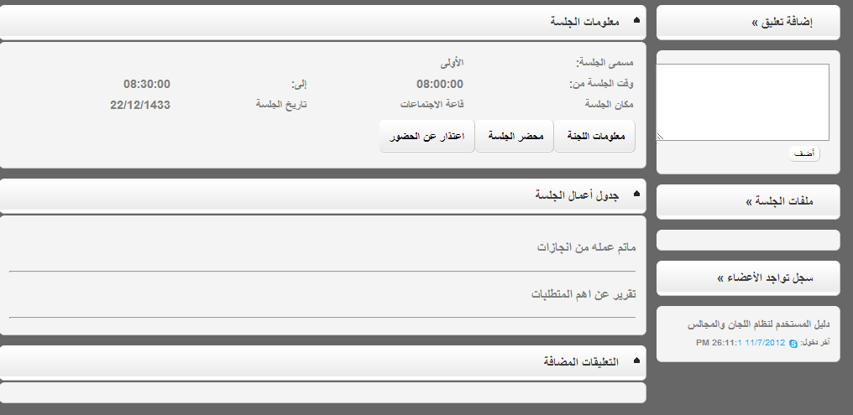
Session page Screen Shot

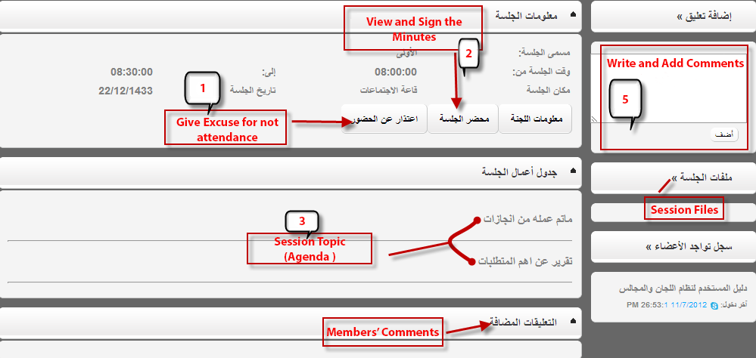

- Excuse Form for Attendance: This form appears when you click on the link (Excuse for attendance) located in the Committee information box after writing the text of the excuse you must click on the save to send the request to the Secretary of the Committee in order to appear on the minute page of the session.
- Minutes Signature form: through the link (session) in the session information box you can access the session page, view the details and express any opinion; with knowledge that a session will not be activated and signed with approval or disapproval unless it is added and accredited by the secretary of the Committee and attended by the its members.

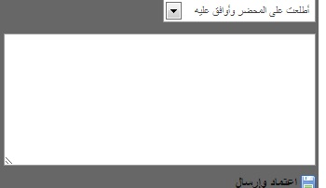
(The field provided for sign in bottom of the session screen)

- Elements of the meeting agenda entered by the secretary of the head of committee, each element contains detailed data when it is clicked.
- The system allows file upload for each committee to be viewed by its members in advance before the session meeting it is the responsibility of the secretary or the head of the committee.
- A box for writing and attaching discussions and suggestions about the agenda.
- Internal mail of the system:
- Internal mail: committee members can exchange e-mails and attach files and read incoming and outgoing messages and view to archive messages.
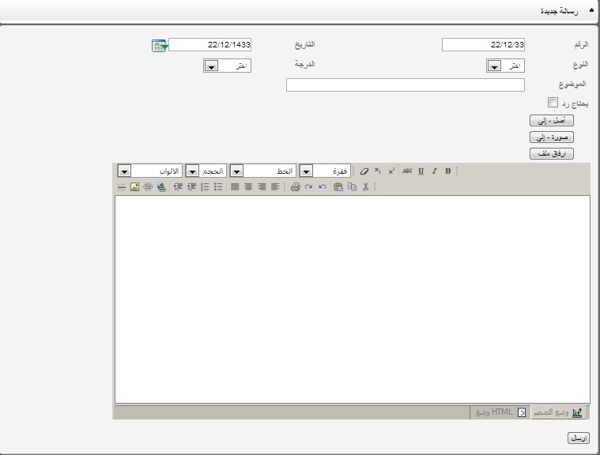
- New Mail Form: as in the following figure a member can send an e-mail for another specified member by the button of (to) and also add a picture and attach files if needed.
- Reading Incoming Mails Form: through clicking on the new mail the member can read and view the details and download attachments.
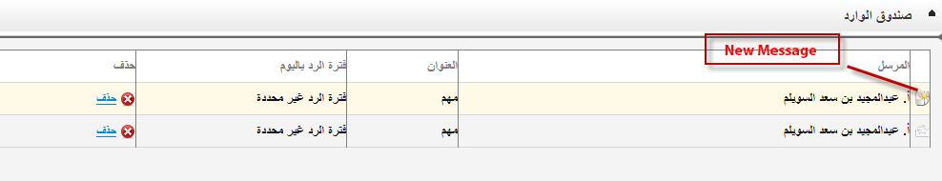
- Committee Secretary Services:
Secretary of the committee has the same authority as the committee members previously mentioned as well as special authorities such as adding a session and editing its data:
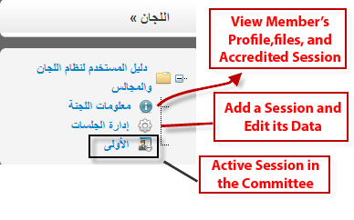
Add and Edit a Session Data: a member can add a new session or edit a location, timing and date of a session. When you select "Add and edit a sessions" from the menu on the right the following page will appear:
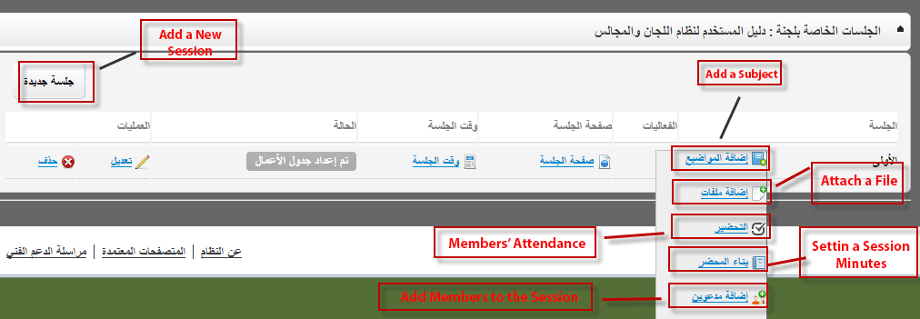

"Add a new Session" button establishes a new session it requires entering data, Committee title, date and time, as well as the Location.
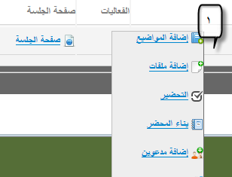
When you click on the icon under the events it show a range of procedures for the new session and details are as follows:
"Subjects of the Session": it enables adding a new topic for the session, when finished you can inform members by an e-mail through "Report Members" it includes all the data of the session (date, time, place of the meeting) and a login request to the system to see the schedule and files, and discussions.
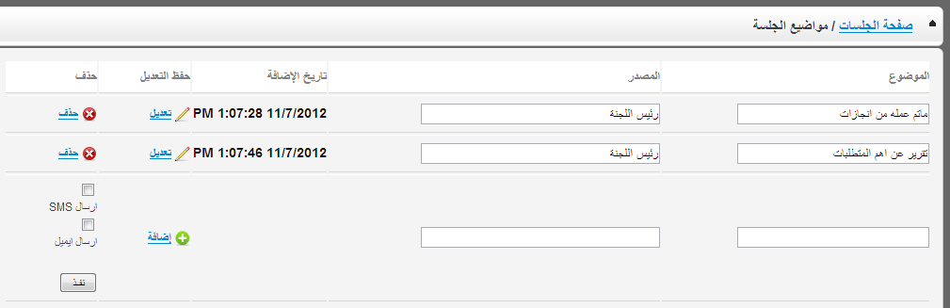

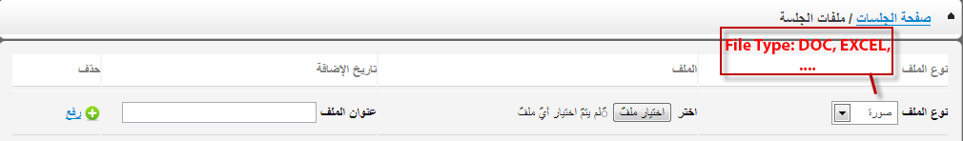
Session Files: from which you can attach files for the session of all extensions.

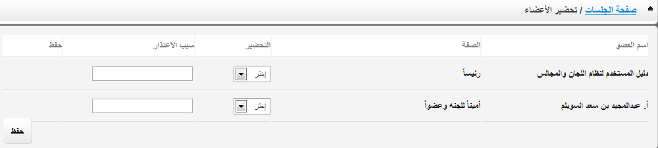
Attending members: through which members’ attendance is ascertained and excuses are stated in case of absence *** A member cannot sign unless it is prepared by the secretary ***.

Setting A Session Minutes: After the session the figure on the right enables setting the minutes of the session, record of the discussion, the final recommendations and its document and the competent authorities.

Add Members: Through which the members’ profiles are recorded, they are given the permission to access and participate in a certain session. This permission ends by the end of the session, so that they can just view their session.

- Services for Head of the Committee:
Head of the Committee has the same authorities of the Secretary mentioned previously as well as the authority of being the only member to send The Minutes for adoption by the authorized member; it can’t be sent unless it is signed by all members.
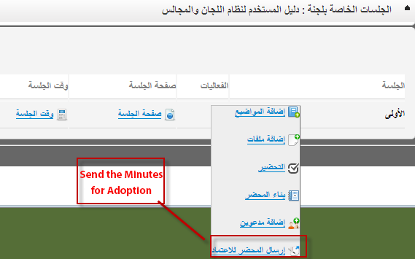
- Technical support:
This service allows sending all inquiries and problems faced by users and also follow-up request.
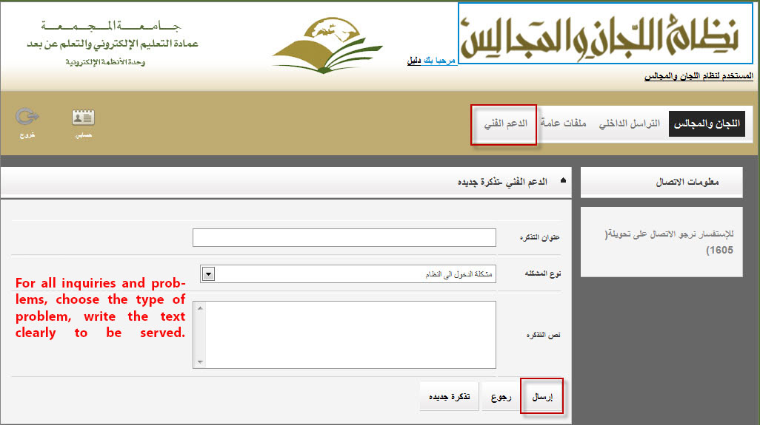

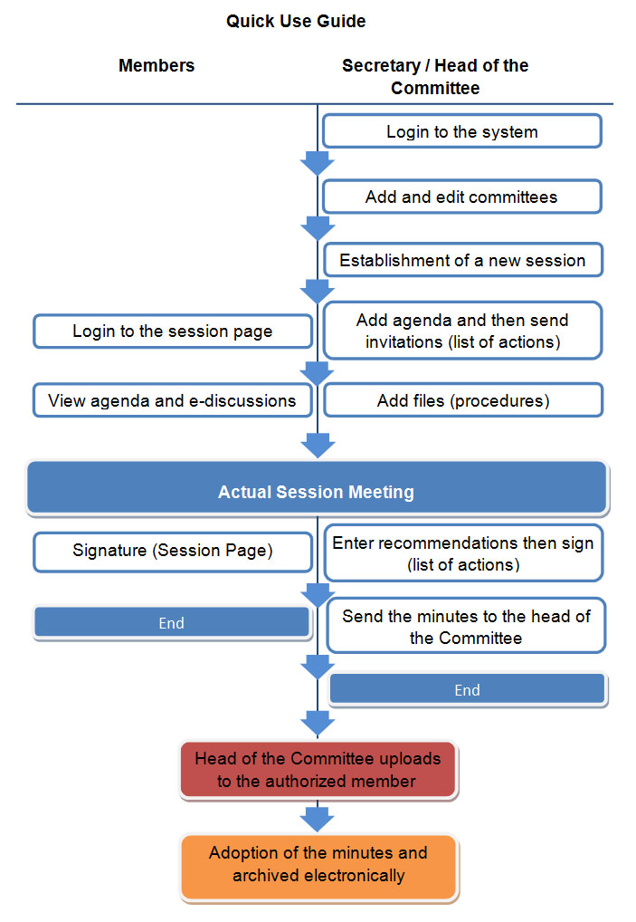

Frequently Asked Questions

Login to the system

- How do I get a user name?
Permission to login is given according to the competent authority that forms committees. After which members are added in the system and Login data are sent to them.

- Forgot your password?
Contact the system administration through the link of technical support, or by calling the beneficiary care in the university (6666) and outside (064 046 666).

- Can I change my username and password?
You can ask to change your username to be as your academic e-mail through the link of technical support, or by calling the beneficiary care in the university (6666) and outside (064 046 666).

Committees and councils:

- Why not all committees and councils are available on my account?
The system allows you to view the committees in which you are added only.

- I am a member of the Committee, but I cannot see it in my account on the system.
Contact the head of the Committee to be invited and added to the Committee.

- Where do I find the previous session of the Committee?
When the minutes is sent for approval by the authorized member all editing and addendum are processes closed in the session. And when approved it is closed permanently and removed from the list of committee sessions, later on the minutes is achieved in a (PDF) format, and can be found electronically to be printed through link "about Committee", you will find all the previous sessions in the archives of the sessions.

- Can recommendations be modified after the adoption of the minutes?
No, Cannot at all.

- I don’t receive e-mails of agenda or SMS notifications to sign the minutes?
Be sure to enter your data correctly in (my account) and the lack of a mail system within the junk mail.

For the Secretary and the Head of committees:
- I can’t establish a session!!
The system gives authority according to the sequence of events in the Committee as follows:
Establish a Committee> enter the agenda> upload files, build the minutes> send to sign> send to the authorized member.

- I would like to place a permanent files for certain committee as executive regulations or standards for work of the committee available for members.
You can put files for specific committee which is available to its members only through the link "about Committee", and then add files.

- Members cannot sign!!
Members must be prepared first before signing the minutes.

- I cannot send the minutes to the authorized member!!

Sending the minutes to the authorized member is the head of committee task.

- What will happen after sending the minutes for adoption?

The following will happen:
- In case of approval:
- Secretary and head of the committee will be informed through internal e-mails of the system.
- The session will be closed and blocked from appearing within the Committee.
- The minutes will be exported electronically as a (PDF) format and will be archived.

- in case of updating:
- Secretary and head of the committee will be informed through internal e-mails of the system.
- The minutes will be reopened so that it is fully editable.



Copyright © Majmaah University
WWW.MU.EDU.sa

