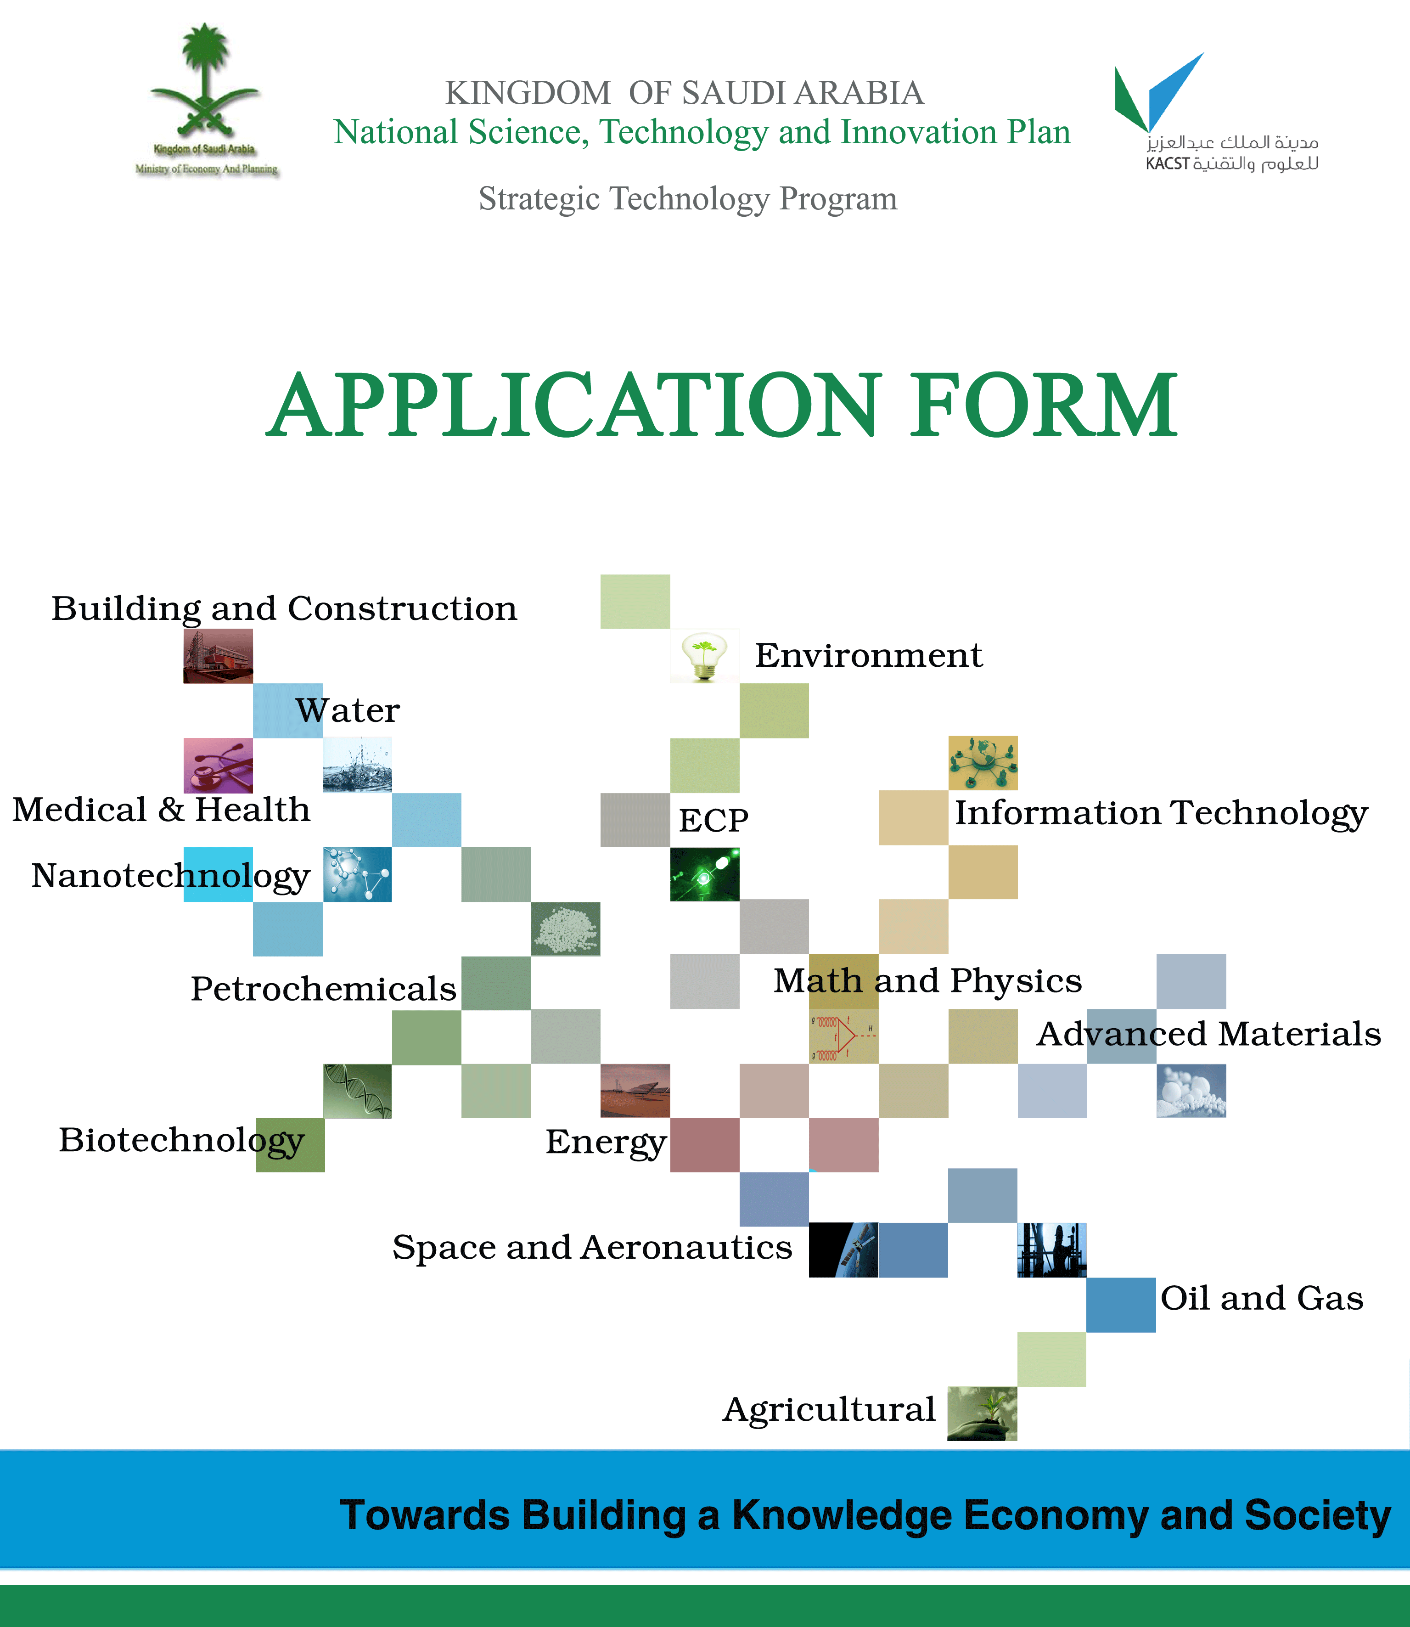

CNPSTI RE-D1: APPLICATION FORM - RESEARCH PROJECT PROPOSAL
ITEM | DESCRIPTION
PLAN | The First Five - Year Science, Technology and Innovation Plan
PROGRAM | Strategic Technologies
SUB-PROGRAM / TECHNOLOGY AREA
TRACK
SUB-TRACK
PROJECT TITLE (ENGLISH)
PROJECT TITLE
(ARABIC)
PRINCIPAL INVESTIGATOR (ENGLISH)
P. INVESTIGATOR (ARABIC )
INSTITUTION

FOR OFFICIAL USE ONLY
SUBMITTED FOR THE DEADLINE OF | 30th of MARCH | 30th of SEPTEMBER
DATE RECIEVED
PROJECT CODE

CNPSTI RE - D1-1: PROJECT INFORMATION
ITEM | DESCRIPTION
PROJECT TITLE
TECHNOLOGY AREA
TRACK
SUB-TRACK
PROJECT TYPE (BASIC, APPLIED, DEVELOPMENT)
PROPOSED TOTAL BUDGET (MAX.  TWO MILLIONS SR ) |  |  | Saudi Riyals
ESTIMATED DURATION ( MAX. 24 MONTHS) |  |  | Months
PROPOSED STARTING DATE |  |  | Month / Year
 | SENIOR PERSONNEL
PROJECT TEAM | No. | Name |  | Role |  | Area of Specialization
PROJECT TEAM | 1 |  |  | P I
PROJECT TEAM | 2 |  |  | CO- I
PROJECT TEAM | 3 |  |  | CO- I
PROJECT TEAM | 4 |  |  | CO- I
PROJECT TEAM | 5 |  |  | CO- I
PROJECT TEAM | OTHER PERSONNEL
PROJECT TEAM | 6 |  |  |  | Postdoctoral Associate
PROJECT TEAM | 7 |  |  |  | Ph.D. Student
PROJECT TEAM | 8 |  |  |  | M.S. Student
PROJECT TEAM | 9 |  |  |  | Technician
PROJECT TEAM | 10 |  |  |  | Project Manager
PROJECT TEAM | 11 |  |  |  | Other
PROJECT TEAM | CONSULTANT*
PROJECT TEAM | 12 |  |  |  | Country:
PROJECT TEAM | *NOTE: a letter of approval from the consultant/s should be attached with the application.
KEYWORDS  (MAX. 4) | 1. |  |  |  | 2.
KEYWORDS  (MAX. 4) | 3. |  |  |  | 4.
IS THIS PROJECT BEING SUBMITTED TO ANY OTHER FUNDING INSTITUTION? | No  Yes, please specify |  |  |  | 1.  2.  3.

- Summary (English):
- Summary (Arabic):
This section should provide a summary of the proposed research project suitable for publication in English and Arabic languages. The summary must not exceed one page in length (max.500 words) and should provide a coherent, clear and concise description of the research activity that would result if the proposal eventually obtains the funding requested. It should describe the objectives and methods to be adopted by the proposed research as well as the expected broader impacts on development and society. It should be informative to other persons working in the same or related fields and understandable to scientifically/technically literate readers. It should not contain any proprietary or confidential information.

- INTRODUCTION
The section should provide a brief background to the research project proposal, briefly explaining the importance of the research being proposed, scope of work and conditions in which the project will be executed. A description of expected results should also be provided as well as an enumeration of fields/areas, and the extent of, their utilization. This introduction must clearly address the relationship of the project to the technology area, its tracks and sub-tracks.

2. PROJECT OBJECTIVES
This section should be set in a SMART way that is the project objectives should be specific, measurable, attainable, relevant, and time-bound.

3. LITERATURE REVIEW
This section should include pertinent, up-to-date background information and cutting edge scientific literatures. This section should, also, identify clearly gaps in knowledge that the proposed project will address; and should be interlinked with any concluded or ongoing work by the project team or by others.

4. DESCRIPTION OF THE PROPOSED WORK
This section should provide sufficient information of the work to be undertaken and should describe in details how the project questions will be tackled. This section should, also, outline the general plan of work, including the broad design and methodology that will be adopted, and, where appropriate, should provide a clear description of experimental methods and procedures as well as expected outcomes. This section should be structured under the following headings:
4.1 Approach, tasks and phases: this sub section should include details of the approaches utilized to achieve each objective of the project (Form RE -D1-2). Research tasks and activities should be divided into groups of assignments, listed in logical sequence and linked with the project objectives to be achieved (Form RE -D1-3).
Form RE -D1-2: APPROACH UTILIZED FOR ACHIEVING OBJECTIVES
OBJECTIVE | APPROACH OF ACHIEVING THE OBJECTIVE
1.
2.
3.
4.
5.
Form RE -D1-3: MAPPING OF PHASES AND TASKS TO ACHIEVE OBJECTIVES
OBJECTIVES | PHASES | TASKS
1.
2.
3.
4.
5.

4.2 Research methodology: this sub section should include procedures and techniques to be used with explanation why these are considered the most suitable to the project questions; detailed description of the experiments and measurements; as well as methods to be used in data collection, analysis, and interpretation. A summary of potential pitfalls and constraints that may be encountered and alternative plans that may be adopted in tracking such pitfalls and constraints. This section should, also, include a consent by applicants to the “ Regulations of Research Bioethics on the Living Creatures ”, when dealing with living creatures, parts of them, or their genetic materials. Please visit the following link for more information about the regulation, (http://www.kacst.edu.sa/ar/depts/bioethics/1/Regul/Bioethic.Rgl.fin.bks.pdf).
4.3 Management Plan: this sub section should indicate how each team member of the project would be involved (with durations) in executing specific tasks relating to the project as illustrated in (Form RE -D1-4). "MS Project" software may be used in this regard. This section should also clearly identify and outline the role of collaborators or consultations (if any) who might be contracted to provide assistance in carrying out the proposed research project. This sub section should also include various elements of the intended work plan; with phases, related tasks and outcomes, assignments, responsibilities, and dates of submission of progress and final technical reports as illustrated in (Form RE -D1-5) .
Form RE -D1-4: ROLE AND INVOLVEMENT DURATION OF PROJECT TEAM
TEAM MEMBERS | ROLE | DURATION  (MONTHS)
SENIOR PERSONNEL:
OTHER PERSONNEL:

Form RE- D1-5: WORK PLAN AND TIME SCHEDUAL
24 | 23 | 22 | 21 | 20 | 19 | 18 | 17 | 16 | 15 | 14 | 13 | 12 | 11 | 10 | 9 | 8 | 7 | 6 | 5 | 4 | 3 | 2 | 1 | INVOLVEMENT  DURATION | PHASES & TASKS
 |  |  |  |  |  |  |  |  |  |  |  |  |  |  |  |  |  |  |  |  |  |  |  | Participation | PHASE I
 |  |  |  |  |  |  |  |  |  |  |  |  |  |  |  |  |  |  |  |  |  |  |  |  | Task 1.1:
 |  |  |  |  |  |  |  |  |  |  |  |  |  |  |  |  |  |  |  |  |  |  |  |  | Task 1.2:
 |  |  |  |  |  |  |  |  |  |  |  |  |  |  |  |  |  |  |  |  |  |  |  |  | PHASE 2
 |  |  |  |  |  |  |  |  |  |  |  |  |  |  |  |  |  |  |  |  |  |  |  |  | Task 2.1
 |  |  |  |  |  |  |  |  |  |  |  |  |  |  |  |  |  |  |  |  |  |  |  |  | Task 2.2:
 |  |  |  |  |  |  |  |  |  |  |  |  |  |  |  |  |  |  |  |  |  |  |  |  | PHASE 3
 |  |  |  |  |  |  |  |  |  |  |  |  |  |  |  |  |  |  |  |  |  |  |  |  | PHASE 4

4.4 Project Deliverables: this sub section should provide a clear statement of the expected real, tangible and measurable outcomes of the proposed research project. Relationship to the project objectives and linkages with goals of the concerned Strategic Technology Program must be elaborated (Form RE -D1-6).

Form RE- D1-6 : RELATIONSHIP TO STRATEGIC FRAMEWORK
PROJECT  EXPECTED  OUTCOMES | STRATEGIC TECHNOLOGY PROGRAM GOALS |  |  |  | PROJECT  OBJECTIVES ACHIEVED
PROJECT  EXPECTED  OUTCOMES | GOAL 1 | GOAL 2 | GOAL3 | GOAL4 | PROJECT  OBJECTIVES ACHIEVED
1.
2.
3.
4.
5.

5. VALUE TO THE KINGDOM
The value to the Kingdom of Saudi Arabia of the proposed research project should be described in detail, in particular the relevance to the industrial base in the areas of technology concerned, or to other strategic sectors of the economy. A description of potential positive impacts on the economy and society at large as well as likely negative outcomes if any should be as clearly elucidated as possible. Benefits for education and training of Saudi students; the career development of researchers; etc. may also be outlined here. It is worth mentioning in this section the targeted end users and the suitable mechanisms for utilization and implementation of the project deliverables.

6. PROJECT EXECUTION
6.1 Current Resources: This sub section should provide information on current or pending funding of the proposed project from any other sources. Equipment and instruments already available at the executing institution, should be enumerated and briefly described.
6.2 Requested Resources: This sub section should include details of all requested human resources, equipment, materials and consumables, as well as details of transportation facilities and travel arrangements that may be needed in the execution of field work or special training required. Applicants must give details of all relevant costs.
6.3 Proposed Budget: this sub section should be completed in accordance to (Form RE-D1-7) for the entire duration of proposed research project. Note that equipment valued at less than SR 10,000 should be included in the materials and consumables section.

SEE INSTRUCTIONS  BEFORE COMPLETING |  | FORM RE- D1-7: PROPOSED BUDGET (in Saudi Riyals)
PROJECT TITLE:
DURATION: |  | ( ) MONTHS
ITEM: | CATEGORY | NO. | COMPENSATION |  |  | FIRST YEAR |  | SECOND YEAR |  | TOTAL
 |  |  |  |  |  | Months | Budget | Months | Budget | TOTAL
Manpower | Consultants
Manpower | Principal investigator
Manpower | Co-investigator
Manpower | Other senior personnel
Manpower | Postdoctoral associate
Manpower | Research assistants
Manpower | PhD students
Manpower | Ms students
Manpower | Undergrads students
Manpower | Project manager
Manpower | Technicians
Manpower | Secretarial- clerical
Manpower | Other
Summer compens. | Compensation 1
Summer compens. | Compensation 2
Total (including summer compensation)
Equipment & materials | major equipment (< = 100.000)
Equipment & materials | Equipment (> 100,000)
Equipment & materials | Materials & supplies
Item total
Travel | Conferences
Travel | Training
Travel | Field trips
Travel | Tickets
Item total
Others | Patent registration
Others | Publications
Others | Workshop
Others | Other expenses
Item total
Grand total
Compensations (including summer compensation) |  |  |  | %
Equipment & materials |  |  |  | %
Travel |  |  |  | %
Others |  |  |  | %
Grand total |  |  |  | %

6.4 Budget Justification: A detailed justification of the funding requested in each budget subcategory outlined in subsection 6.3. should specify if the equipment and infrastructure to be purchased using requested funds would be used in other research projects

7. UNDERTAKING OF THE RESEARCH TEAM:
This section includes a consent of the project team to some scientific rules and ethics (Form RE -D1-8)

RE- D1-8: UNDERTAKING OF THE PROJECT TEAM
The project team undertakes that this project or any part of it, is:
- Prepared in full conformity with the SCIENTIFIC INTEGRITY RULES.
- Original work of the signatories or individuals working under their supervision, including the text, graphics, publications, and documents, unless otherwise indicated.
- Not funded by any other sources.
- Not submitted to any other funding institution during the evaluation process.
- Not sought fund from any other sources if it is funded by the NSTIP.
SIGNATURE | ID NUMBER | NAME | ROLE
 |  |  | PI
 |  |  | COI. 1
 |  |  | COI. 2
 |  |  | COI. 3
 |  |  | COI. 4
 |  |  | COI. 5

8. REFERENCES
References should be cited in the standard style used in scientific/technical publications. Links to online versions may be provided together with dates on which the material was accessed.

9. RESUMES :
A biographical sketch (max.3 pages) is required for each senior personnel involved in the research project. Resumes should include information related to professional preparation, appointments, publications, synergistic activities and collaborators and other affiliations.



Applicants are advised to visit the following link for more information about technology areas, tracks and sub-tracks http://www.kacst.edu.sa/en/research/Pages/default.aspx.
Applicants are advised to visit the following link for more information about technology areas, tracks and sub-tracks http://www.kacst.edu.sa/en/research/Pages/default.aspx.
ID number includes National ID for citizens and Iqama for non-citizens team members.

