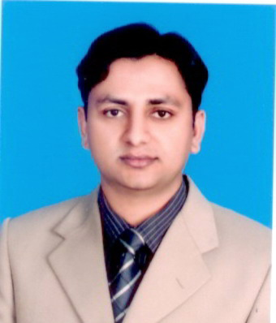
Muhammad Humran Khan
Address: College of Engineering, Majmaah University, Al-Majmaah KSA.
Mobile: 00966503639591
E-mail: humrankhan@hotmail.com
Date of Birth: 25th December 1981

EDUCATION

2007 – 2009 |  | Blekinge Institute of Technology (Karlskrona), Sweden.  [ http://www.bth.se ]  MSc Electrical Engineering in Telecommunication Systems
2007 – 2009 | - Telecommunication Systems  - Wireless Networks  - Simulation  - Applied Signal Processing |  | - Network Management  - Modern Techniques Networking  - Wireless Personal Area Networks  - Network Security
2001 – 2005 |  | Allama Iqbal Open University Islamabad Pakistan.  [ http://www.aiou.edu.pk ]  BSCS (Bachelor in Computer Science) 4 Years
2001 – 2005 | - Data Communication  - Electronics  - Digital Logic Design  - Business Communication |  | - Network Design  - Management Information System  - Multimedia Systems  - Artificial Intelligence
1998 – 2000 |  | Govt. College Bosan Road Multan Pakistan.  Fundamentals Of Sciences (FSc)
1996 – 1998 |  | Islamia Cadet school Multan, Pakistan.  Matriculation
1996 – 1998 | - Science Group ( Physics, Chemistry, Mathematics, Biology)
July 2010 | CCNA ( Cisco Certified Network Associate )

EXPERIENCE

May 2011 to Present  2009 -- 2010  2006 – 2007  Feb 2010- July 2010 | Al-Majmaah University (Saudi Arabia)  College of Engineering  Lecturer (Electrical Engineering Department)  Superior University Lahore (Pakistan)  Lecturer ( Electrical Engineering Department)  Brain Telecommunication Ltd. Pakistan  Designation : Officer Corporate Technical Support and Sales
Responsibilities
- Onsite & Online Support
- Hand on LAN , MAN , WAN , WIRELESS Technologies
- Worked with Optical Fiber Networking, Routers, Switches and Hub.
- Design Network Strategies and Implementation.
- Provide technical and complete solution to End User.

Nokia Siemens Networks Pakistan

I was working as an internee in RF Planning And Optimization Department
My tasks included generation and Analysis of log files, Check lists. Working with TEMS (Air Interface Tool) Drive Testing. Worked with Mapinfo, Ms Access
Final Year Projects

2009 | APSEN Analysis Beyond 3G Wireless Networks  Final Project of MSc
2009 | - Application, Session and Network layer Analysis, Issues and their appropriate  Solutions while migrating from 3G to 4G.  - Research in the field of wireless communications of different major issues  containing layers and their solutions provision beyond 3G.
2005 | Sale Purchase and Inventory Control System  Final Project of B.S(CS)
2005 | - Maintain administrator(s) / user(s) record  - Maintain vender/customer record

Skills & Abilities

- Ability to effectively lead and manage people
- Familiar with C, C++, SQL, VB, HTML, VC++, Java, programming
- RFID, Matlab, Zigbee, Handoff, Fading
- Blue tooth, Multilevel Security,
- IP Routing, OPNET Simulation, Free BSD6.2

