**م علوم الحاسب والمعلومات**

**Commission Alumni Affairs and Employment**

**For the Programs of Computer Sciences and Information Department**

**College of Sciences in Al-Zulfi**

Prepared By

Dr.Loai Kayed Hassan Bani Melhim

In collaboration with the College of Sciences graduates unit

Revised By

**Associated Prof. Yossry Azzam**

**Department Head**



المحتويات

Introduction 4

Vission, Mission & Goals 5

The Committee establishment decision 6

Committee Members 7

Authorization 8

Achievements and Activities 8

Problems and Obsticals 9

Suggestions and Recomendations 10



# 

# Introduction

The Commission Alumni Affairs and Employment consider the needs of its graduated students by communicating with them and providing information about training and employment opportunities available in the private and public sectors and by inviting them to the career and activities day in the college.



# Committee Vision, Mission & Goals

## Committee Vision

The establishment of a permanent and effective partnership with college graduates for the highest standards of quality and excellence to ensure its graduates and their ability to integrate into the community service.

## Committee Mission

To stay connected with the students by letting them involve in the college activities that support communication with the community and develop their sense of belonging to the College and believe in their contribution to the development of educational programs and maintain a commitment to excellence through continuous coordination with the institutions of the public and private sectors.

## Committee Goals

* Directing fresh graduates to get jobs through various means (liaison with employment - exhibitions meet with officials of the graduates employment agencies - to provide training programs for college graduates in the fields of labor market needs .. etc).
* Create opportunities for collaboration and participation in academic and research activities and community service held at the college.
* Follow college graduates by employers enrolled and the concentration of a database for the purpose.
* Questioner the graduates about the content of the educational programs and the extent of its contribution to their success in their life.
* Poll views of government employer’s agencies and other agencies about the extent the college educational programs in response to the needs of the labor market.
* Development the college academic, research and training plans in accordance with the needs of the labor market.
* To determine the percentage of graduates who work in their area or in other areas or still search for work.
* To build a database about graduated students so that to follow up their status continuously.
* Inform alumni on developments in the areas of academic and research within the college.

# The Committee establishment decision

The Alumni Affairs and Employment Committee was created Based on the Department of Computer and Information Sciences decision at the meeting No. (1) Dated 10/13/1434.

**Committee Members**

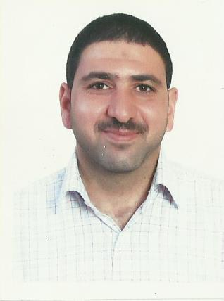

**Dr.Loai Kayed Bani Melhim – Committee Head**

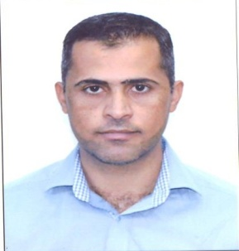

**Mr. Mohammad Elkhaledy - Member**



**Dr.Eng. Mustafa Redha Tantawi - Member**

**Authorization**

Dr.Eng. Mustafa Redha Tantawi will, head the tasks of alumni affairs and employment in the absence of the committee head Dr. Loai Bani Melhim.

# Achievements and Activities

# - Building the Database of the College’s Graduation students :

The formation of an electronic database containing data and information about the various alumni is considered the first step in an effective communication with alumni which is also among the major tasks of the committee. The following fields were suggested to be as a basic for the established database. (Name, major, year of graduation, mobile, email, personal webpage, ID, address, current position, address of the employer) as shown in Table 1.

Data gained from the alumni or from the students who are expected to graduate, will be kept as a soft and hard copy.

Table 1: Form1 for the suggested Alumni Database

|  |  |
| --- | --- |
|  | Name |
|  | Year of Graduation |
|  | University ID |
|  | General Major |
|  | Specific Major |
|  | Mobile |
|  | Email |
|  | Personal web site |
|  | Address |
|  | Current position |
|  | Employer address |

**Users of the Alumni Database (Employers)**

Employers are considered the primary beneficiary from the college products; which lead to the need of building another database that has all the required data about employers. These data can be used to communicate with the different establishments about the aspects of possible common cooperation. The suggested fields that can be used in this database are shown in Table 2.

Table 2: Form2, Employer Basic data

|  |  |
| --- | --- |
|  | **Establishment Name** |
|  | **Establishment Type: Public/Private** |
|  | **Mobile** |
|  | **Telephone** |
|  | **Email** |
|  | **Website** |
|  | **Establishment Address** |
|  | **‘s Name  Establishment Liaison Officer** |
|  | **‘s Number  Establishment Liaison Officer** |
|  | **Establishment business field** |
|  | **Jobs Available at the Establishment** |
|  | **Population of the Establishment** |
|  | **The number of beneficiaries of the Establishment** |

**Poll graduates and beneficiaries viewpoints:**

The performance of the Alumni committee is based mainly on the analysis of data and the available diverse information about the graduates and the beneficiaries to Poll graduates and employers viewpoints about the outputs of the Faculty of Science in Al-Zulfi.

**Problems and obstacles**

* The absence of the opinion of employers and the industrial sector (public and private).
* It is difficult to keep up with the labor market evolution compared with the academic plan.
* Continuous change in labor market.
* Weak access to similar local and global experiences.
* The weak participation of the beneficiaries, (students, alumni, public and private sectors).

**Suggestions and Recommendations:**

* Encourage cooperation and communication between the departments of the college and employers in the Kingdom.
* Discuss the skills, knowledge and abilities required in the labor market.
* Discuss any possible modification occurs to the programs and the appropriateness of this change to the labor markets.
* Contribute to an active role in the process of evaluation and development of the academic program goals.
* Take advantage of courses review s and study plans to achieve development.
* Transfer the current challenges facing the information technology and develop future plans to address these challenges.

# 