EBSCOhost User Guide—Searching

Basic, Advanced & Visual Searching, Result List, Article Details, Company Information, Additional Features

support.ebsco.com

Table of Contents
What is EBSCOhost® 5
System Requirements 5
Inside this User Guide 5
Learning More about a Database 6
Choosing Databases to Search 7
Selecting Databases by Database Name 7
Selecting Databases by Subject Area 8
Multilingual Options 9
Changing the Language of the Interface 9
Translating an Article 10
Search Screens 11
Basic Search 11
Advanced Search Screens 13
Advanced Search with Single Find Field 13
Advanced Search with Guided Style Find Fields 15
Viewing Search Results 17
Viewing the Result List 17
Left - Limiters and Clustering 17
Middle - Results Display 18
Right - Related Information 18
Page Options 19
Alert/Save/Share 20
Clustering 21
Using the Breadbox 22
Reading an Article 23
Detailed Record 23
HTML Full Text View 24
PDF Full Text Viewer 25
Linked Full Text View 27
Tools Menu 27
Using Text-To-Speech 28
Saving Results to the Folder 30
Saving Articles to a Specific Folder 31
Citation Matcher 32
Visual Search 34
Searching for Images/Video 38
Searching for Company Information 40
Company Information Result List 41
Parent Companies 42
Company Landing Page 42
Searching for Company Profiles 44
Preferences 46
Setting Preferences 46
Trying New Features 49
What’s New Area 49
Coming Soon Area 49

What is EBSCOhost®
EBSCOhost is a powerful online reference system accessible via the Internet or direct connection. It offers a variety of proprietary full text databases and popular databases from leading information providers. The comprehensive databases range from general reference collections to specially-designed, subject-specific databases for public, academic, school, medical, corporate, and government libraries.

System Requirements
In order to effectively use all EBSCOhost features, the minimum browser requirements are Internet Explorer 7.0, Firefox 3.0, Google Chrome, and Safari 3.0 (for Macintosh). You must also have Adobe ® Reader® installed to view the PDF Full Text files. If you are using Visual Search, you must also install Adobe ® Flash Player 8.0 or higher.

Inside this User Guide
This guide is designed to cover the basics of searching and finding results. Additional user guides cover topics such as browsing, searches and alerts, and printing, e-mailing and saving. All user guides can be downloaded from the EBSCO Support Site: support.ebsco.com.

Learning More about a Database
There are two versions of the Choose Database Screen—brief and detailed. The brief version of the Choose Database Screen is available from any search or browse screen, result list, or citation details.

To learn more about a database:
- Click the Choose Databases link.
- Place your mouse over the Preview icon. A brief description of the database is displayed. To return to your previous screen, click OK. 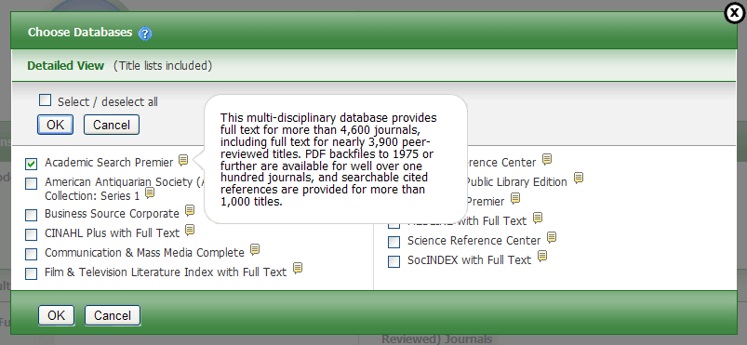
- To view descriptions of all the databases available to you, click the Detailed View link. The Choose Databases Screen displays.
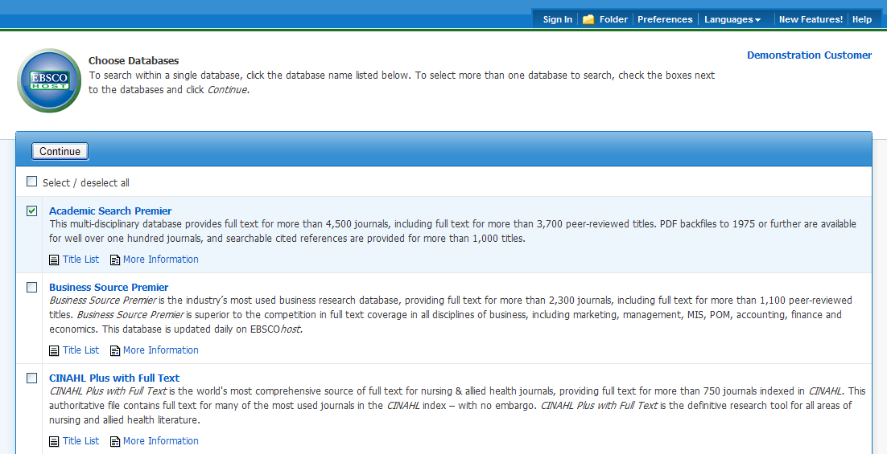

Choosing Databases to Search
EBSCOhost offers the ability to select the databases you want to search by database name or by subject area. Your library administrator decides how databases will be selected.

Selecting Databases by Database Name

To select a database:
- Click the Choose Databases link. Select the database name, e.g., Academic Search Complete, MasterFILE Premier, etc. from the list of databases.
- To search more than one database, mark the check boxes to the left of the database names. You can also use the Select / deselect all check box to make your selections. 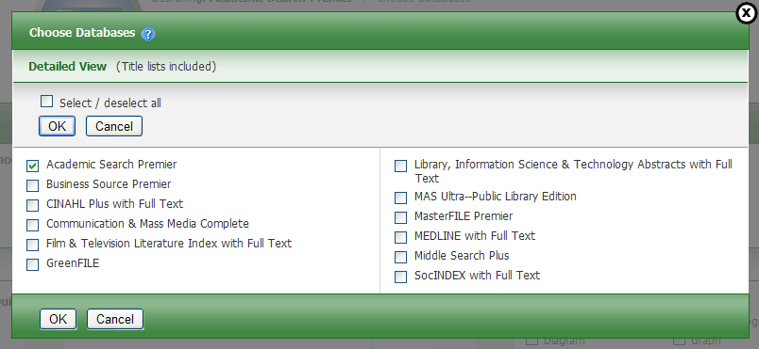
- To save your selections, click OK; or click Cancel to discard your changes.

Selecting Databases by Subject Area
If your library groups your databases by subject area, the two most recently selected database groups are listed above the Find field. If additional groups are available, click the hyperlinked ellipsis (…) to view them.
To select databases by subject area:
- Click the Choose Databases link. Select the subject area, e.g., Communications/Media Databases, General/News Databases, etc.
- To search more than one subject area, mark the check boxes to the left of the subject areas. (You can also use the Select / deselect all check box to make your selections.
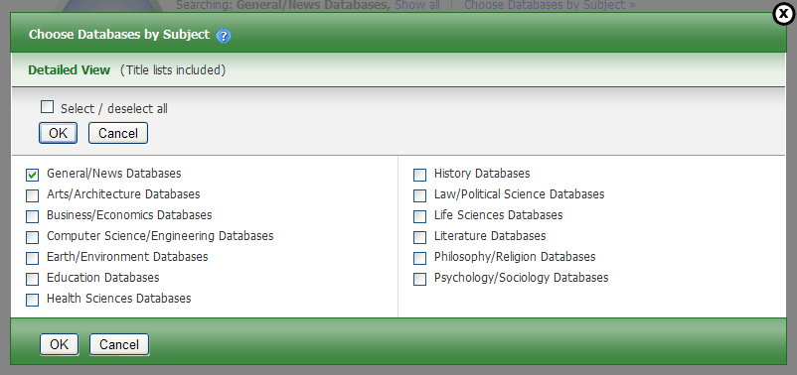
- To save your selections, click OK; or click Cancel to discard your changes.

Multilingual Options

Changing the Language of the Interface
If enabled by the library administrator, you can change the interface text of EBSCOhost from English to:
• Arabic | • Greek | • Russian
• Bahasa Indonesian | • Hebrew | • Simplified Chinese
• Brazilian Portuguese | • Hungarian | • Slovenian
• Croatian | • Italian | • Spanish
• Czech | • Japanese | • Thai
• Dutch | • Korean | • Traditional Chinese
• French | • Polish | • Turkish
• German | • Romanian
The language selection feature is located on top toolbar and the Preferences Screen in EBSCOhost.
To change the language of the interface:
- Hover your pointer over Language on the top toolbar on the interface.
The drop-down menu of available languages appears.
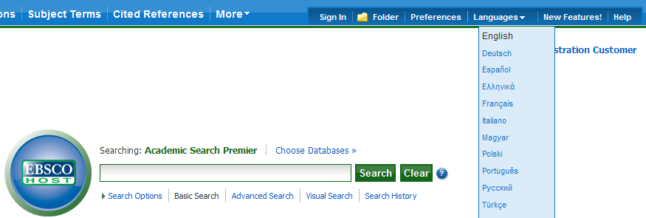
- Select by clicking on the desired language in the list.
The interface is refreshed and translated into the selected language.
You can set your default language to any of the languages listed above, and the next time you sign in to My EBSCOhost, the screens will display in your selected language.
To set a default language preference:
- Sign in to My EBSCOhost.
- From your search screen or Result List, click the Preferences link that appears below the Find field.
- In the General Settings area, select your language from the drop-down list
- Click Save.

Translating an Article
EBSCOhost screens are presented in English, by default. If provided by your library administrator, you may be able to translate a full text article from English into the following languages:
- Arabic | - Hausa | - Polish
- Bulgarian | - Hebrew | - Portuguese
- Simplified Chinese | - Hindi | - Pashto
- Traditional Chinese | - Hungarian | - Romanian
- Czech | - Indonesian | - Russian
- Danish | - Italian | - Spanish
- Dutch | - Japanese | - Serbian
- French | - Korean | - Swedish
- German | - Norwegian | - Thai
- Greek | - Persian | - Urdu
To translate the full text of an article:
- From the article detail, select a language from the Choose Language drop-down list.
- Click Translate. The full text of the article is presented in the language you selected.
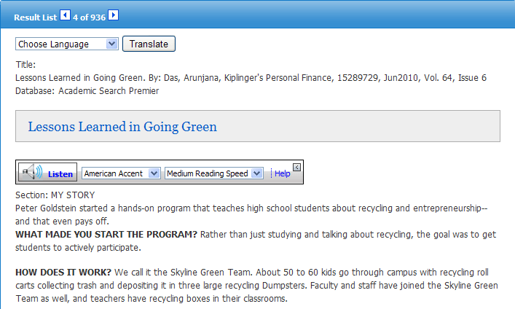
- To return to English, click Return.
Note: If you print, e-mail or save the full text, it will be delivered in the language of the database. However, you can print the translated text using your browser's Print function.

Search Screens
EBSCOhost offers a variety of search screens, which are described in this section.

Basic Search
The Basic Search Screen lets you create a search with limiters, expanders, and Boolean operators.
To use Basic Search:
- On the Basic Search Screen, enter your search terms in the Find field. 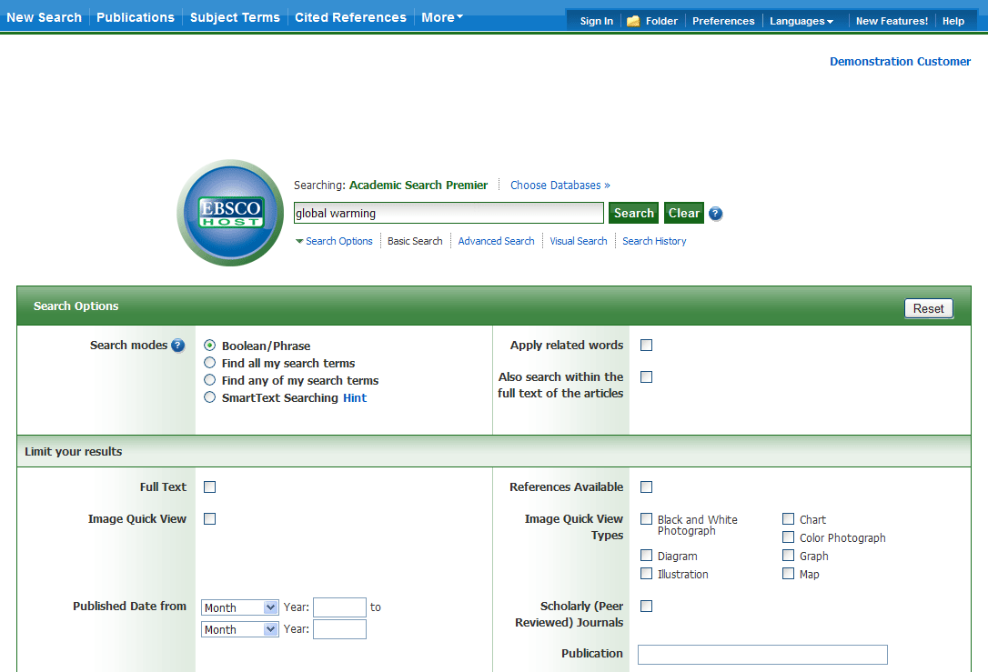
- If you want to use any of the optional Limiters or Expanders, click the Search Options link.
You can use a specific Search mode, such as “Find all of my search terms,” or “SmartText Searching”; apply Limiters such as Full Text or Publication type; or use search options that expand your search, such as “Apply related words.”
- To close the Search Options, click the link again.

- Click the Search button. The Result List displays.
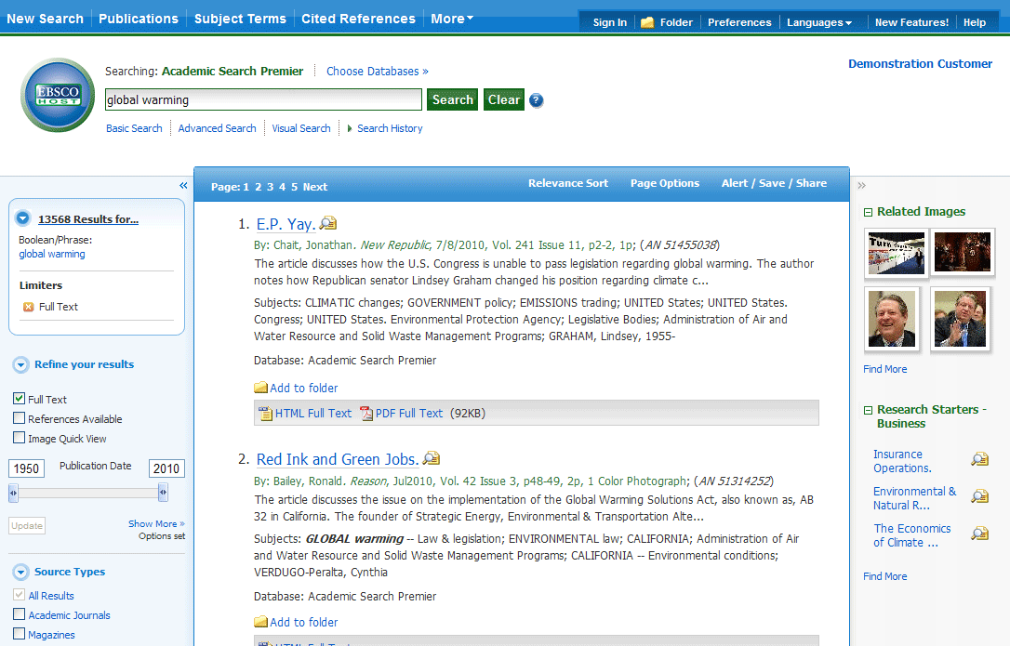
The search field is displayed above the Result List. Your search terms, limiters and expanders are retained. To revise your search, you can apply the limiters under Refine your results on the left or click the Show More link to view all available limiters.

Advanced Search Screens
The library administrator can choose from three styles of Advanced Search: Single Find Field or Guided Style Fields.

Advanced Search with Single Find Field

To use Advanced Search with Single Find Field:
- Click the Advanced Search link below the Find field.
- On the Advanced Search Screen, enter your search terms in the Find field. 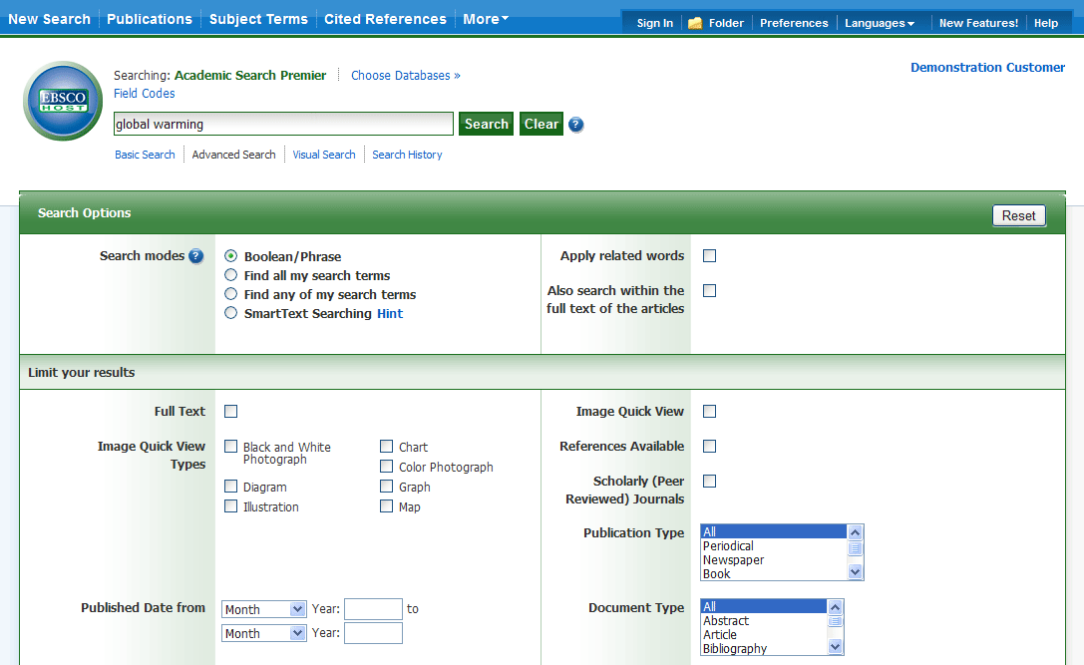
- Select from the available Search Options:
- Search modes – Use specific search modes, such as “Find all of my search terms,” or “SmartText Searching,” or use search options that expand your search such as “Apply related words.”
- Limit your results – such as Full Text or Publication type.
- Special Limiters – Apply limiters specific to a database. If you select a special limiter, it is applied only to the database under which it appears

- Click the Search button. The Result List displays.
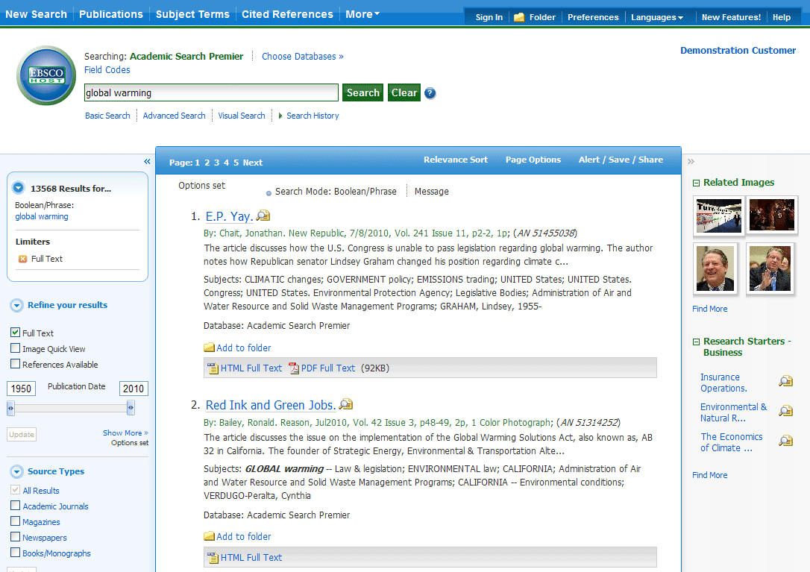
The search field is displayed above the Result List. Your search terms, limiters and expanders are retained. To revise your search, you can apply the limiters under Refine your results on the left. Click the Show More link to view all available limiters and expanders.

Advanced Search with Guided Style Find Fields

To use Advanced Search with Guided-Style Fields:
- Click the Advanced Search link below the Find field.
- On the Advanced Search Screen, enter your search terms in the first Find field.
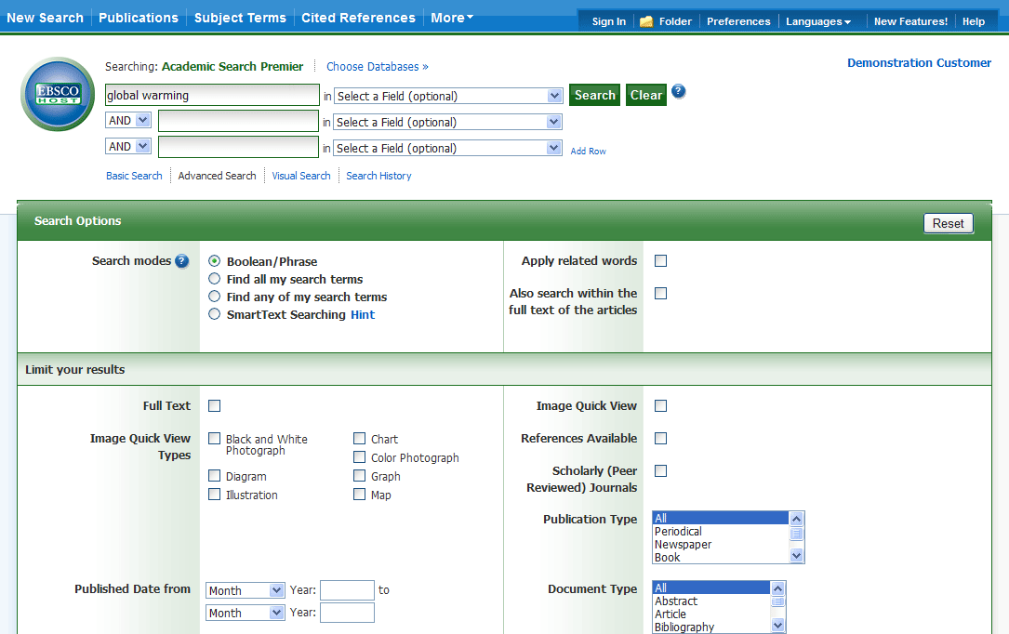
- Choose the search field from the optional Select a Field drop-down list (for example, search in only the Subject Terms field of the citation).
- Repeat steps 1 and 2 for the second set of Find fields.
- Select a Boolean operator (AND, OR, NOT) to combine the two Find field entries.
- You can enter another Boolean operator, keyword, and search field in the third set of fields.
- If you need additional rows, click the Add Row link. Up to 12 rows can be displayed. To delete a row, click the Remove Row link.
- Select from the available Search Options:
- Search modes – Use specific search modes, such as “Find all of my search terms,” or “SmartText Searching,” or use search options that expand your search such as “Apply related words.”
- Limit your results – such as Full Text or Publication type.
- Special Limiters – Apply limiters specific to a database. If you select a special limiter, it is applied only to the database under which it appears

- Click the Search button. The Result List displays.
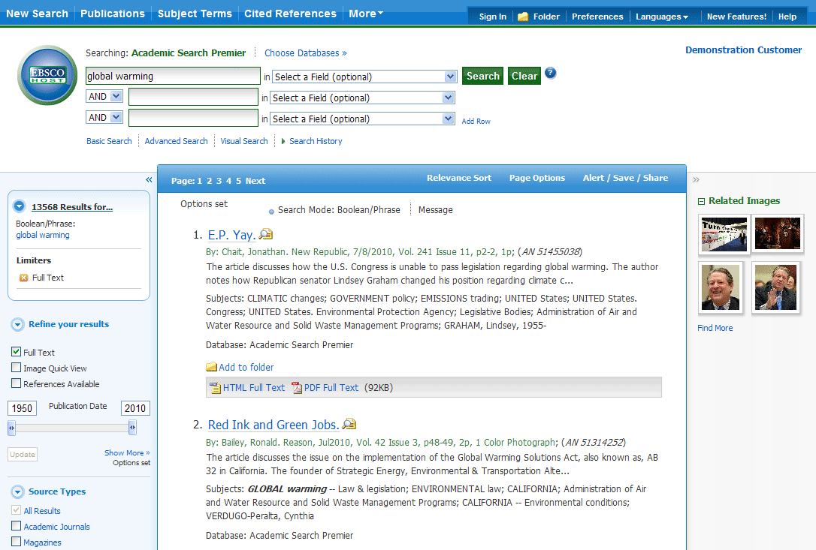

The search field is displayed above the Result List. Your search terms, limiters and expanders are retained. To revise your search, you can apply the limiters under Refine your results. Click the Show More link to view all available limiters and expanders.

Viewing Search Results

Viewing the Result List
Search results can be citations, full text articles, document summaries or abstracts, and can include links to full text.
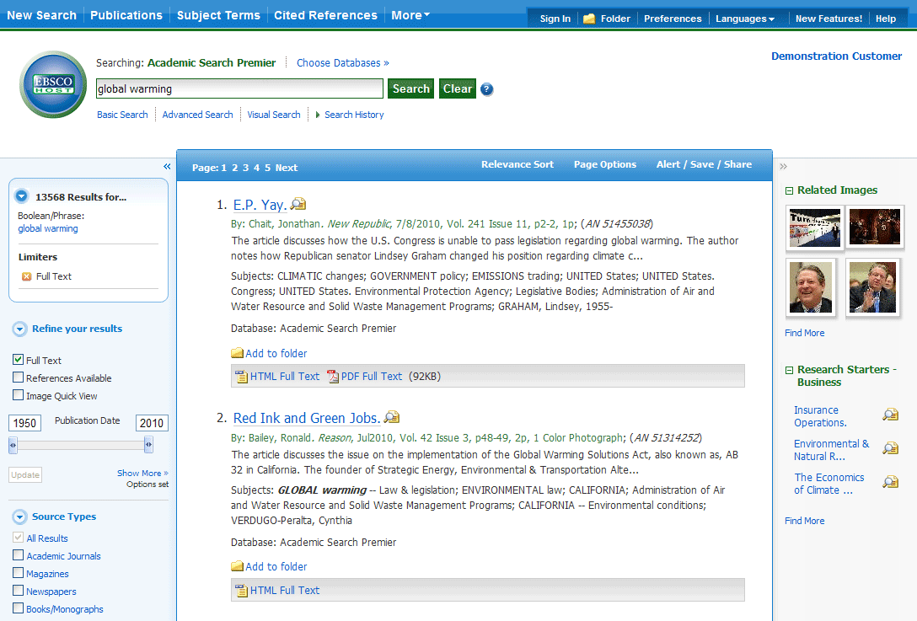
The Result List Screen has three columns:
- Left - Limiters and Clustering
- Middle - Results Display
- Right - Related Information
You can hide or show the different areas by clicking the control arrows at the top of the left and right columns. Your library administrator decides whether the subject clusters in the left column are displayed.

Left - Limiters and Clustering
The Left Column displays the Breadbox feature, Limiters, and Clusters
- Breadbox - Click the toggle arrow to open the Breadbox. The Breadbox keeps track of the numbers of results, your search terms, search options, and clusters applied to your search.
- Limit your results – Apply limiters right from the Result List. Select any of the limiters displayed and click Update. A revised Result List displays. (You can refine your search even more by clicking the Show More link under Limit your results.)
- Clustering – You can narrow by source type, subject, journal, author, and more. This feature, also known as “clustering,” is helpful if you want to discover the major subject groups for your topic without having to browse multiple pages of results, or checking individual articles to see if they are relevant.
  - To narrow your results, check the box for one or more subject terms in a section of your choice and click Update. A new Result List, limited to the chosen term or terms is displayed and the list of subject terms is refreshed.

Middle - Results Display
Results Display – The articles that were found are displayed in the center of the Result List Screen. You can also access the Result Sort, Page Options, and Alert/Save/Share drop-down menus from the Results column.
- The article title link takes you to the citation information and/or the full text. Place your mouse over the Preview icon to view the Abstract.
- The HTML Full Text link takes you directly to the full text of the article.
- The PDF Full Text link takes you to a PDF version of the full text. The PDF will open in the Adobe ® Reader®.
- The Audio Summary link prompts you to download or listen to audio summaries. (Business Book Summaries database only.)
- Add to Folder – To save an article to the Folder, click the Add to Folder link to the right of the Relevancy indicator, or inside the Article Preview that you hover over with your mouse.
- The Relevancy indicator tells you how relevant the article based on your search terms.
- Subjects – Subject Terms that are assigned to each item are displayed in the result list.
- Result List Sort – Click this link to select one of the following result list sorting options: Date Descending, Date Ascending, Author, Source, or Relevance.
- Page Options – Click this link to view the page display options.
- Alert/Save/Share – Click this link to view alerting, linking and bookmarking options.

Right - Related Information
When additional sources such as images, blogs, widgets, and Web news are available, they will be displayed in this column.
- Folder – If articles are stored in the folder, they will appear in this column under Folder has items. To view the items in your Folder, click the Go to Folder View link. To save them, sign in to your My EBSCOhost folder.
- Related Images – Place your mouse over an image—a full size view of the image displays.
- Additional Source Types – You may be able to refine your results list by additional source types when the appropriate databases are being searched. These additional Source Types include:
  - Company Profiles
  - Videos
  - Business Videos
  - Small Business Videos
  - Historical Images
- Widgets – If any additional resources have been added by your administrator using widgets, they will appear in this column.
Notes:
- The library administrator decides which features will be available, so your Result List may look slightly different.
- You can save the look of your Result List for future sessions by making changes in the Preferences area and signing in to your My EBSCOhost folder.

Page Options
Use this drop-down menu to customize how your result list page is displayed.  Note: The setting currently being used is highlighted with a yellow box.  To set your Page Options:  - Result Format - Click the select a result list format.  - Image QuickView - Select whether or not you would like thumbnails of images from your articles to display on the result list.  - Results per page - Select the number of results per page you would like displayed.  - Page Layout - Select your desired column layout for the Result List. | 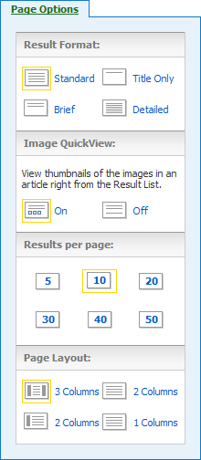

Alert/Save/Share
To use the Alert/Save/Share menu:  - Add to folder - Add all displayed articles to the folder or add the search to the folder as a persistent link to a search.  - Create an alert - Create a search alert e-mail or an RSS feed right from the Result List, even if you are not signed in to My EBSCOhost.  - Use Permalink - Highlight the link text and copy using your browser's copy function. You can immediately paste the link into a web site, document or e-mail.  You can also store links to your EBSCOhost pages to social bookmarking sites such as dig, del.icio.us, Technorati, bloglines, etc.  - Export Results - If enabled by your administrator, click to email a link to download exported results. | 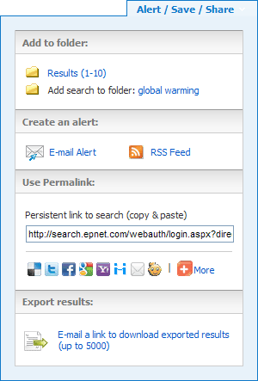

Clustering
Your library administrator decides whether the subject clusters will display with your results. When subject clusters are available, they will appear in the column on the left side of the Result List.
Hide or show the different clusters by clicking the control arrows near the top of each cluster. You can narrow by source type, subject, journal, author, and more. This feature is helpful if you want to discover the major subject groups for your topic without having to browse multiple pages of results, or checking individual articles to see if they are relevant.
To use subject clusters:
- Select a term or multiple terms by selecting the checkboxes in a cluster.
Note: Terms can be selected in only one section at a time. The rest of the screen will be grayed out until you have finished making selections and click Update.
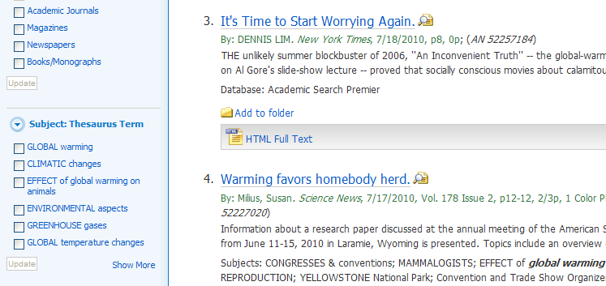
- Click the Show More link (if available) to view all available Subject Terms.
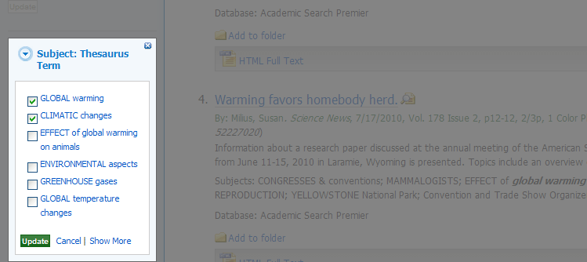
- Finish making your selections and Click Update.
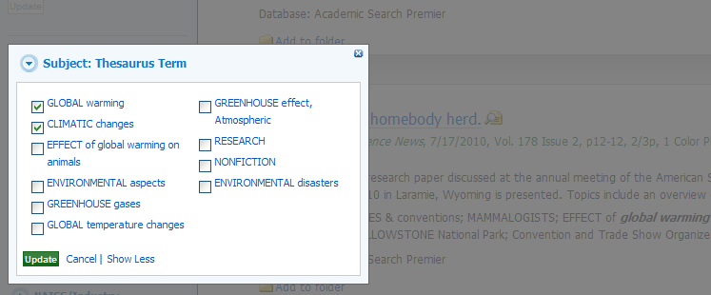
A new Result List, limited to the chosen term or terms is displayed and the selected terms are added to the Breadbox.

Using the Breadbox
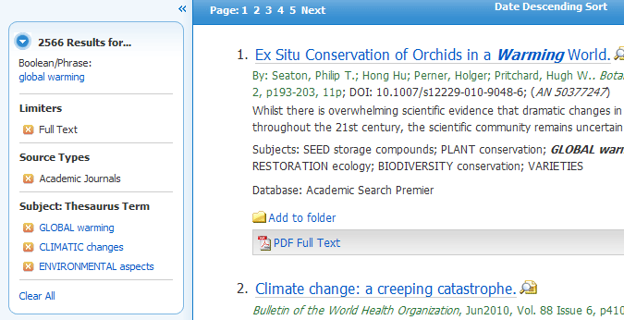
The Breadbox is located at the top of the left column and keeps track of your entire search by displaying:
- The number of available results.
- Your search query.
- All applied limiters and expanders.
- Applied source types.
- Applied subject terms.
Each limiter, expander, source type, and/or subject term you selected is added to the Breadbox with an 'x' icon. Clicking on the icon will remove the corresponding term from the search and a new result list will be displayed.
Clicking on a hyperlinked breadcrumb item will execute a search for only that term.

Reading an Article
When you click the title of an article, the "Best View" selected by your library administrator is displayed. To view a different format, click on the citation, HTML full text or PDF icon.

Detailed Record
When the Detailed Record is displayed, it may also include a summary or an abstract. If activated by your library administrator, the full text of the article may appear below the Detailed Record. The Image Quick View feature provides the ability to view thumbnails of the images in an article right from the citation.
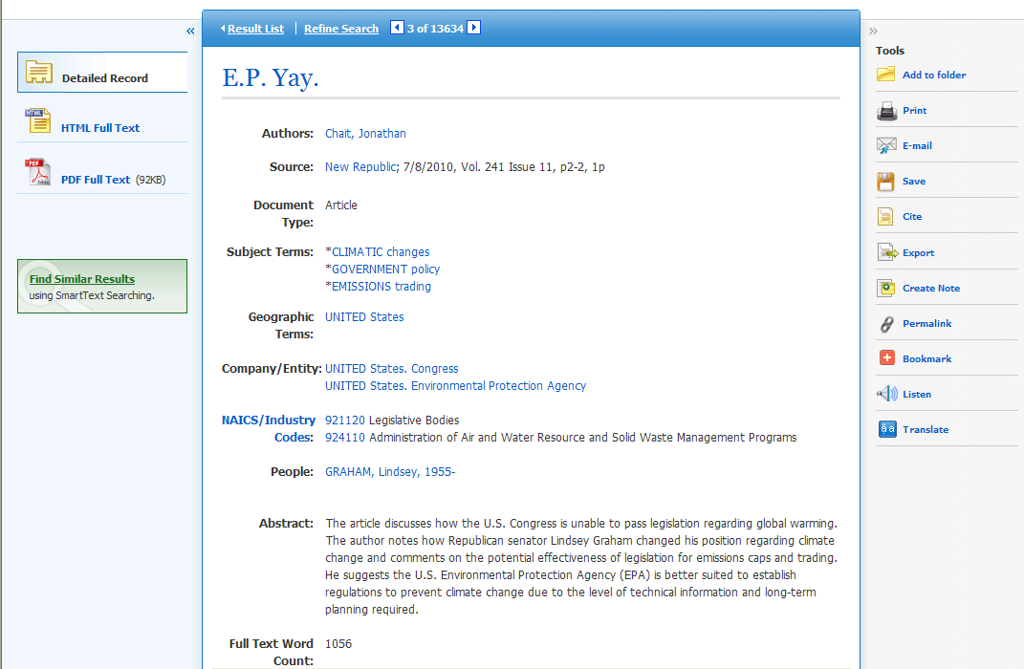
- The author and subject terms of the record can appear as links that let you perform a search of that particular field.
- When available, a Find Similar Results link will display on the citation. Click the link to perform a SmartText search for related articles. SmartText Searching will run the search using the citation's abstract and a new Result List will display. If no abstract is available, SmartText Searching will run the search on the article title. If SmartText Searching is not available in the database being searched, Find Similar Results searches the article's subject headings or descriptors.
- The source may display a link or journal logo that leads to a detailed view of the source or publication. Clicking on the journal logo links you to a detailed description of the journal. Clicking Back returns you to the full record of the article.
- The source may also include a table of contents link that lets you perform a search on the same issue of the source or publication.

HTML Full Text View
When the HTML full text view is displayed, you can also return to the Detailed Record, or any PDF or linked text by clicking on the available icons. The text is displayed formatted and ready for printing. A brief citation is always included at the end of the article.
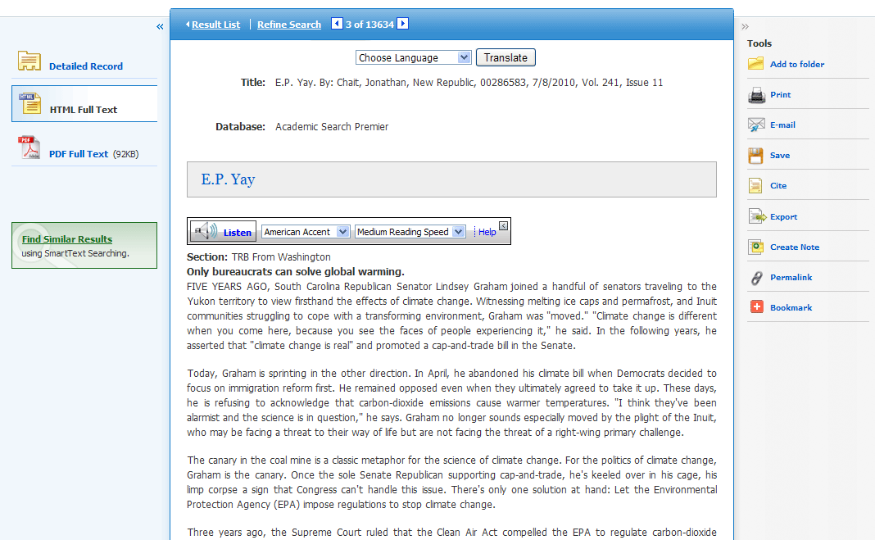
- From either the Detailed Record or Full Text views, you can refine your search and return to the Result List.
- When available, a Find Similar Results link will display on the Detailed Record and HTML Full Text views. Click the link to perform a SmartText search for related articles. SmartText Searching will run the search using the citation's abstract and a new Result List will display. If no abstract is available, SmartText Searching will run the search on the article title. If SmartText Searching is not available in the database being searched, Find Similar Results searches the article's subject headings or descriptors.

PDF Full Text Viewer
The PDF Full Text Viewer allows you to view PDF full text content using a variety of features.
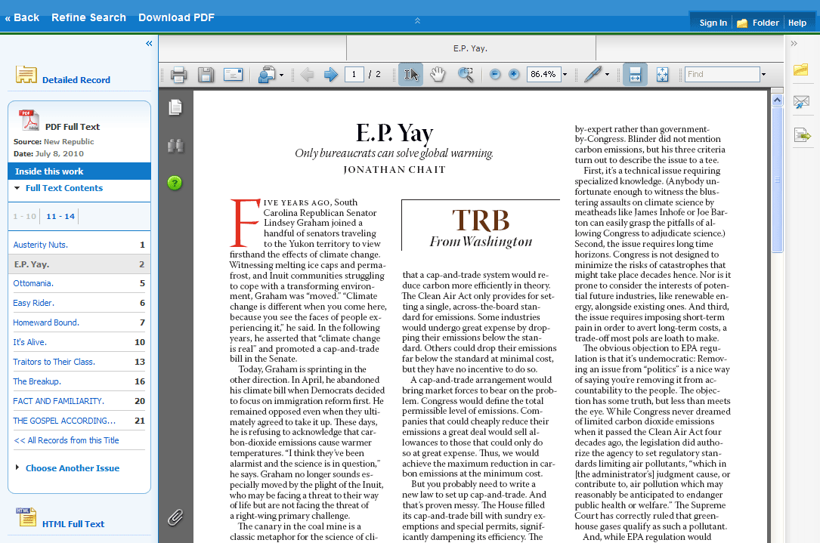

Left Column Options
Under the column on the left-hand side, you can:
- Detailed Record – Display title, author and subject information for the current article.
- Full Text Contents – Display article or chapter titles for the entire issue or individual monograph. Titles are hyperlinked for easy access to each article.
- Illustrations – Display links to illustrations found in the issue.
- Choose Another Issue – Choose another issue of the publication you are viewing by selecting a publication year and then selecting an issue you would like to view.
- HTML Full Text - Click the HTML Full Text link to view the article in HTML format.
Note: The HTML Full Text version may not be available for the article you are viewing.
Note: You can collapse the left and right columns and top header to expand the viewport to fit the entire browser window by clicking the arrows found at the top of the columns and above the PDF viewing area.

E-mail/Save/Print PDF Functions
You can also:
- Return to the Result List - Click the Back link to return to the result list.
- Refine Your Search Results - Click the Refine Search link to apply additional limiters and expanders to your search terms.
- Download PDF - Click the Download PDF link to open the PDF in Adobe Reader.
- Add to Folder - Click the Folder icon to add the article to the session folder. You can permanently save the article by signing into your personal My EBSCOhost folder.
- E-mail Article - Click the E-mail icon to e-mail the PDF to yourself.
- Export Article - Click the Export icon to export the article to your bibliographic management software.
From the Adobe Reader toolbar, you can:
- Print the Article - Click the Printer icon to print the article.
- Save the Article - Click the Diskette icon to save the PDF to your computer.

Linked Full Text View
EBSCOhost links to full text articles from other EBSCOhost databases or from electronic journals subscribed to through EBSCO Subscription Services and Electronic Journals Service.
When the linked full text result is displayed, you can also return to the citation, full text, or linked text by clicking on the available icons. When you click on an available hyperlink and open full text, you can refine your search, return to the Result List, and print, e-mail or save the article.

Tools Menu
When viewing an article, there are several tools available to you on the right-hand side of the screen.
- Add to folder - Add the article to the session folder or your personal My EBSCOhost folder.
- Print - Print the article.
- E-mail - E-mail the article to yourself or multiple e-mail addresses.
- Save - Save the article to a destination on your computer.
- Cite - Retrieve citation information for the article in several different formats.
- Export - Export the article to your bibliographic management software.
- Create Note - Save a note on the article to your My EBSCOhost folder.
- Permalink - Copy and paste a persistent link to the article.
- Bookmark - Bookmark the article to one of many to social bookmarking sites such as dig, del.icio.us, Technorati, bloglines, etc
- Listen - Hear the HTML Full Text of an article read to you using Text-to-Speech. (If enabled by your administrator.)
- Translate - Translate the HTML Full Text of the article to one of many available languages. (If enabled by your administrator.)

Using Text-To-Speech
If enabled from the Try New Features area, EBSCOhost can read HTML articles aloud to you using the Text-To-Speech feature.
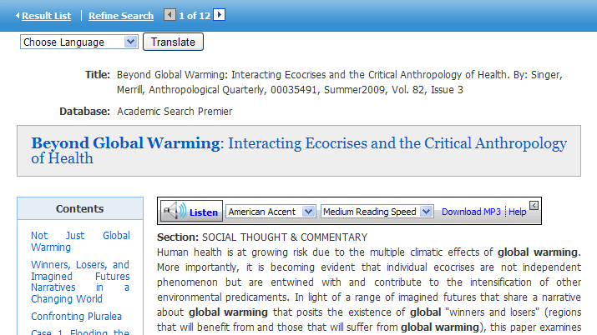
To use Text-To-Speech:
- Locate an EBSCOhost article in HTML format which you would like read to you.
- From the Accent drop-down menu, select an accent in which you would like the article to be read.
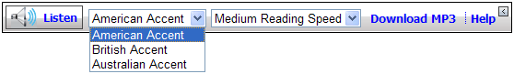
- From the Reading Speed drop-down menu, select a reading speed in which you would like the article to be read.
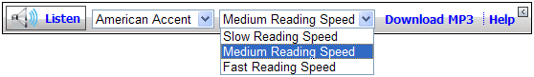
- Click the Listen button to hear the article read outloud.
-OR-
Click the Download MP3 link to download an MP3 file of the article being read to your computer.
- Click the Help link to view instructions on using Text-To-Speech in your browser window.

Use Text-To-Speech to Hear a Section of an Article
You may also choose to have only a section of an article read to you.

Highlight the passage of text you would like to be read outloud and click Listen.

Saving Results to the Folder
You can save an article to the Folder from the article, or from the Result List.
Click the Add to Folder link or icon.
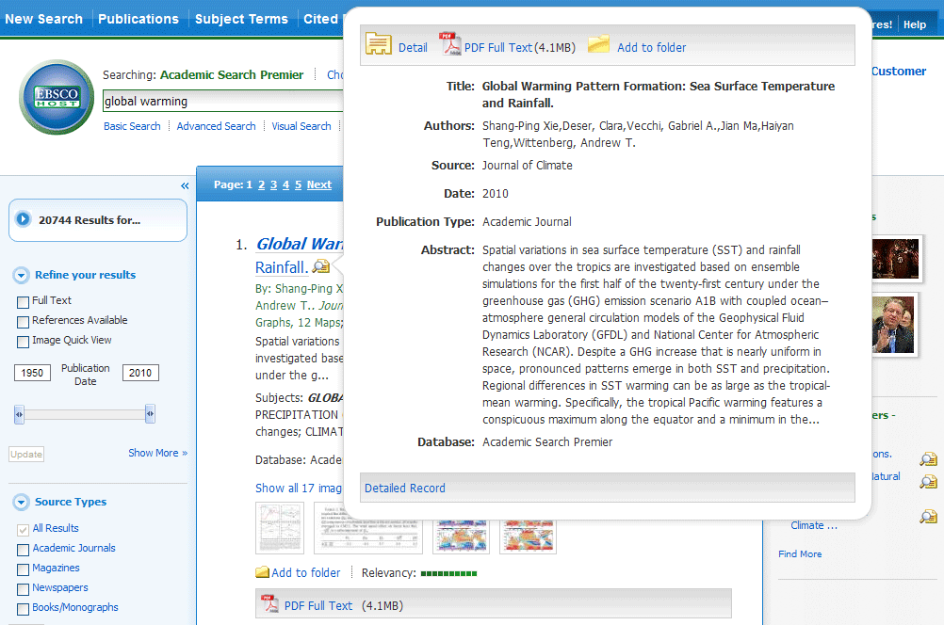
As you add the articles to the folder, you can click the Folder icon (or the Go to Folder View link) and review which items have been added. 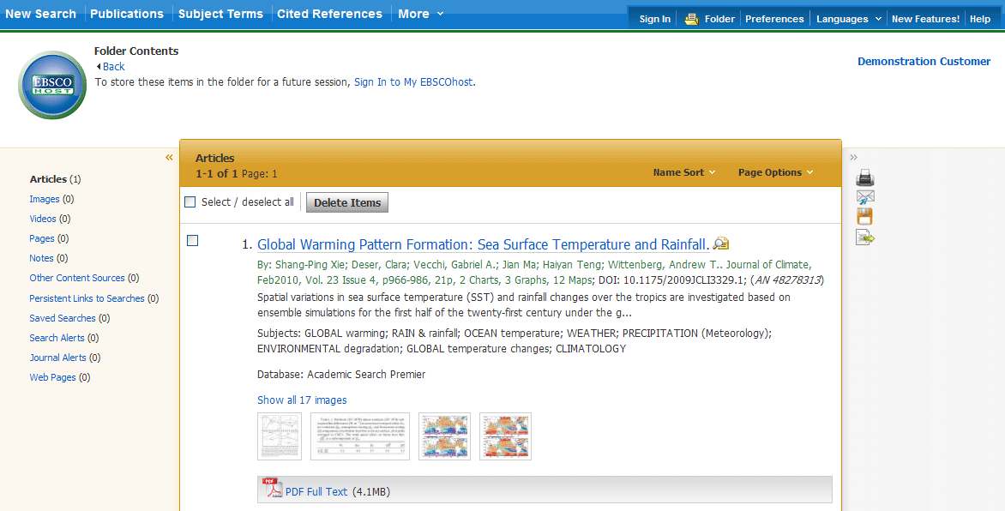
You can then print, e-mail or save many results all at the same time. If you have signed in via My EBSCOhost, any search results that you collect in your folder will be automatically saved at the end of the session.

Saving Articles to a Specific Folder
If you have custom folders created within your My EBSCOhost folder, you can specify which folder you would like your articles saved in, when you click the Add to Folder link.
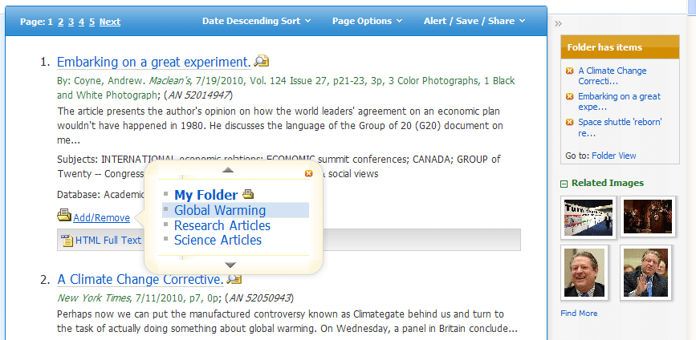
The article is added to the folder you specify.
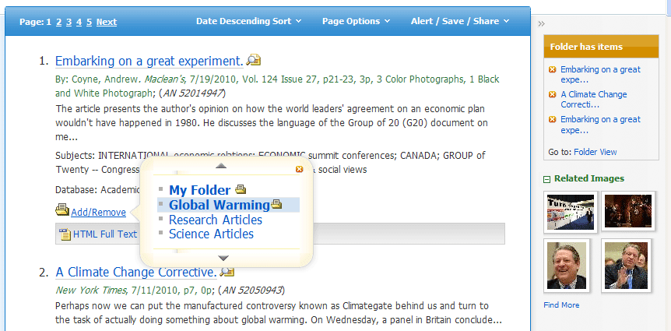
When you click the Add/Remove link, the name of the folder which contains the article displays a folder icon.
- To move the article to a different folder, click the name of the folder you would like to move the article to.
- To remove the article from the folder entirely, click the name of the folder that contains the article.

Citation Matcher
If available for your selected database, you can access the Citation Matcher search screen to search for article citations for which you have incorrect or incomplete information.
To use the Citation Matcher search screen:
- From any search screen, click on Citation Matcher in the top toolbar.
Note: Depending on the database being searched, this may also appear under More in the toolbar.
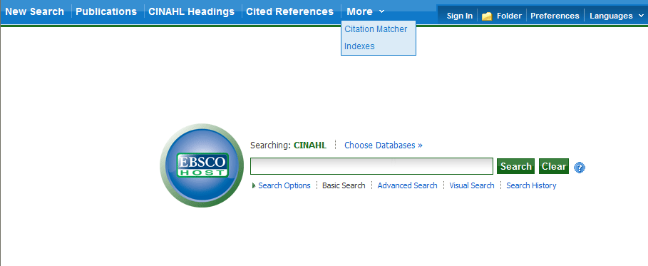
- On the Citation Matcher search screen, enter as much information as you have into the fields provided (Publication, Volume, Author, Title, etc.) and click Search.
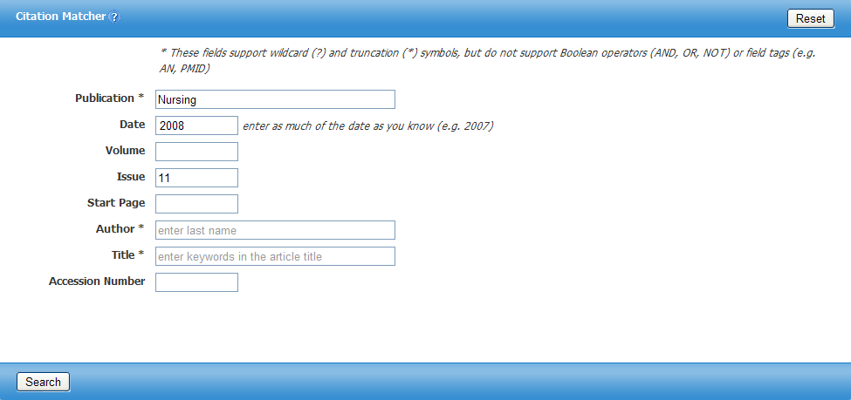

- A result list will be displayed that matches the information you provided in the Citation Matcher fields. Browse the result list to locate the citation you are searching for.
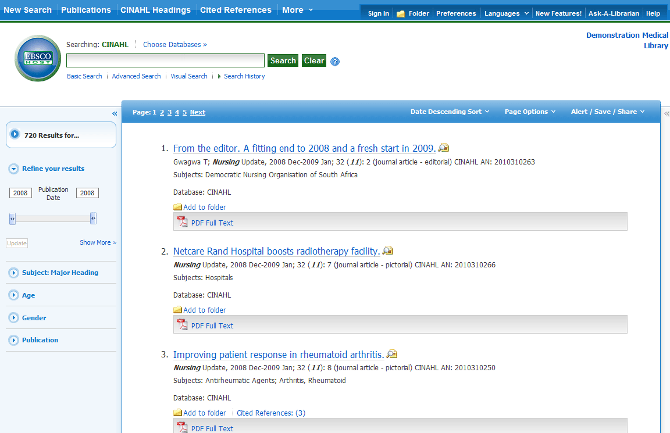

Visual Search
Visual Search is a new and innovative way to search EBSCOhost. Your results are sorted by topic in an interactive, visual map. You can switch between Result List styles at any time by selecting either Block style or Column style from the Display Style menu. Adobe Flash Player 8.0 or higher is required when using Visual Search.
To conduct a visual search:
- Click the Visual Search link, and then enter your search terms in the Find field.
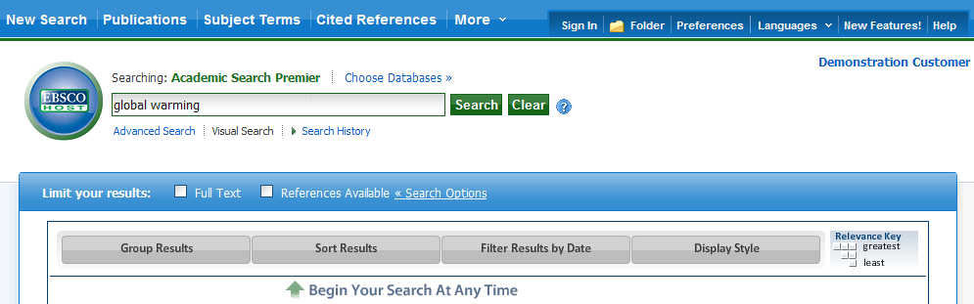
- If you want to use any of the optional Limiters or Expanders, click the Search Options link.
You can use a specific search mode, such as “Find all of my search terms,” or “SmartText Searching”; apply Limiters such as Full Text or Publication type; or use search options that expand your search, such as “Apply related words.”
- To close the Search Options, click the link again.
- Click Search. Your search results are displayed in columns. To follow a path, click on the subject (or publication) name. Your results are narrowed even further.
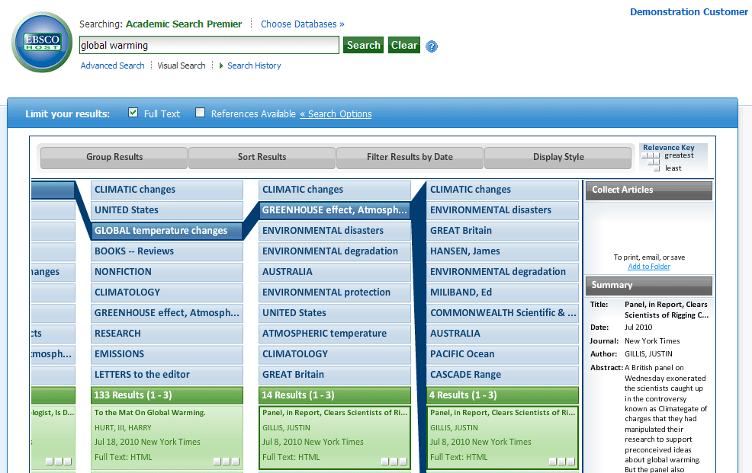

- Results Sorting Options - To see different ways to group, sort, or filter your search, click any of the buttons above the Result List. You can select these options at any time – before you run your search, or after, when you are viewing your results.
  - Group Results – You can group by Subject or by Publication Name.
  - Sort Results – You can sort the results by Date (newest to oldest), or by Relevance (articles with the greatest relevance at the top of the list; those with the least relevance at the bottom of the list).
  - Filter Results by Date – Move the Date Range slider to filter from the newest articles to the oldest.
  - Display Style – Switch between the Blocks or Columns style at any time.
To preview an article:
- To view the citation, click the article title inside the result. The Summary window displays more information about the article, including Title, Author, Journal Name, and a brief abstract.
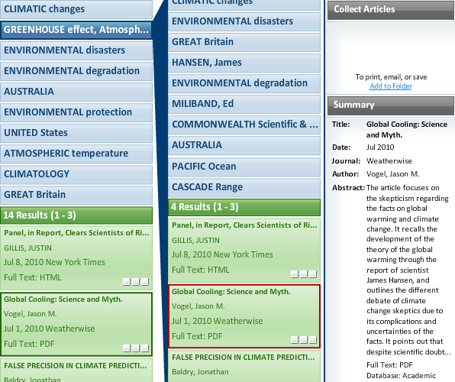
- To view the full text of the article (if available), click the More link at the bottom of the citation. The Summary window will expand to display the full article.

To collect articles:
Use the Collect Articles area to "drag-and-drop" articles that you are interested in. Items that you "collect" will remain there for the current session, unless you remove them. You will need to collect the items that you want to save to your folder.
To save items to your folder:
- With your Result List displayed, drag the articles to the Collect Articles area.
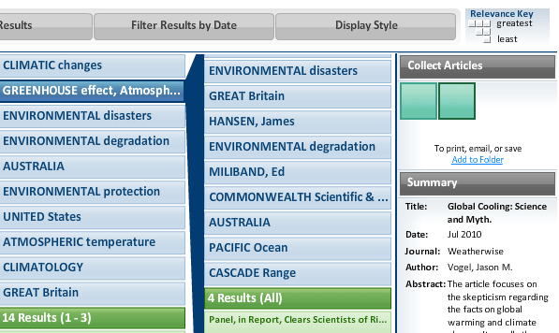
- Click the Add to Folder link. The items are immediately added to your "session" folder.
- If you want to save the items for use in a future session, be sure to sign into your My EBSCOhost account.
Block Style Result List
If you select a Display Style of Blocks, the "block-style" Result List will display.
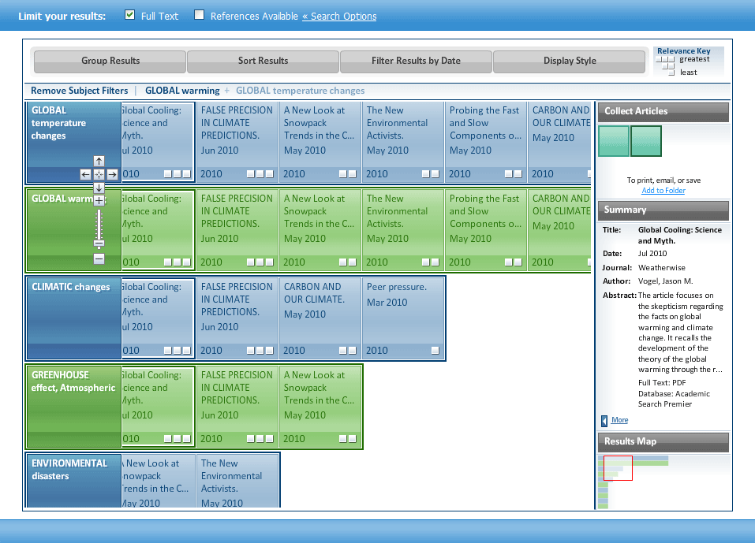
The Block Style Result List has two additional features - the control arrows, and the Results Map. To follow a path, use the control arrows on the left-hand side of the screen. Or, click in a new block within the Results Map to move to a different area of the Result List.
Note: Your library administrator decides whether Visual Search will be available, and which style (blocks or columns) will be the default.

Searching for Images/Video
The Image Collection provides you with instant access to more than 180,000 images relating to people, natural science, places, history, and flags.
Focus your image search by using the categories available: Photos of People, Natural Science Photos, Photos of Places, Historical Photos, Maps, and Flags.

To search for an image:
- Click the Images (or Images/Video) link. The Image Collection Search Screen displays.
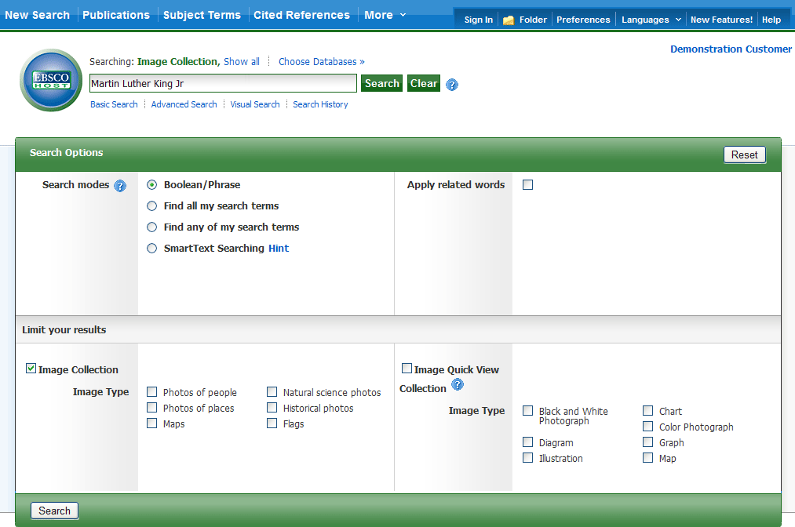
- Enter your search terms in the Find field, for example: Martin Luther King.
Your search terms must exactly match a word in the title or caption of an image; the search term Roosevelt does not yield the same results as the search terms Eleanor Roosevelt. You can use Boolean terms to broaden your search, for example: Eleanor AND Roosevelt.
- Under Limit your results, you can limit your search to either the Image Collection or Image Quick View Collection or search both. Select from the available categories to narrow the focus of your search. If you make no selections, all categories are searched.

- Click Search. A Result List consisting of thumbnail images with brief descriptions appears. (Click on a thumbnail image—a full size view of the image displays.) For Image Quick View Collection results, you will also see a link to the article that the image appears in. Click the link to view the full article details.
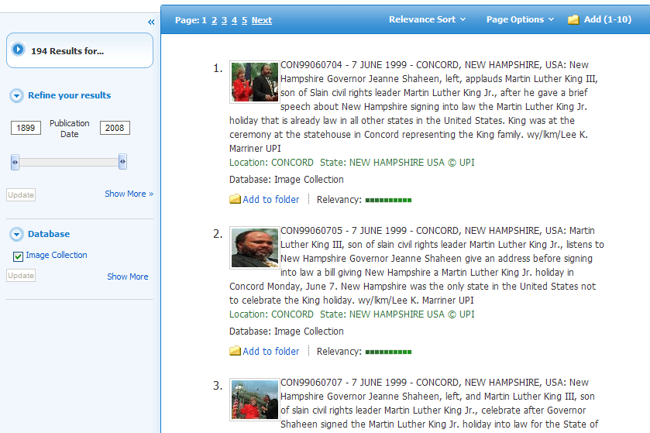
- Apply limiters right from the Result List. Select any of the limiters displayed and click the Update button. A revised Result List displays.
  - To print the image, click on the thumbnail image and click Print. The Print Manager Screen is displayed. Click the Print icon.
  - To save the image, click on the thumbnail image and click Save to Disk. The Save Manager Screen is displayed. Click the Save icon, and then save from your browser window.
Note: Your library administrator decides whether image searching will be available. If enabled by the library administrator, you may also be able to search for video content. The Images/Video link would display, and additional limiters would be available. You can filter your Result List to display only images, or only videos.

Searching for Company Information
The Company Information screen offers detailed company information including hierarchical corporate structures and access to company profiles.
If your EBSCOhost profile includes the Business Source Corporate Plus database, the Company Information feature is available to you.
To search Company Information:
- Click the Company Information link in the top toolbar.
The Company Information search page is displayed.
- Enter your search terms in the Find field and select one of the radio buttons below.
Select:
  - Company Name: to search by the name of a company.
  - Ultimate Parent: to search by the name of the Parent company.
  - Ticker Symbol: to search by the stock symbol, or abbreviation.
  - Keyword Search: to search by keyword.
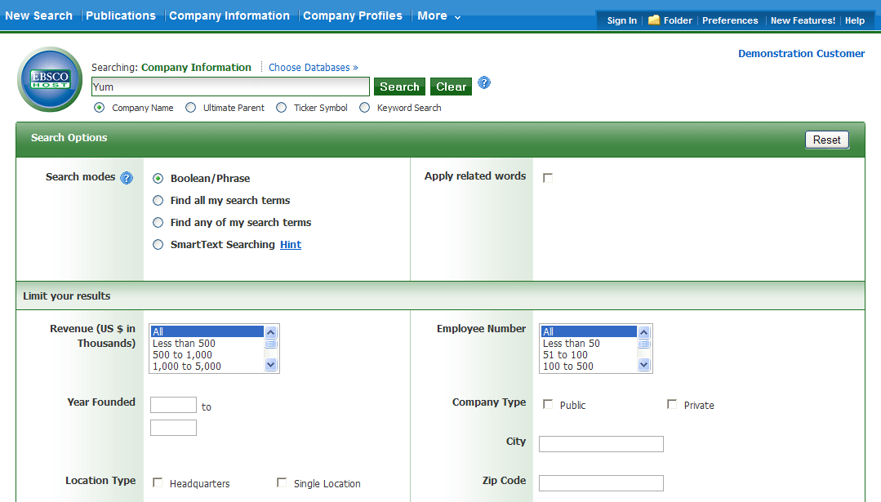
- Apply any desired Limiters and Expanders and click Search.
The Company Information Result List is displayed.

Company Information Result List
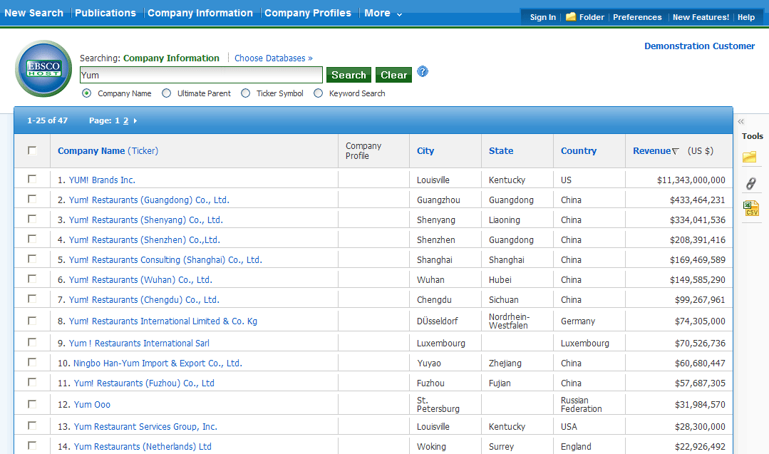
The Company Information result list is sorted by Revenue (descending) by default. The result list can be re-sorted (ascending or descending) by clicking the hyperlinked column heading for:
- Company Name (Ticker)
- City
- State
- Country
- Revenue
From the Company Information result list:
- Company Landing Page: Click a hyperlinked Company Name to view the Company Landing page.
- Add to Folder: Add Companies to the folder by marking the checkboxes for your selected items and clicking the Folder icon in the Tools column on the right.
- Persistent Link: Click the Persistent Link icon in the Tools column on the right to copy and paste a persistent link to your result list.
- Download a CSV file: Mark the checkbox for companies for which you would like to export a .csv file of company information and click the CSV icon in the Tools column on the right.
Note: You can export up to 25 results (one page) at a time.

Parent Companies
When searching with the Ultimate Parent radio button, parent companies are displayed in the result list and can be expanded to view all subsidiaries by clicking the plus icon (when applicable).
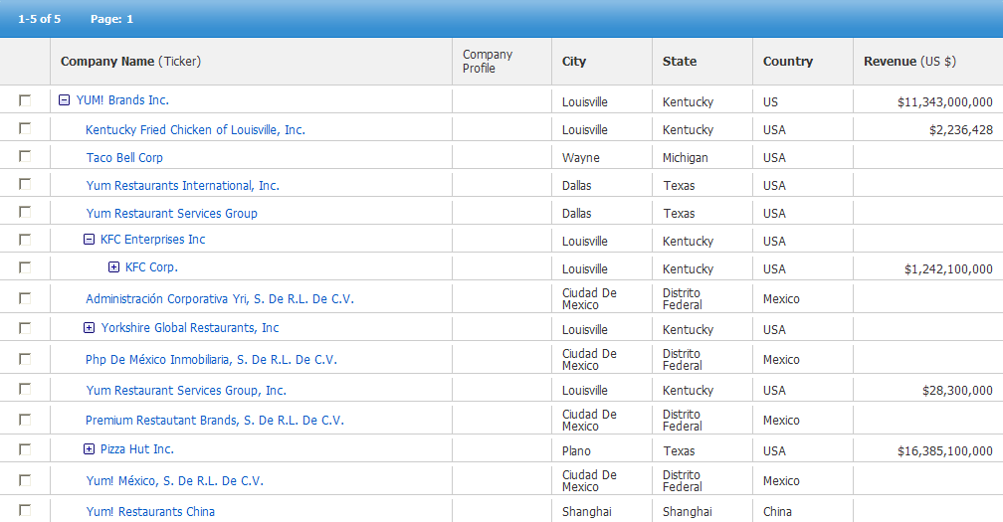

Company Landing Page
The Company Landing Page displays company details including information related to financials, employees, and industry.
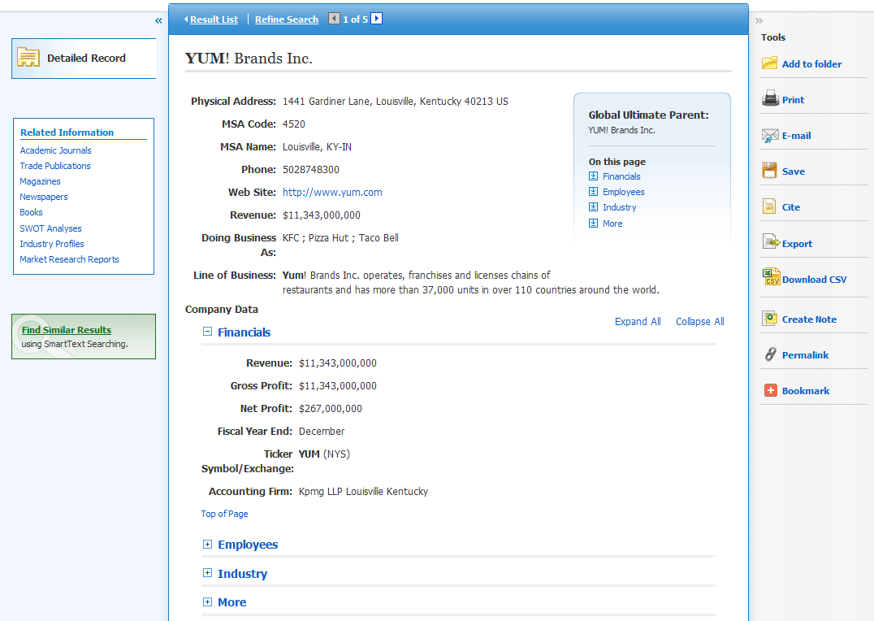
From the Company Landing Page:
- Click Download CSV in the right column to export a .csv file of all of the company's information.
- Click the Company Snapshot link to view the company profile from Zoom Info. Clicking this link will open the profile in a new browser window or tab.
- When you click the Add to Folder link, the Company Landing page is added to the folder in the Companies area.
- Click a source type in the Related Information box on the left to view a result list of items related to the company.
- The At A Glance box contains quick links to the collapsible Company Data sections in the lower part of the Company Landing Page, including Financials, Employees, and Industry. The Financials section is expanded by default.

Searching for Company Profiles

To search for company profiles:
- Click the Company Profiles link at the top of the EBSCOhost screen. The Company Profiles List Screen appears with the beginning of the list displayed. You can use the Next | Previous and A - Z links to page through the Company Profiles List.
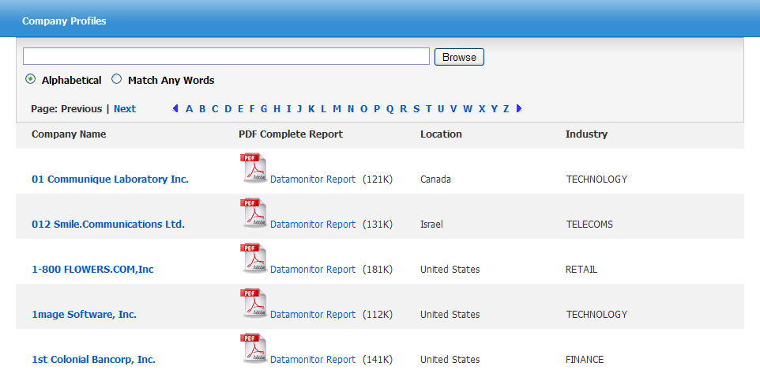
- Enter your search terms in the Browse for field. You can enter all or part of a company name. (For example, you could enter GE, or General, or Gen.)
- Select a search type. Click one:
  - Alphabetical - Finds companies beginning with the letters you entered. Results are displayed in alphabetical order.
  - Match Any Words - Finds companies with one or more of your terms in the company name. Results are displayed in order of relevance to your search terms.
- Click Browse to view a Result List of companies that match your search terms. Use the Next | Previous links to page through the list of results. To print, e-mail or save several search results, open the detail view for each item and add to the folder.
To view the company details:
- Click a linked company name. The Detailed Record is displayed. You can print, e-mail or save the result.
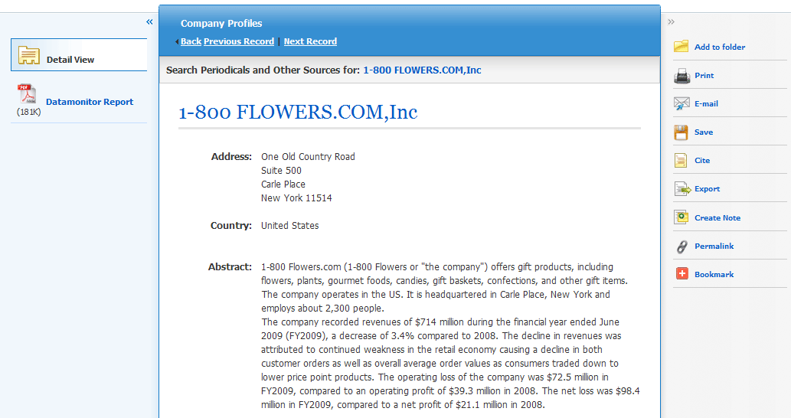
- To view the complete report, click the Datamonitor Report link. The report opens in Adobe Reader. To return to the Result List, click the Company List link.
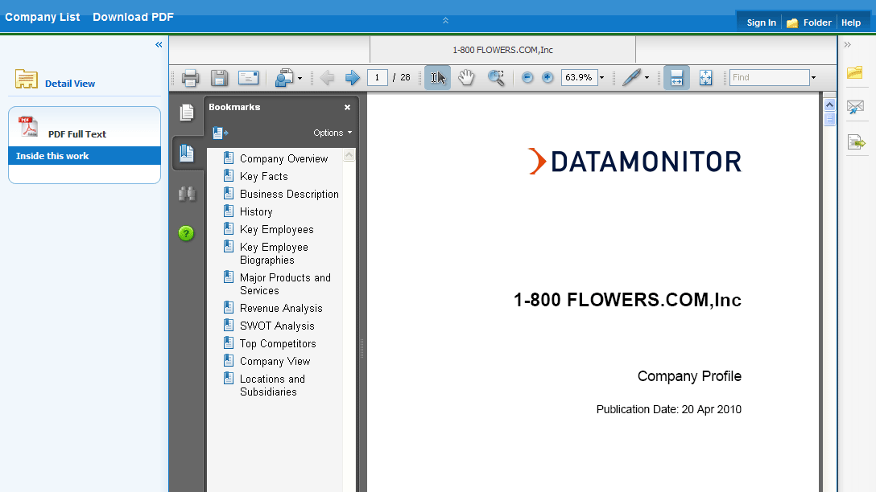
- To search the database for results related to the company you are viewing, to the right of: Search Periodicals and Other Sources for, click the linked company name (on Detailed Record). A Result List is displayed.

Preferences
Setting Preferences allows you to control the look and feel of the EBSCOhost 2.0 Result List. The selections you make on the Preferences Screen can now be saved to your personal account (My EBSCOhost) and retrieved for use at any time. Once you sign in to My EBSCOhost, your personal preferences are applied. And, if you make changes to your preferences, those changes are saved for future use.

Setting Preferences
- From the search screen or the Result List, click the Preferences link below the Find field. (The Preferences feature is also available from the Folder Screen.)
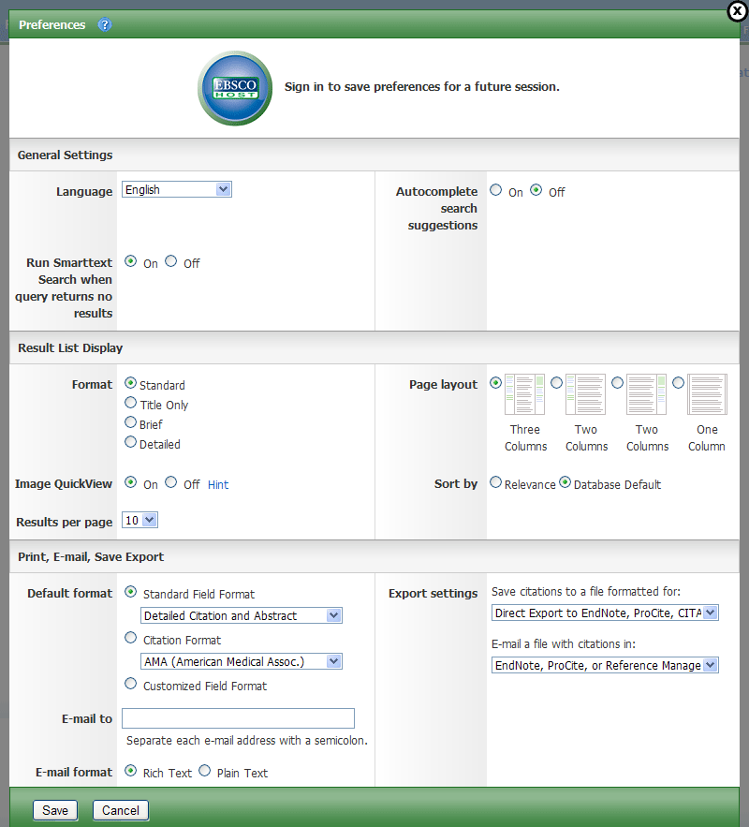
- General Settings – Choose language and keyword suggestion settings.
- Language – Select the language in which you want to display the interface: Spanish, French, German, Italian, Portuguese, Russian, Korean, Japanese, Simplified Chinese, Traditional Chinese, Turkish, Greek, Polish, Arabic and Thai. (Your library administrator decides whether this feature will be available.)
- Autocomplete search suggestions – As you begin to enter a search term in the Find field, keyword suggestions are automatically displayed. (Set to On or Off.)
- Run SmartText Search when query returns no results – If enabled by your administrator, set to automatically run your search using the SmartText Searching search mode when your initial query returns no results.
- Result List Display – Choose the look and feel of your Result List.
- Format – Select the level of detail for each result: Standard, Title Only, Brief or Detailed.
- Image Quick View – Turn on or off the display of image thumbnails on the Result List, Citation, and Folder. (Availability varies by database.)
- Results per page – Specify how many results (or records) are displayed per page (for example: 5, 10, 20, 30, 40 or 50). (Will be applied to both the Result List and the Folder.)
- Sort by – You can set how you would like your results sorted. All sort options for the database you are using are available. (For example, date, author, source, etc.) If you select “Database Default," the results are sorted using the database defaults. (Will be applied to only the Result List.)
- Page layout – Control which columns display on the Result List.
- Print, E-mail, Save, Export – Set your defaults for Print, E-mail, Save and Exporting of your results. You can still change these settings when you print, e-mail, save or export your results.

- Default Format – Decide how much information you want to include with your results.
  - Standard Field Format – Defaults to "Detailed Citation and Abstract." You can also select from the drop-down list:
    - Brief Citation – Indicates that only a brief citation should be printed.
    - Brief Citation and Abstract – Indicates that a brief citation and an abstract should be printed.
    - Detailed Citation and Abstract – Indicates that a detailed citation and an abstract should be printed.
  - Citation Format – If you would like to default your citations to a specific format, select one from the drop-down list:
    - AMA - American Medical Association
    - APA - American Psychological Association
    - Chicago/Turabian Author - Date
    - Chicago/Turabian Humanities
    - MLA - Modern Language Association
    - Vancouver/ICMJE
  - Customized Field Format – A list of all fields available for the databases you are searching will display. The fields shared by all the databases you are searching appear in the Fields in Common area at the top of the screen. Mark the check boxes to the left of the fields you want to include.

- E-mail From – The “From” address on the e-mail you send defaults to ephost@epnet.com. If you would like to change that address, enter the information in this field. (For example, you could enter your own e-mail address, or a library e-mail address.) This will automatically fill in the “From” field on the e-mail that is sent.
- E-mail To – The “To “address on the E-mail Manager defaults to a blank field. If you would like to automatically fill in the E-mail Address field with a specific e-mail address, enter the information in this field. (For example, you could enter your own e-mail address, or list of e-mail addresses for the students in class or a group of colleagues.)
- E-mail Format – Select whether you want to default your e-mails to Rich Text or Plain Text format
- Export Settings – You may be able to export your results into a format compatible with your bibliographic management software. (For example, RefWorks, EndNote, ProCite, etc.) Your library administrator decides whether the Export feature is available.
  - Save citations to a file formatted for – Select the default bibliographic management format to save a file.
  - E-mail a file with citations in – Select the default bibliographic management format to e-mail a file.
- Click Save. If you were previously at the Result List, it is updated according to your selections. If you were previously at the Search Screen, you must first perform a search before viewing the customized Result List.

Trying New Features
“Try New Features” is an innovative way to learn about the features and functionality available on EBSCOhost. When the library administrator activates “New Features,” the New Features link will display in the top toolbar on EBSCOhost. You can visit the New Features Screen, try out selected features for your session, learn about additional features that are already active, and read about features that will be coming soon.
EBSCO Publishing decides which features can be tried and which features will display on the New Features Screen. The library administrator decides whether to show or hide these features, and sets profile level defaults for any “try able” features. (Note: Sample features shown below.)
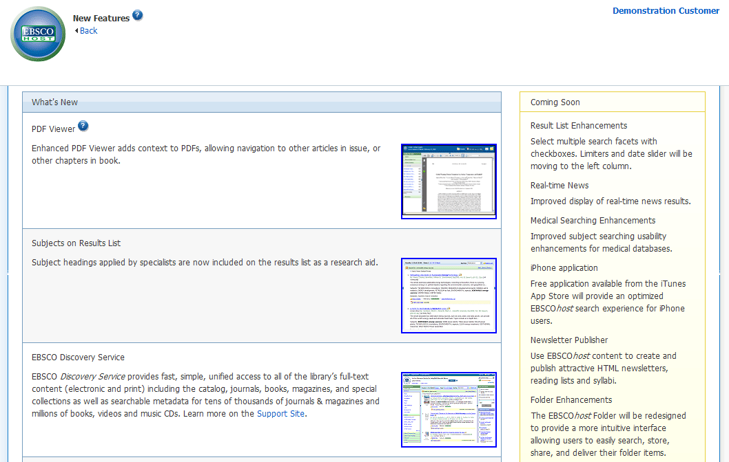

What’s New Area
You can turn on any of the features above the dotted line, and they are applied for the entire EBSCOhost session, unless you choose to turn them back off. Once you mark the Try It! check box, the Feature Enabled indicator displays. The feature is now active for the length of your session.
Features that are displayed below the dotted line are active, newly-released features, but the Try It! feature is not available. You can read a description of the feature, and when displayed, can click the thumbnail image and view a sample screen. Your library administrator decides whether to enable these features.

Coming Soon Area
The Coming Soon area previews features that will be available in future releases.

