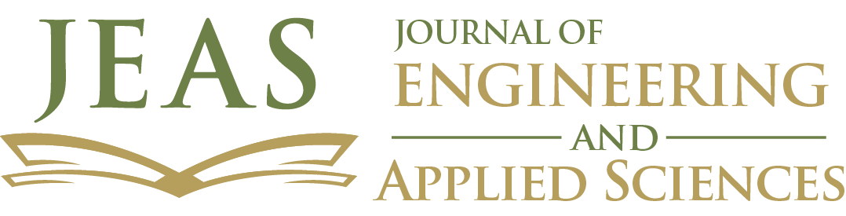
Journal of Engineering and Applied Sciences
Biannual, peer-reviewed journal
ISSN: 1658-6638
Published by Majmaah University
email: jeas@mu.edu.sa
AUTHOR DECLARATION
The authors declare that:
- This manuscript is original, has not been published before, and is not currently being considered for publication elsewhere.
- There are no known conflicts of interest associated with this publication; and there has not been any financial support for this work that can influence its outcome.
- The manuscript has been read and approved by all named authors, no other persons who satisfied the criteria for authorship are not listed, and the order of authors listed in the manuscript has been approved by all authors.
- Due consideration has been given to the protection of intellectual property associated with this work and that there are no impediments to publication, including the timing of publication, with respect to intellectual property.
- The corresponding author is the sole contact with the JEAS editorial board in matters related to the submissions of revisions and final approval of proofs.
- Authors acknowledge the support from any funding agency and the authors have received the permission from the funding agency if required.

Signed by all authors as follows:
[LIST AUTHORS AND DATED SIGNATURES ALONGSIDE]

