Mechanical and Industrial Engineering Department | Experimental

Mechanical Power Lab (ME 493 & ME 494)
Experiments Manual
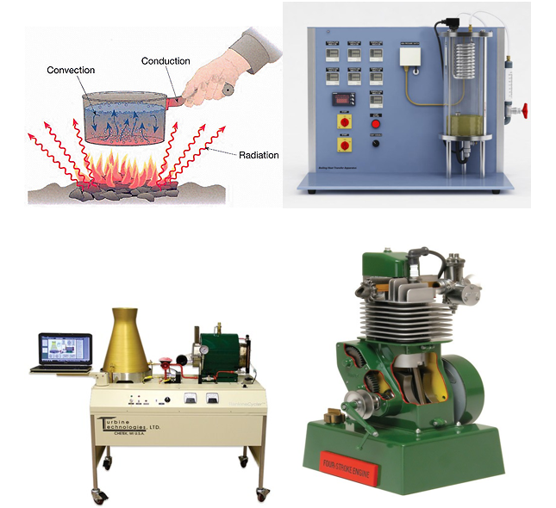

Updated 2017

Table of Contents

No | Experiment | Page
1 | Experimental determination of thermal conductivity of the material by linear heat conduction method. | 3
2 | Experimental determination of thermal conductivity of the material by radial heat conduction method. | 9
3 | Test parameters of radiation heat transfer experiment | 14
4 | To demonstrate the principles of a vapor power cycle | 20
5 | To compare the heat transfer characteristics of free and forced convection | 27
6 | To study two stroke and four stroke petrol engines. | 32

Mechanical and Industrial Engineering Department

Experiment (1) | Linear Heat Conduction

Student Name : | ID: | Section No.:
Supervisor: Dr. Nadeem Khan | Submission Date: | SLO:
Academic Year: 2017-2018 | Semester: First

Object : Experimental determination of thermal conductivity of the material by linear heat conduction method.

Theory: Heat transfer is defined as energy-in-transit due to temperature difference. Heat transfer takes place whenever there is a temperature gradient within a system or whenever two systems at different temperatures are brought into thermal contact. Heat, which is energy-in-transit cannot be measured or observed directly, but the effects produced by it can be observed and measured. Since heat transfer involves transfer and/or conversion of energy, all heat transfer processes must obey the first and second laws of thermodynamics. However unlike thermodynamics, heat transfer deals with systems not in thermal equilibrium and using the heat transfer laws it is possible to find the rate at which energy is transferred due to heat transfer. From the engineer’s point of view, estimating the rate of heat transfer is a key requirement. Refrigeration and air conditioning involves heat transfer, hence a good understanding of the fundamentals of heat transfer is a must for a student of refrigeration and air conditioning. This section deals with a brief review of heat transfer relevant to refrigeration and air conditioning.
Generally heat transfer takes place in three different modes: conduction, convection and radiation. In most of the engineering problems heat transfer takes place by more than one mode simultaneously, i.e., these heat transfer problems are of multi-mode type.
Difference between Heat and Temperature: In heat transfer problems, we often interchangeably use the terms heat and temperature. Actually, there is a distinct difference between the two. Temperature is a measure of the amount of energy possessed by the molecules of a substance. It manifests itself as a degree of hotness, and can be used to predict the direction of heat transfer. The usual symbol for temperature is T. The scales for measuring temperature in SI units are the Celsius and Kelvin temperature scales. Heat, on the other hand, is energy in transit. Spontaneously, heat flows from a hotter body to a colder one. The usual symbol for heat is Q. In the SI system, common units for measuring heat are the Joule and calorie.

Conduction Heat Transfer:
Conduction heat transfer takes place whenever a temperature gradient exists in a stationary medium. Conduction is one of the basic modes of heat transfer. On a microscopic level, conduction heat transfer is due to the elastic impact of molecules in fluids, due to molecular vibration and rotation about their lattice positions and due to free electron migration in solids.

The fundamental law that governs conduction heat transfer is called Fourier’s law of heat conduction, it is an empirical statement based on experimental observations and is given by:
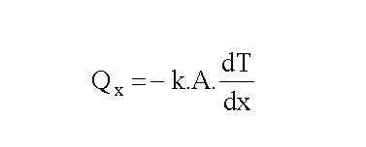
In the above equation, Q_{x} is the rate of heat transfer by conduction in x-direction, (dT/dx) is the temperature gradient in x-direction, A is the cross-sectional area normal to the x-direction and k is a proportionality constant and is a property of the conduction medium, called thermal conductivity. The ‘-‘ sign in the above equation is a consequence of 2nd law of thermodynamics, which states that in spontaneous process heat must always flow from a high temperature to a low temperature (i.e., dT/dx must be negative).

The thermal conductivity is an important property of the medium as it is equal to the conduction heat transfer per unit cross-sectional area per unit temperature gradient. Thermal conductivity of materials varies significantly. Generally it is very high for pure metals and low for non-metals. Thermal conductivity of solids is generally greater than that of fluids. Table 7.1 shows typical thermal conductivity values at 300 K. Thermal conductivity of solids and liquids vary mainly with temperature, while thermal conductivity of gases depend on both temperature and pressure. For isotropic materials the value of thermal conductivity is same in all directions, while for anisotropic materials such as wood and graphite the value of thermal conductivity is different in different directions. In refrigeration and air conditioning high thermal conductivity materials are used in the construction of heat exchangers, while low thermal conductivity materials are required for insulating refrigerant pipelines, refrigerated cabinets, building walls etc.

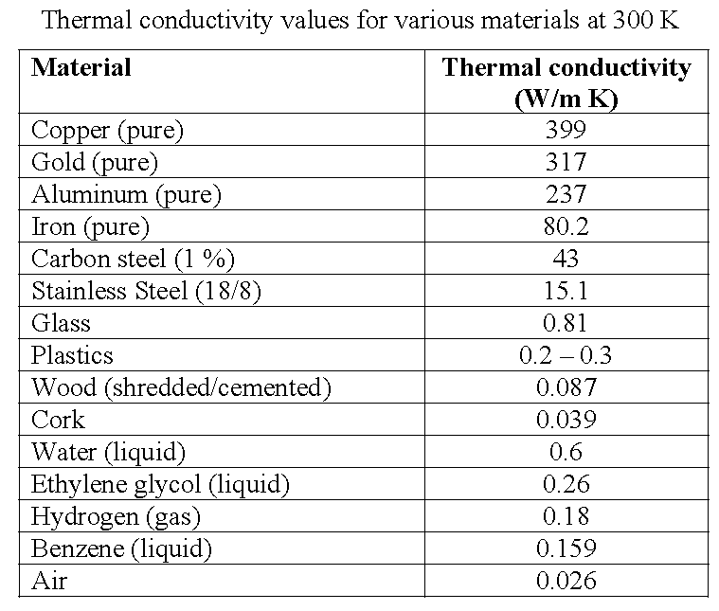

Determining Thermal Conductivity:
Measuring the temperature difference between the faces on the intermediate section for known heat flow and using Fourier’s equation will enavle to determine the thermal conductivity of the sample: $k_{int}=\frac{{∆x}_{int}.Q}{A_{int}.(T_{hotface}-T_{coldface})}$

$$∆x_{int}=0.03 m$$
$$D_{int}=0.025 m$$

The temperature of the hot face will be lower than T₃ and it can be calculated with the following formula:
$$T_{hotface}=T_{3}-\frac{(T_{2}-T_{3})}{2}$$
The temperature of the cold face will be lower than T₃ and it can be calculated with the following formula:
$$T_{coldface}=T_{6}-\frac{(T_{6}-T_{7})}{2}$$
$$Q=V.I (Watts)$$
$$A_{int}=\frac{πD_{int}^{2}}{4}$$

Procedure of experiment:
- Clamp the intermediate test section between the heating and cooling section applying thin film of thermal past on the metal/ metal interface.
- Set the voltage at 10 V.
- Wait until temperature stabilize and record their values.
- Increase the voltage to 12V.
- Wait until temperature stabilize and record their values.

Observation Table
Material of test piece:
Diameter of test piece:
Thickness of test Piece:
Volt (V)
Ampere (I)
T₁(⁰C)
T₂(⁰C)
T₃(⁰C)
T₄(⁰C)
T₅(⁰C)
T₆(⁰C)
T₇(⁰C)
T₈(⁰C)
F (L/hr.)

Result Table
Volt (V) | Ampere (I) | Q (Watts) | $${∆T}_{int}$$ | $$k_{int}$$

Average experimental value of thermal conductivity ($k_{int}$) =
Theoretical value of thermal conductivity =
Percentage Value =

Sample calculation:

Mechanical and Industrial Engineering Department

Experiment (2) | Radial Heat Conduction

Student Name : | ID: | Section No.:
Supervisor: Dr. Nadeem Khan | Submission Date: | SLO:
Academic Year: 2017-2018 | Semester: First

Object: Experimental determination of thermal conductivity of the material by radial heat conduction method.

Theory: Heat transfer is defined as energy-in-transit due to temperature difference. Heat transfer takes place whenever there is a temperature gradient within a system or whenever two systems at different temperatures are brought into thermal contact. Heat, which is energy-in-transit cannot be measured or observed directly, but the effects produced by it can be observed and measured. Since heat transfer involves transfer and/or conversion of energy, all heat transfer processes must obey the first and second laws of thermodynamics. However unlike thermodynamics, heat transfer deals with systems not in thermal equilibrium and using the heat transfer laws it is possible to find the rate at which energy is transferred due to heat transfer. From the engineer’s point of view, estimating the rate of heat transfer is a key requirement. Refrigeration and air conditioning involves heat transfer, hence a good understanding of the fundamentals of heat transfer is a must for a student of refrigeration and air conditioning. This section deals with a brief review of heat transfer relevant to refrigeration and air conditioning.
Generally heat transfer takes place in three different modes: conduction, convection and radiation. In most of the engineering problems heat transfer takes place by more than one mode simultaneously, i.e., these heat transfer problems are of multi-mode type.
Difference between Heat and Temperature: In heat transfer problems, we often interchangeably use the terms heat and temperature. Actually, there is a distinct difference between the two. Temperature is a measure of the amount of energy possessed by the molecules of a substance. It manifests itself as a degree of hotness, and can be used to predict the direction of heat transfer. The usual symbol for temperature is T. The scales for measuring temperature in SI units are the Celsius and Kelvin temperature scales. Heat, on the other hand, is energy in transit. Spontaneously, heat flows from a hotter body to a colder one. The usual symbol for heat is Q. In the SI system, common units for measuring heat are the Joule and calorie.

Conduction Heat Transfer:
Conduction heat transfer takes place whenever a temperature gradient exists in a stationary medium. Conduction is one of the basic modes of heat transfer. On a microscopic level, conduction heat transfer is due to the elastic impact of molecules in fluids, due to molecular vibration and rotation about their lattice positions and due to free electron migration in solids.

The fundamental law that governs conduction heat transfer is called Fourier’s law of heat conduction, it is an empirical statement based on experimental observations and is given by:
In the above equation, Q_{x} is the rate of heat transfer by conduction in x-direction, (dT/dx) is the temperature gradient in x-direction, A is the cross-sectional area normal to the x-direction and k is a proportionality constant and is a property of the conduction medium, called thermal conductivity. The ‘-‘ sign in the above equation is a consequence of 2nd law of thermodynamics, which states that in spontaneous process heat must always flow from a high temperature to a low temperature (i.e., dT/dx must be negative).

The thermal conductivity is an important property of the medium as it is equal to the conduction heat transfer per unit cross-sectional area per unit temperature gradient. Thermal conductivity of materials varies significantly. Generally it is very high for pure metals and low for non-metals. Thermal conductivity of solids is generally greater than that of fluids. Table 7.1 shows typical thermal conductivity values at 300 K. Thermal conductivity of solids and liquids vary mainly with temperature, while thermal conductivity of gases depend on both temperature and pressure. For isotropic materials the value of thermal conductivity is same in all directions, while for anisotropic materials such as wood and graphite the value of thermal conductivity is different in different directions. In refrigeration and air conditioning high thermal conductivity materials are used in the construction of heat exchangers, while low thermal conductivity materials are required for insulating refrigerant pipelines, refrigerated cabinets, building walls etc.

Determining Thermal Conductivity:
Measuring the temperature difference between the faces on the intermediate section for known heat flow and using Fourier’s equation will enavle to determine the thermal conductivity of the sample: $k_{int}=\frac{Qln\left(\frac{R_{6}}{R_{1}}\right)}{\left(2π∆x\right)\left(T_{1}-T_{6}\right)}$
$$∆x=0.03 m$$
R₆ = 0.05m
R₁ = 0.007m
$$Q=V.I (Watts)$$

Procedure of experiment:
- Clamp the intermediate test section between the heating and cooling section applying thin film of thermal past on the metal/ metal interface.
- Set the voltage at 10 V.
- Wait until temperature stabilize and record their values.
- Increase the voltage to 12V.
- Wait until temperature stabilize and record their values.

Observation Table
Material of test piece:
Diameter of test piece:
Thickness of test Piece:
Volt (V)
Ampere (I)
T₁(⁰C)
T₂(⁰C)
T₃(⁰C)
T₄(⁰C)
T₅(⁰C)
T₆(⁰C)
T₇(⁰C)
T₈(⁰C)
F (L/hr.)

Result Table
Volt (V) | Ampere (I) | Q (Watts) | $${∆T}_{int}$$ | $$k_{int}$$

Average experimental value of thermal conductivity ($k_{int}$) =
Theoretical value of thermal conductivity =
Percentage Value =
Sample calculation:

Mechanical and Industrial Engineering Department

Experiment (3) | Radiation Heat Transfer

Student Name : | ID: | Section No.:
Supervisor: Dr. Nadeem Khan | Submission Date: | SLO:
Academic Year: 2017-2018 | Semester: First

Object: The purpose of this experiment is to study details of radiation heat transfer mechanism and test parameters of radiation heat transfer experiment

Introduction:
There are three modes of heat transfer. These are conduction, convection and radiation. Conduction is the transfer of heat from an atom (molecule) to an atom (molecule) within a substance. Convection is a heat transfer mode that occurs between a surface and a moving fluid when they have different temperatures. Radiation is energy transfer across a system boundary due to a temperature difference ΔT. The energy of radiation is transported by electromagnetic waves or photons. Thermal radiation can occur in solids, liquids, and gases. Also, it occurs at the speed of the light so it is the fastest heat transfer mode. While the transfer of energy by conduction or convection requires the presence of a material medium, radiation does not. The significance of this is that radiation is the only mechanism for heat transfer that can occur in the vacuum. Likewise, as shown in the Figure 1, heat energy can reach to the Earth from the Sun although there are no particles between the Sun and the Earth.
Figure 1. Radiation heat transfer between the Sun and the Earth.

All bodies with a temperature above absolute zero (0 K) radiate energy in the form of photons moving in a random direction, with random phase and frequency. When radiated photons reach another surface, they may be absorbed, reflected or transmitted. The behavior of a surface with radiation incident upon it can be described by the following quantities:
α : Absorptance - fraction of the incident radiation absorbed
ρ : Reflectance - fraction of the incident radiation reflected
τ : Transmittance - fraction of the incident radiation transmitted
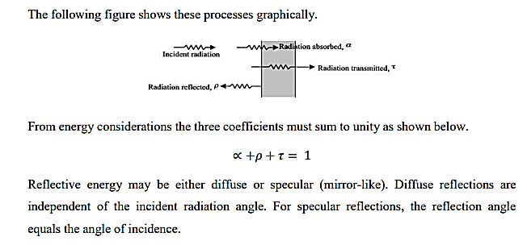

Theory

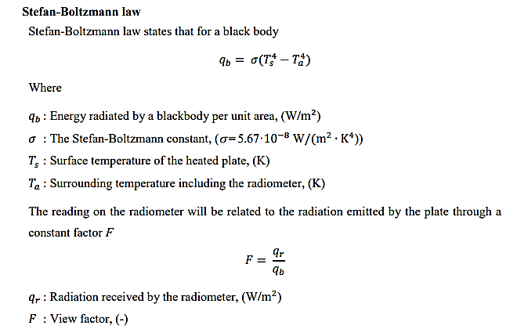

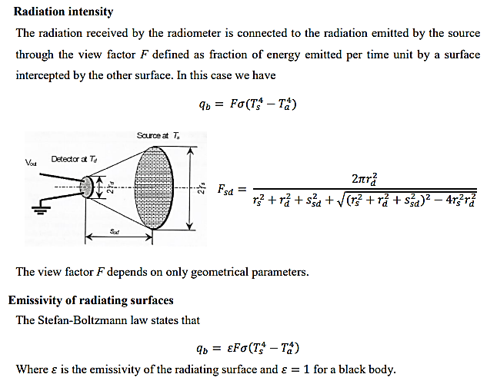

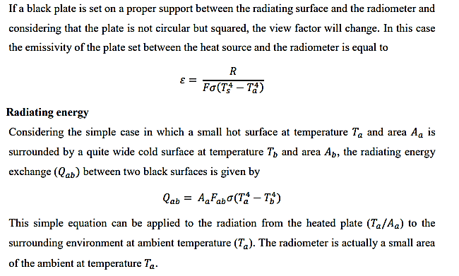

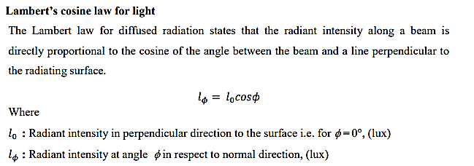

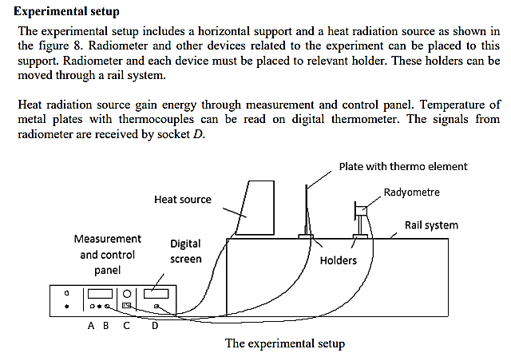

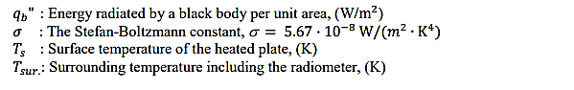

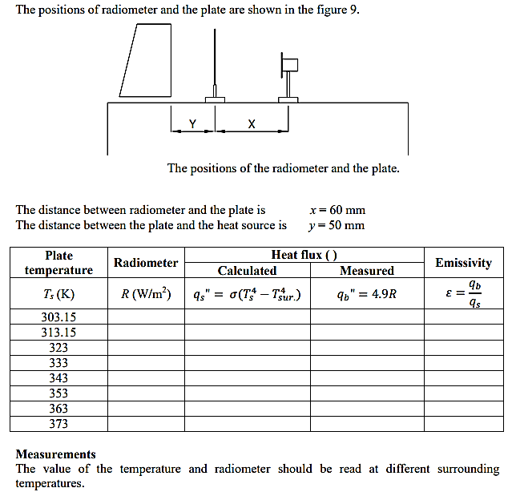

Sample calculation:

Mechanical and Industrial Engineering Department

Experiment (4) | Rankine Cycle Experiment

Student Name : | ID: | Section No.:
Supervisor: Dr. Nadeem Khan | Submission Date: | SLO:
Academic Year: 2017-2018 | Semester: First

Objective: To demonstrate the principles of a vapor power cycle

Introduction:
The Rankine cycle is the vapor power cycle used in most large industrial power plants. It operates by boiling a working fluid (most often water) using a heat source (coal combustion, nuclear fusion, solar energy), expanding the high pressure steam through a turbine to produce mechanical work, condensing of the steam back into the liquid phase, and pumping it back into the boiler to complete the cycle. Although the experiment performed in this laboratory is not a closed cycle, it demonstrates many of the aspects of the closed Rankine cycle. The Rankine Cycler experimental apparatus manufactured by Turbine Technologies is shown in Fig. 1 consisting of a boiler, a turbine and generator, a condenser, and instrumentation including a flow meter, thermocouples, pressure transducers, and a PC data-acquisition system.

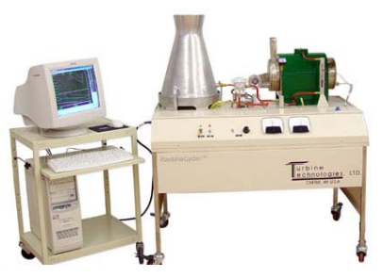
Figure 1: Picture of Rankine Cycle Experiment

The Rankine Cycle Experiment is a fossil-fuel burning steam electric power plant. It was designed solely for educational purposes and yields data in a quantitative and qualitative form in a manner easily understood by the student regardless of their level of interest in the subject. The equipment is compact, bench mounted and instrumented sufficiently for students to make measurements and perform calculations. All instruments are located at the actual point of measurement and connecting pipes are open to view to allow the lab instructor to conveniently describe the sequence of events occurring in the vapor power cycle.

System Components:
- Boiler: The Rankine Cycler boiler is a dual-pass, flame through tube-type unit as shown in the left in Fig. 2. A forced air gas burner fires it. The burner fan speed is electronically adjustable to operate with a minimum of excess air. The system’s purpose-built burner fan results in extremely clean combustion while burning LP gas. A vortex disc, located downstream of the blower unit as illustrated in the right of Fig. 2, mixes fuel and air and sets up a vortex gas flow that results in efficient heat transfer from the flame tube to the boiler’s water.
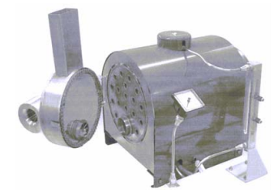
Figure 2: Boiler’s Inlet/Exhaust Header Door

- Steam Turbine / Generator Set:
The steam turbine, shown in the left of Fig. 3, consists of the following major components:
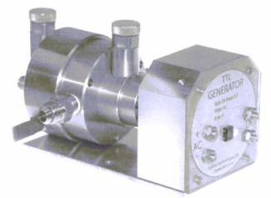
Figure 3: Steam Turbine and Generator

- A precision machined, stainless steel front and rear housing.
- Front and rear bronze bearings.
- Front and rear bearing oilers.
- A stainless steel shaft.
- A nozzle ring and a single stage shrouded impulse turbine wheel.

- Impulse Steam Turbine:
The turbine wheel, shown in Fig. 4, is mounted to the drive shaft by the flange of a taper lock bushing. Front and rear bronze bearing seal and support the rotating components, which are lubricated by back pressure sealed oilers. Mechanical power transmission to the generator is achieved through a “spring pin coupler.” This coupling provides for smooth and relatively quiet operation.
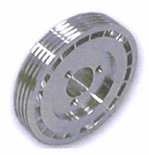
Figure 4: Steam Turbine

- Generator:
The generator, shown in the right of Fig. 3, is a 4-pole, permanent magnet, brushless unit. The rotor is supported by pre-loaded precision ball bearings. The generator includes a full wave, integral rectifier bridge that delivers direct current to the generator’s DC terminals. The generator’s terminal board also carries a set of AC output terminals for experimental procedures that may entail the use of a transformer, or deal with frequency related topics, RPM measurement, and other AC related experiments.

- Condensing Tower:
The condenser tower’s outer mantle is formed from a single piece of aluminum. The tower’s large surface area affects heat transfer to ambient air and provides a realistic appearance. Turbine exhaust steam is piped into the bottom of the tower. The steam is kept in close contact with the outside mantle by means of 4 baffles. A drain hose and clamp are located at the left rear of the system. Following an experiment, the condensate can be drained into a beaker and measured.

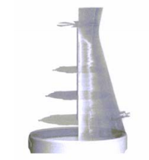
Figure 5: Cutaway View of Condensing Tower

Set Up and Operating Instructions:
The apparatus is delivered complete, ready to operate with the minimum of preparatory work. A single phase electricity supply, a fume hood, a water supply and water drain are the only external facilities required. The following order of instructions should be followed:
- Fill the oil reservoirs with specified oil.
- The large graduated cylinder will be used only for backfilling the boiler, while the smaller one will be used for measuring the amount of liquid in the condensing unit. Use of separate graduated cylinders for each operation prevents the entry of oil from the bearings into the boiler.
- Make sure the boiler is filled to about ¾ its capacity – try to do this one day before the experiment in order to achieve temperature equilibrium with the surroundings. Open the steam admission valve for 5 seconds in order to equalize tank pressure to atmospheric pressure.
- Turn on the main power.
- Start the data acquisition code and examine the different readings. Under Edit … and File Settings … set the filename to be saved to the current group number and day one or day two. Press START to run the code, turn Logging On to write to the data file.
- Make sure the propane tank is connected, that the tank valve open, and the valve on the control panel is turned counterclockwise to the ON position (3 o’clock position).
- Turn the burner on and wait until the pressure in the boiler reaches 130 psig. At this point the boiler should turn off.
- With the load switch off, open the steam admission valve and let the system run for around 20 seconds. The voltage will speed up quickly – try to keep it near the maximum voltage but not over.
- Close the steam admission valve.
- Get one person to set the upper sight glass to denote the fluid’s level.
- Open the steam admission valve, and turn on the load and get one person to set the current to 0.4 A and the voltage to 9 V. This must be done by adjusting both the steam admission valve and the load knob.
- Once these conditions are established, reset the top sight glass to the liquid level and note the time from the data acquisition code.
- Run the system for 5 minutes under these settings making sure to maintain the operating point voltage and current.
- After 5 minutes, close the steam admission valve and turn off the boiler. Close the valve on the propane tank and the gas valve at the top of the control panel (turn clockwise to the 6 o’clock position). Turn the burner fan back on and let the fan cool the boiler. The flame will not ignite as the fuel is turned off.
- Wait until the pressure in the boiler drops below 10 psig. This may take up to 45 minutes.
- Open the steam admission valve slightly to drop the boiler pressure to 0 psig. Close the steam admission valve. Turn logging off and STOP the data acquisition program. Make sure data was saved to the file. Turn the burner switch off.
- Measure the amount of liquid in the condensing unit using the small 250 ml graduated cylinder. This will need to be done several times as there will most likely be more than 250 mL in the condensing unit.
- Fill the large graduated to 6 L. Put the tank on top of the condensing tower, and plug the hose end into the boiler as shown in Fig. 6.
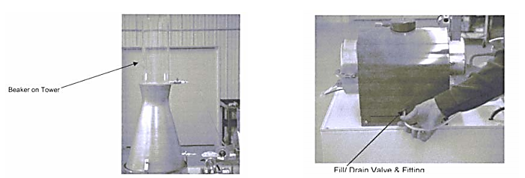
- Backfill the boiler by opening the valve to the 6L tank. Hot liquid from the boiler will probably run back into the 6 L tank, and then it will slowly start to backfill the boiler. When the liquid level in the boiler comes back to the point where the sight glass was set at the start of the 5 minute test, close the valve on the 6 L tank and stop backfilling.
- Determine how much liquid was added to the boiler by draining the liquid in the 6 L tank down to 5 L using the small 250 mL graduated cylinder to accurately measure the amount of liquid that is removed. This will enable you to determine how much liquid was in the 6 L tank at the end of backfilling (5.xx L). You can determine the amount of liquid that went through the turbine in the 5 minute test by computing the difference between 6 L and 5.xx L.
- Turn the computer off, disconnect the data acquisition cable.
- Clean up the oil that may have dripped beneath the turbine bearings using a paper towel.
- Turn the main power off on the control panel.

Mechanical and Industrial Engineering Department

Experiment (5) | FORCED AND FREE CONVECTION HEAT TRANSFER

Student Name : | ID: | Section No.:
Supervisor: Dr. Nadeem Khan | Submission Date: | SLO:
Academic Year: 2017-2018 | Semester: First

OBJECTIVE: The objective of this experiment is to compare the heat transfer characteristics of free and forced convection.

THEORY
Convection is the mechanism of heat transfer through a fluid in the presence of bulk fluid motion. Convection is classified as natural (or free) and forced convection depending on how the fluid motion is initiated. In natural convection, any fluid motion is caused by natural means such as the buoyancy effect, i.e. the rise of warmer fluid and fall the cooler fluid. Whereas in forced convection, the fluid is forced to flow over a surface or in a tube by external means such as a pump or fan.
By applying simple overall energy balance, the heat transfer rate from a heated surface can be calculated as,

where Cp is the specific heat of the fluid [ J / kgK ], Tm is the mean temperature, subscript e and i stands for exit and inlet, and m& is the mass flow rate [ kg/s] which can be written as,

Where ρ is the density of the fluid [ kg/m3 ], um is the mean velocity of the fluid [ m/s], and Ac is the cross-sectional area of the flow [ m2 ]. The average heat transfer coefficient of the system, ℎ̅ [W /m2 K ], can be calculated as,

where q is the heat transfer rate, A is the area of the heated surface, and ΔTlm is the log-mean temperature difference defined as,

where Ts is the surface temperature. The heat transfer characteristics of a system strongly depends on whether the flow is laminar or turbulent. The dimensionless quantities are Rayleigh number (Ra) (for free convection) and Reynolds number (Re) (for forced convection) that are used to determine the flow characteristics of the system. If they are smaller than a critical value, the flow is assumed to be laminar, otherwise the flow is assumed to be turbulent. The definitions of Ra and Re together with the critical values are given as follows,

&
where g is the gravitational acceleration [ m2 /s], β is the volumetric thermal expansion coefficient (for an ideal gas, β =1/T), T∞ is the ambient temperature, ν is the kinematic viscosity of the fluid [ m2 /s], α is the thermal diffusivity of the fluid [ m2 /s], and L is the characteristic length of the flow. The average heat transfer coefficient h can be calculated for a given geometry by using the correlations given in the literature. In the case of free convection from a heated vertical surface, the average value of the Nusselt number (), which is a dimensionless number and provides a measure of the convective heat transfer, can be determined by using the following correlation,
where k is the thermal conductivity of the fluid. C and n are the correlation coefficients given as C = 0.59, n=1/4 for laminar flow and C = 0.10, n = 1/3 for turbulent flow case. 3 In the case of a forced convection from a heated surface, the average Nusselt number can be calculated as,

(Laminar)
(Turbulent)
where Pr is the Prandtl number (Pr = ν /α).

EXPERIMENTS TO BE PERFORMED
During the experiments, the power input value, the flow speed of the air inside the duct, the inlet and exit temperatures of air and the temperature of the heater surface are recorded.

Procedure
1. Turn on the power and adjust a power input value.
2. Wait until the system reaches the steady-state.
3. Record inlet and exit temperatures of the air.
4. Record the surface temperature of the heater.
5. Turn on the fan.
6. Record the speed of the air, inlet and exit temperatures of the air.
7. Record the surface temperature of the heater.

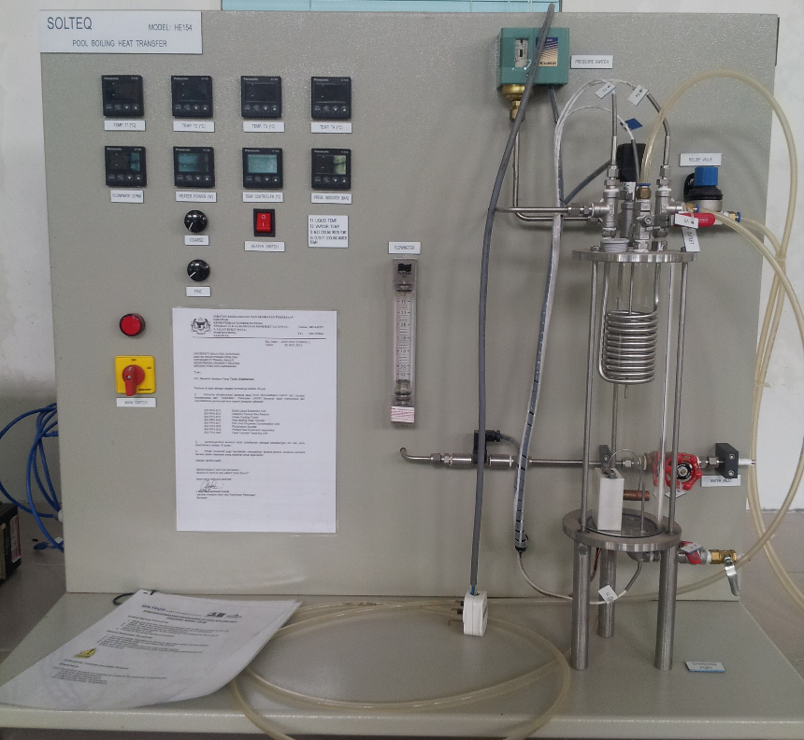
Figure: Experimental Set up

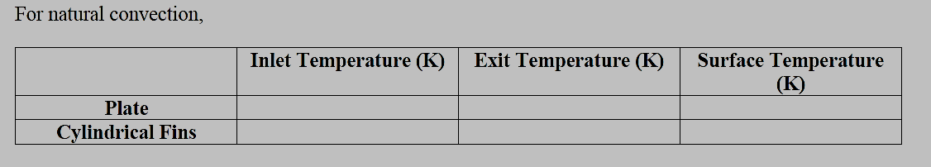
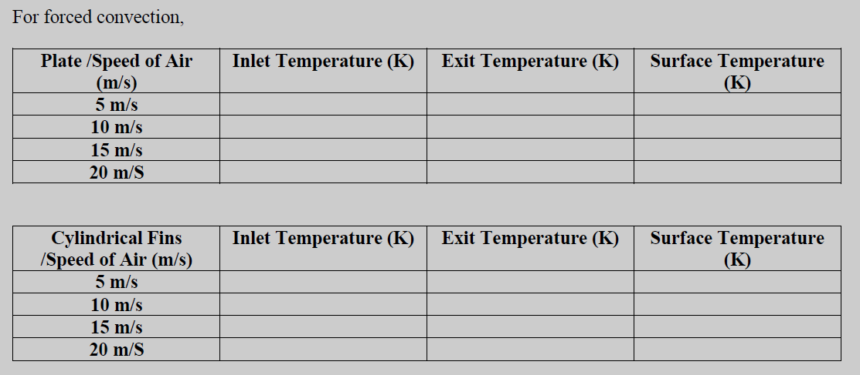

ANALYSIS
For free convection:
1. Calculate the mass flow rate of the air and the heat transfer rate.
2. Calculate the efficiency (η) of the heat transfer, which is the measure of what fraction of energy input is transferred to the fluid (η = q/Pel).
3. Calculate the log-mean temperature difference and the average heat transfer coefficient.
4. Calculate Ra and the corresponding Nu and the average heat transfer coefficient.
5. Compare the measured heat transfer coefficient with the theoretical value.

For forced convection:
1. Calculate the mass flow rate of the air and the heat transfer rate.
2. Calculate the efficiency (η = q/Pel).
3. Calculate the log-mean temperature difference and the average heat transfer coefficient
4. Calculate Re and the corresponding Nu and the average heat transfer coefficient.
5. Compare the measured heat transfer coefficient with the theoretical value.

Mechanical and Industrial Engineering Department

Study(6) | TWO STROKE AND FOUR STROKE PETROL ENGINE

Student Name : | ID: | Section No.:
Supervisor: Dr. Nadeem Khan | Submission Date: | SLO:
Academic Year: 2017-2018 | Semester: First

AIM: To study two stroke and four stroke petrol engines.
APPARATUS: Model of two stroke and four stroke petrol engine.
THEORY: The engine which converts the heat energy into mechanical energy is known as heat engine.

WORKING PRINCIPLE OF FOUR STROKE PETROL ENGINES
There are four strokes which are as follows:
i) Suction stroke
ii) Compression stroke
iii) Expansion or working or power stroke
iv) Exhaust stroke
- SUCTION STROKE: The suction stroke starts with the piston at top dead centre position. During this stroke, the piston moves downwards by means of crank shaft. The inlet valve is opened and the exhaust valve is closed. The partial vacuum created by the downward movement of the piston sucks in the fresh charge (mixture of air and petrol) from the carburetor through the inlet value. The stroke is completed during the half revolution (180^{O}) of the crank shaft, which means at the end of the suction stroke, piston reaches the bottom head centre position.
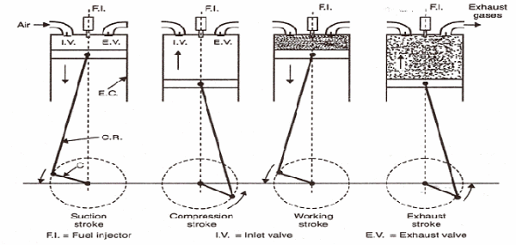
Figure of Four Stroke SI Engine Cycle

- COMPRESSION STROKE: During this stroke the inlet and exhaust valves are closed and the piston returns from bottom dead centre position. As the piston moves up, the charge is compressed. During compression the pressure and temperature rises. This rise in temperature and pressure depends upon the compression ratio (in petrol engines the compression ratio generally varies between 6:1 and 9:1). Just before the completion of the compression stroke, the charge is ignited by means of an electric spark, produced at the spark plug.
- WORKING OR EXPANSION STROKE: The ignition of the compressed charge. Just before the completion of compression stroke, causes a rapid rise of temperature and pressure in the cylinder. During this stroke the inlet and exhaust values remain closed. The expansion of gases due to the heat of combustion exerts pressure on the piston due to which the piston moves downward, doing some useful work.
- EXHAUST STROKE: The exhaust value is opened and the inlet valve remain closed. The piston moves upward (from its BDC position) with the help of energy stored in the flywheel during the working stroke. The upward movement of the piston discharges the burnt gases through the exhaust value.
At the end of exhaust stroke, piston reaches its TDC position and the next cycle starts

WORKING PRINCIPLES OF 2-STROKE PETROL ENGINE
The working principle of 2-Stroke petrol engine is discussed below:-
- 1st Stroke: To start with let us assume the piston to be at its B.D.C. position. The arrangement of the ports is such that the piston performs two jobs simultaneously.As the piston starts rising from its B.D.C. position it closes the transfer port and the exhaust port. The charge (mixture, of the air and petrol) which is already there in the cylinder, as the result of the previous running of the engine is compressed at the same time with the upward movement of the piston vacuum is created in the crank case (which is gas tight). As son as the inlet port is uncovered; the fresh change in sucked in the crank case. The charging is continued until the crank case and the space in the cylinder beneath the piston is filled with the charge. As the end of third stroke, the piston reached the T.D.C. position.
- 2nd Stroke: Slightly before the completion of the compression stroke, the compressed charge is ignited by means of a spark produced at the spark plug.
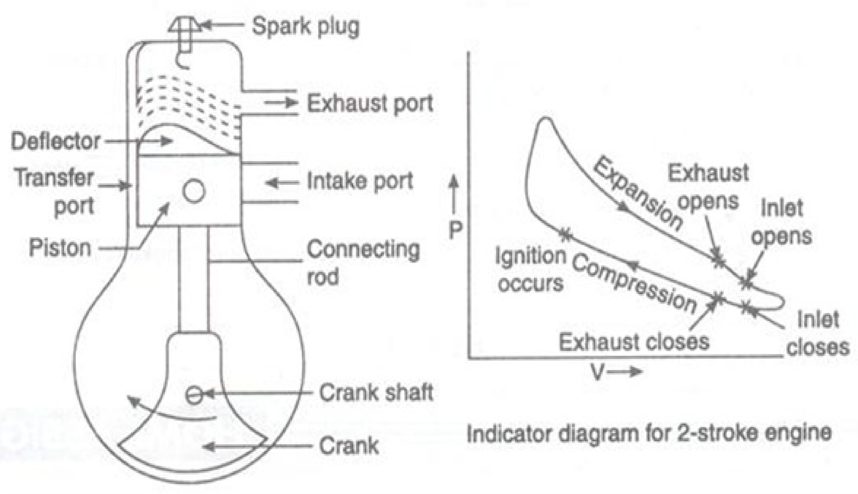
Figure of Two stroke SI Engine
Pressure is exerted on the crank of the piston due to the combustion of the piston is pushed in the downward direction producing some useful power. The downward movement of the will first close the inlet port and then it will compress the charge already sucked in the crank case.
Just the end of power stroke, the piston uncovered the exhaust port and the transfer port simultaneously the expanded gases start escaping through the exhaust port and the same time the fresh charge which is already compressed in the crank case, rushed into the cylinder through the transfer port and thus the cycle is repeated again.
The fresh charge coming into the cylinder also helps in exhausting the burnt gases out of the cylinder through the exhaust port. This is known as scavenging.

