Mechanical and Industrial Engineering Department | Experimental

Work Study (ME 495)
Experiments Manual

Updated 2017

Table of Contents

No | Experiment | Page
1 | Time Study | 3
2 | Operation Flow Process Chart | 9
3 | Activity Chart (Right/Left Hand Activity Chart) | 16
4 | String Diagram | 21
5 | Motion Study (Therbligs Technique) | 26

Mechanical and Industrial Engineering Department

Experiment(1) | Direct Time Study Method

Student Name : | ID: | Section No.:
Supervisor:Dr. Chandra Mouli | Submission Date: | SLO:
Academic Year: 2017-2018 | Semester: First

1.1 Theory
Direct Time Study is a direct and continuous observation of a task using a stopwatch or other timekeeping device to record the time taken to accomplish the task. Direct time study is also known as stopwatch time study method. The direct time is one of the most work measurements that uses to determine the standard time of a task. However, while observing and recording the time, an appraisal of the worker’s performance level is made to obtain the normal time for the task. Since, the performance rating in this method is important in order to determine the standard time. The normal time in this method obtain by multiply the observation time of the work element with worker performance rating in percentage. The data are then used to compute a standard time for the task after adding the PFD allowances (personal needs, fatigue and delay allowance time). The direct time study is much more appropriate for repetitive tasks (batch and mass production).

- In order to implement the direct time study (DTS) the work study engineer should follow the following procedures:

- Define and document the standard method
- Divide the task into work elements
- Time the work elements to obtain the observed time T_{obs}
- Evaluate worker’s pace relative to standard performance to obtain normal time T_{n}
  - Called performance rating (PR %)
T_{n} = T_{obs}(PR) (1)
- Apply allowance factor to compute standard time
T_{std} = T_{n}(1 + A_{pfd}) (2)

- The engineer should be consider the following guidelines while divide task into work elements:

- Each work element should consist of a logical group of motion elements.
- Beginning point of one element should be the end point of the preceding element.
- Each element should have a readily identifiable end point.
- Work elements should not be too long nor too short (less than 3 sec).
- Separate irregular elements (non-frequent element) from regular elements.
- Separate manual elements from machine elements.
- Separate internal elements (during machine work) from external elements.

- There are two important stopwatch timing methods used in direct time study to record the observation time:
Figure 1: Standard Form of Therblig Analysis Sheet
  - Snapback timing method Flyback – stopwatch is reset to zero at the start of each work element
  - Continuous timing method – stopwatch is allowed to run continuously throughout the duration of the work cycle

1.2 Objectives
The objectives of this laboratory experiment are as follows:
- To understand the concept and the technique of direct time study method in time measurement.
- To learn the direct time study in order to determine the normal time and standard time for a task.
- To learn and understand the calculation of the appropriate number of time readings (i.e., number of time observations) that are need to give an accurate standard time value for a task.

1.3 Instrument

A wooden plate and two uprights have small wooden plates with 6 bolts for each upright plate and each bolt has nuts and washers (Hand tool dexterity test, model 32521, Lafayette Instrument, US; see Figure 2) for a total of 12 bolts. The device has the following dimensions: 0.76×0.40×0.40 m. Two types of hand tools (10-inch Crescent wrench and screwdriver) are used to fix the bolts to the wooden plate (see Figure 1).

A digital stopwatch (Dad-7141, China) also records the time to complete a task. The stop watch has these features: 10-500 laps and split memory with 1/100sec memory recall during operation, calendar and time (12/24 hour format), 5 daily alarms, countdown and repeat (9h 59m 59s) and water resistance (See Figure 2).
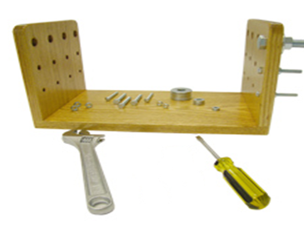
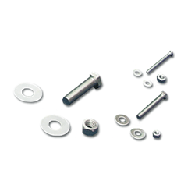

Figure 1: Roeder Board (Model 32026; Lafayette Inst. Company) and four receptacles for holding washers, rods, caps, and nuts.

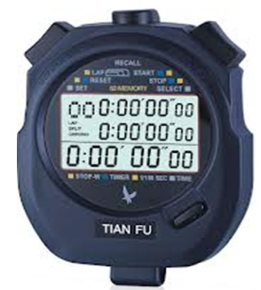

Figure 2: Digital stopwatch. (Dad-7141, Japan)

1.4 Experiment Procedures (Cutting saw machine task)
The experiment procedures are as follows (group work):

1. Participants are given a brief introduction to the experiment in order to familiarize themselves with the procedure. They are provided with instructions and advised on how to assemble the wooden plates.

- The students need to divide task into work elements. The assembly task includes 12 bolts so; the student should consider each bolt as a one work element (12 work elements).

- They need to use the Form of Direct Time Study (see Figure 3) to record the observation time and performance rating for the task. Also, they require to write all work elements in the form.

- One student in the group assembles all the components supplied. In one plate assembly the student is required to fix 12 complete bolts sets (consisting of bolts, nuts and washers) with different sizes on both upright plates. The student needs pick up the small bolts and nuts in order to fix them and he requires to check the tight quality of the assembly. After that he needs to pick up the large bolts and nuts and fix them and also, he needs to check it. Finally, the student to needs to lift the plate (assembled object) and put it in other location.

- The other students record the observation time to complete each work element (fix one bolt) as well as the performance rating for each work element. The performance rating of the student depends on the speed and the quality of assembly task. Therefore, the students require to check the tight quality of the assembly. The student should assign PR = 100% for the normal performance, greater than 100% for the faster and good accuracy performance and lower 100% for the slower student performance and poor accuracy.

- Each group have to collect the data of observation time and performance rating for each work element from all other class groups and complete these data in cycle columns as illustrated in the form direct time study.

- Then the students need to compute the normal time for each work element by using the previous equation (1) in section 6.1. After that, they require to add all normal time for all work elements to determine the total normal time for the task.
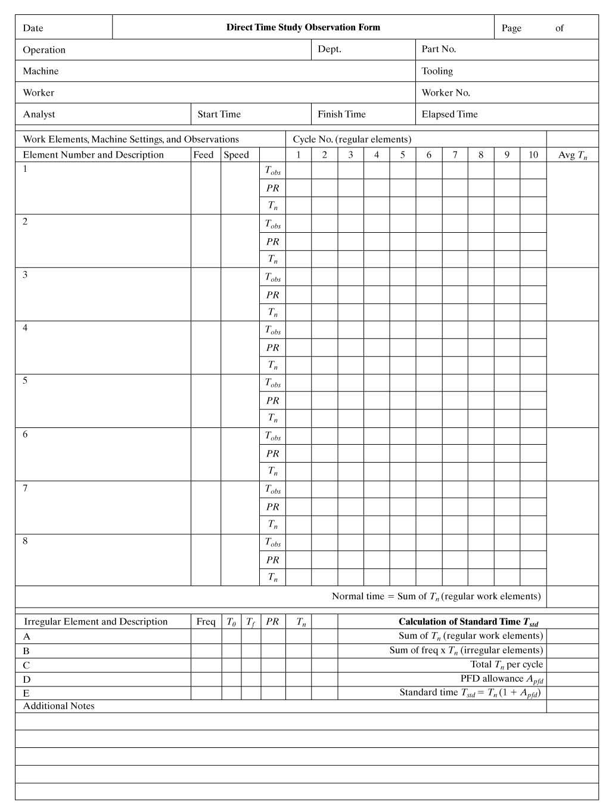

Figure 3: Direct Time Study Form

1.5 Results of the Experiment

Mechanical and Industrial Engineering Department

Experiment(2) | Operation Flow Process Chart

Student Name : | ID: | Section No.:
Supervisor:Dr. Chandra Mouli | Submission Date: | SLO:
Academic Year: 2017-2018 | Semester: First

2.1 Theory
The Flow Process Chart was developed many years ago as a means of listing out the activities performed by a worker, with quantities, times, and movement distances. In fact, flow Process Chart is chart that uses 5 symbols to analysis and detail the work performed on a material or work part through a sequence of operations and other activities. It uses five symbols to detail the work performed on a material or workpart as it is processed through a sequence of operations and activities (ASME, 1972):

- Operation (O) – Processing of a material, an object is changed intentionally, assembled or dis-assembled to/from another, or prepared for another process, or information is given or received.
- Inspection ( ) – Check for quality or quantity, an object is examined for identity, quality, or quantity.
- Move ( ) – Transport of material to new location, an object is moved from place to place, except as part of an operation
- Delay (D) – Material waiting to be processed or moved, The next planned step cannot take place immediately
- Storage ( ) – Material kept in protected location, an object is stored under some control
In addition, the flow process chart is a simple half-text, half-picture method of showing the steps in a process, using symbols to indicate the type of action being taken and text to give details of the action. The Standard form for flow process chart is showed in Figure 1.

This exercise plays an important part in forming a critical way of thinking about the design of work, that is, making full use of both hands, eliminating unnecessary tasks and delays, shortening distances, and simplifying the tasks involved. Such experiences aim to make the student critically aware of deficiencies and avoidable effort whenever work designs are examined, and help to develop a consciousness of the need for high productivity.

There are five important questions that are used to improve the steps of process and contents of the flow process charts in order to reduce the waste time, effort and cost of the specific process. These questions are:
- Questions Related to Material
  - Make or buy decisions: Should the part be produced in the factory or purchased from an outside vendor?
- Questions Related to Operations and Inspections
  - Is the operation time too high?
  - Is the inspection operation necessary?
- Questions Related to Moves
  - How can moves be shortened or eliminated by combining or eliminating operations?
  - Can the level of mechanization in material handling be increased?
  - Questions Related to Delays
  - Is the delay avoidable?
  - What is the reason for the delay? Can the reason be eliminated?
  - Questions Related to Storage
  - Is the storage necessary?
  - Why can’t the material be move immediately to the next operation?

Figure 1.Flow Process Chart

There are three principal types of process charts:

Flow process chart – analysis of a material or workpiece being processed

Worker process chart – analysis of a worker performing a task

Form process chart – analysis of the processing of paperwork forms

2.2 Objectives
The objectives of this laboratory experiment are as follows:
- To use the flow process chart type of task analysis to describe a two-operation process:
- First: to describe a simple assembly process task in a laboratory setting which simulates an industrial task process (laboratory experiment).
- Second: to describe a task process of changing a flat tire, this demonstrates a non-industrial task. This task will be given to a student with a text and video (non-laboratory experiment).
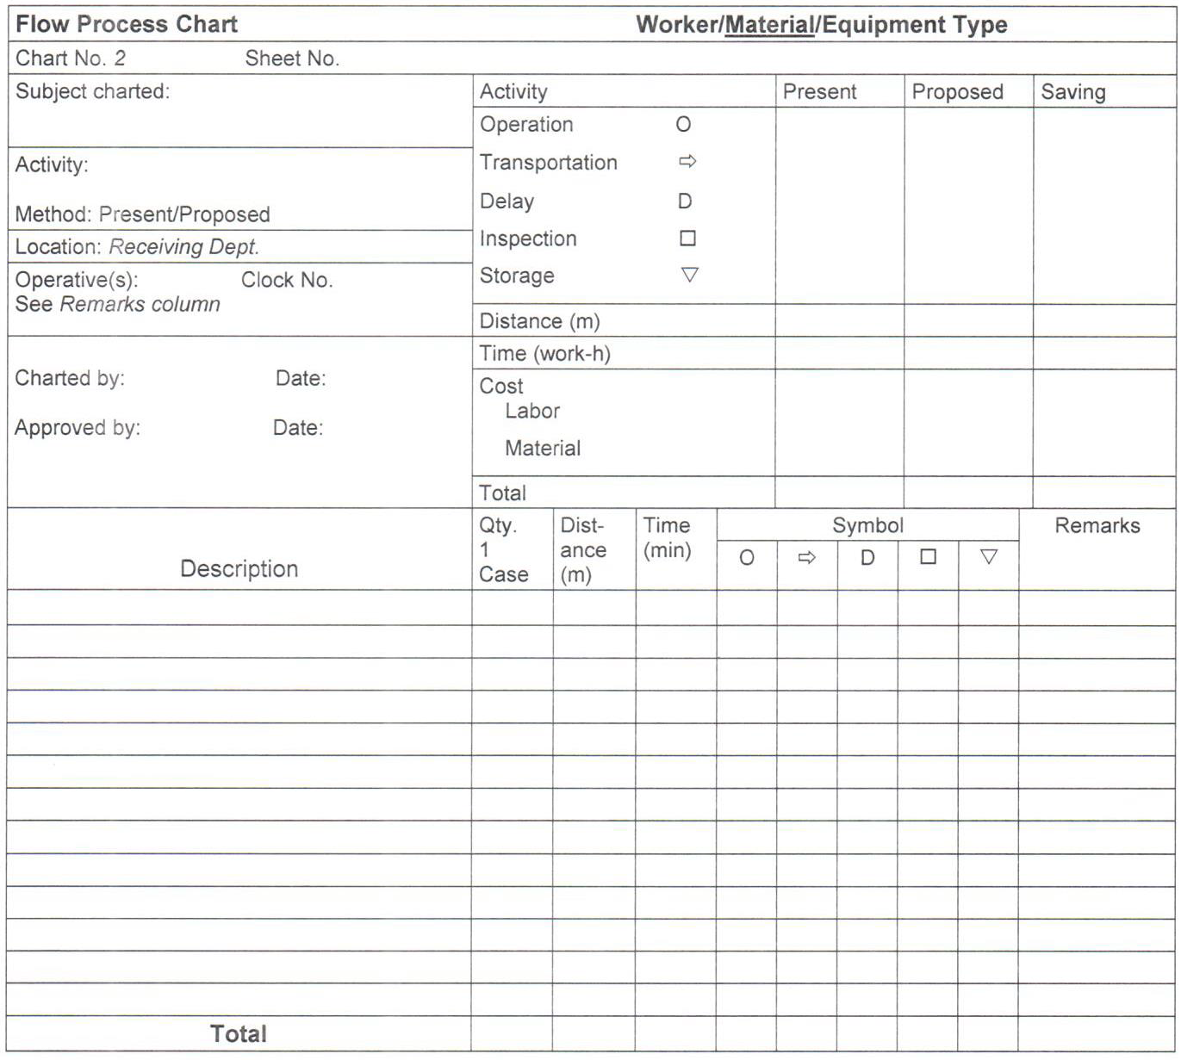
- Obtain an improved solution and recommendations through critical questioning of the contents of the chart for the both tasks: assembly and tire change.
Figure 1: Standard form of flow process chart

2.3 Instrument

A wooden plate and two uprights have small wooden plates with 6 bolts for each upright plate and each bolt has nuts and washers (Hand tool dexterity test, model 32521, Lafayette Instrument, US; see Figure 2) for a total of 12 bolts. The device has the following dimensions: 0.76×0.40×0.40 m. The wooden plate simulates the assembly task because this type of task is common in many different factory jobs, particularly in the industrial sector, and the operator can assume an awkward posture to perform this type of task. Two types of hand tools (10-inch Crescent wrench and screwdriver) are used to fix the bolts to the wooden plate (see Figure 2).

A digital stopwatch (Dad-7141, China) also records the time to complete a task. The stop watch has these features: 10-500 laps and split memory with 1/100sec memory recall during operation, calendar and time (12/24 hour format), 5 daily alarms, countdown and repeat (9h 59m 59s) and water resistance (See Figure 3).

Figure 2: Assembly wooden plate, hand tools and bolts with nuts and washers.

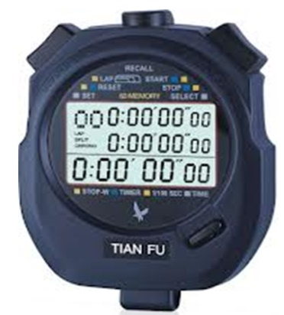

Figure 3: Digital stopwatch. (Dad-7141, Japan)

2.4 Experiment Procedures (assembly task)
The experiment procedures are as follows (group work):

- Participants are given a brief introduction to the experiment in order to familiarize themselves with the procedure. They are provided with instructions and advised on how to assemble the wooden plates.

- Participants devise an assembly procedure in which the work is done largely by the dominant hand, and helped by the other hand.

- One student in the group assembles all the components supplied (without any arrangements for the bolts, nuts, washers and hand tools). In one plate assembly the student is required to fix 12 complete bolts sets (consisting of bolts, nuts and washers) with different sizes on both upright plates.

- The students must work at a pace that can be maintained for an 8 hours shift. Assuming that pay is $25 per hour; he needs to complete 75 assembled plates during the shift.

- A second student records the time to complete each assembly (i.e., the cycle time) as well as the time to affix each bolt as an element times or subgroups of element times. These times are recorded in the flow process chart as illustrated previously in Figure 1.

- A third student records the order of operations in the flow process chart and any events of note, such as bad parts or a difficult insertion task.

- As the group repeats the assembly task and similar measurements, they need to arrange the components in individual bins depending on the type and size of bolt and hand tools in a line in front of the student.

2.5 Non-industrial process task (Tire change task)

In this exercise, the group needs to use the flow process chart to describe the steps of the service task which is changing a flat tire (non-industrial task). The exercise is:
A motorist experienced a flat tire on the driver side rear wheel of his car and went through the following procedure to replace the flat tire with the spare. The tire change occurred in the middle of the day in his own driveway about six metres in front of his garage.
He first secured the other three wheels of the car with three bricks from his garage to prevent the vehicle from rolling (two trips back and forth to the garage) with a distance of 11.5m. He then took out the jack, crank, and lug nut wrench from the trunk of the car, traveling a distance of 1.5m. He then removed the spare tire from the trunk and placed it near the rear left wheel with a time of 1.04 min. Next, he proceeded to position the jack under the car at the recommended support beam on the car frame with a time of 0.44 min. He then began to turn the crank to elevate the car with a time of 1.09 min. After the left rear portion of the car was lifted a few inches, but before the flat tire was lifted from the driveway surface, he used the lug nut wrench to loosen the five lug nuts securing the tire to the wheel hub with time 0.85 min. He then returned to the task of elevating the car, turning the jack crank until the flat tire was completely off the driveway surface (0.92 min).
The next step was to remove the loosened lug nuts, placing them in a nearby position within reach (0.12 min). The flat tire was then removed with time 0.10 min and lifted into the trunk with a distance of 2.5 m. The motorist then moved the spare tire into position with a distance of 2.5 m and lifted it onto the five studs protruding from the wheel hub with a time 0.22 min. He then reached for the five lug nuts, one at a time, placing them onto the studs and rotating them until finger tight (0.60 min). The lug nut wrench was then used to tighten the five nuts with a time of 1.01 min. With the tire secure, he proceeded to lower the car by cranking the jack down slowly until the spare tire supported the car with a time of 1.14 min. For good measure, he again tightened the five lug nuts now that the car was securely on the ground (0.62 min). He then collected the hardware (0.09 min), put it back into the trunk (2.5 m), and removed the bricks from the other three rear right tire, front right tire and front left tire wheels with a distance of 1.5, 3.6 and 1.5, respectively. Then, he put them back into his garage with distance 9 m.
2.6 Results of the Experiment
Mechanical and Industrial Engineering Department

Experiment(3) | Activity Chart (Right/Left Hand Activity Chart)

Student Name : | ID: | Section No.:
Supervisor:Dr. Chandra Mouli | Submission Date: | SLO:
Academic Year: 2017-2018 | Semester: First

3.1 Theory
In general, the activity chart is a listing of the activities of one or more subjects (e.g., workers, machines) plotted against a time scale to indicate graphically how much time is spent on each activity. There are various types of activity charts and the right/left hand activity chart is one of the common activity charts that are used to describe the manual repetitive task such as manual assembly task.
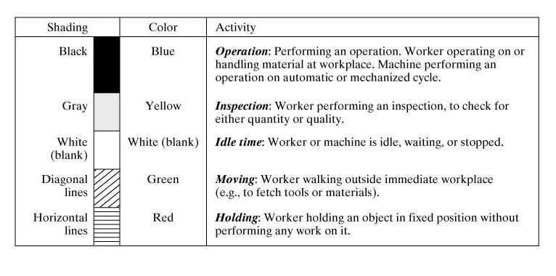
The usual is to provide brief descriptions of the work activities against a vertical time scale. The activities in the activity charts are indicated by vertical lines or bars instead of using symbols for the work activities as in the other charting such as process charts. When the bars are used, they are shaded or colored to indicate the kind of the activity being performed as illustrated in Figure 1.
Figure 1: Shading Formats for Activity Chart
However, the right-hand/left hand activity chart explains the left and right activities during performing a task that is highly repetitive. The chart includes four columns one column for the right hand, second column for the left hand and the other two columns for the time (min) and total task cumulative time (min) as shown in Figure 2 also, represents the Standard Form for right-hand/left hand activity chart. The right-hand/left hand activity chart is also, called Workplace Activity Chart since it is usually describes a repetitive task which is performed at single place such as assembly task in production line. The main objective of this activity chart is to achieve a more even balance of the workload during task performing between the right and left hands.

 | Left hand (activity description) |  | Time (min) |  | Right hand (activity description) | Cumulative time (min)
Figure 2: Standard Form of Right /left Hands Activity Chart

3.2 Objectives
The objectives of this laboratory experiment are as follows:
- To understand and use the activity chart (Right/Left Hand Activity Chart) while performing a task:
- To describe a simple assembly process task in a laboratory setting that simulates a simple repetitive task, such as a basic assembly task (laboratory experiment) and create an appropriate right/left hand activity chart for the simple repetitive task.
- Understand how to improve the simple repetitive task's activities and create the proposed right/left hand activity chart for the improved activities.

3.3 Instrument
The Grooved Pegboard (Simple assembly tool test, model 32025, Lafayette Instrument, US; see Figure 3) is a manipulative dexterity test that consists of 25 holes with randomly positioned slots. the pegs are keyhole-shaped must be rotated to match the hole before they can be inserted, requiring more complex visual-motor coordination.

A digital stopwatch (Dad-7141, China) also records the time to complete a task. The stop watch has these features: 10–500 laps and split memory with 1/100sec memory recall during operation, calendar and time (12/24 hour format), 5 daily alarms, countdown and repeat (9h 59m 59s) and water resistance (See Figure 4).
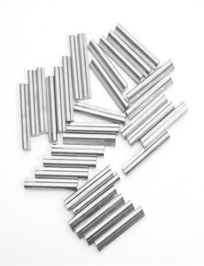
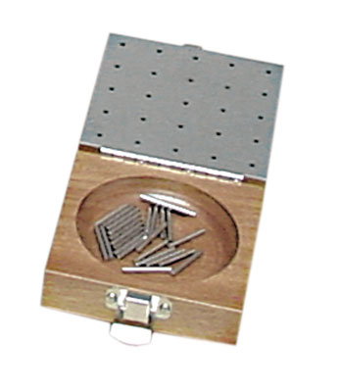

Figure 3:Grooved pegboard tool and pegs.

Figure 4: Digital stopwatch. (Dad-7141, Japan)

3.4 Experiment Procedures (simple repetitive assembly task)
The experiment procedures are as follows (group work):

- Participants are given a brief introduction to the experiment in order to familiarize themselves with the procedure. They are provided with instructions and advised on how to insert the pegs inside the holes.

- In the first part of the experiment (present method), one student in the group needs to hold the board with his left hand and is required to pick up the peg and then insert it into the hole in the board with his right hand.

- The student needs to insert 25 pegs in order to complete the assembly.

- A second student records the order of left- and right-hand activities in the right/left hand activity chart form. At the same time a third student records the time for each activity that the subject needs to complete the assembly task.

- The group then repeats the repetitive assembly task and similar procedures, but in the second part of experiment (proposed method), the student needs to put the board on the table and then put the first 12 pegs near his right hand and the other 13 pegs near his left hand. After that, the subject he needs to pick up the pegs and insert them into the holes with both hands, simultaneously. The other two students are required to record the descriptions of the activities for both hands as well as the time, as mentioned in step 4.

3.5 Results of the Experiment

Mechanical and Industrial Engineering Department

Experiment(4) | String Diagram

Student Name : | ID: | Section No.:
Supervisor: Dr. Chandra Mouli | Submission Date: | SLO:
Academic Year: 2017-2018 | Semester: First

Theory
The string diagram is a scale plan or model on which a thread is used to trace and measure the path of workers, material or equipment during a specified sequence of events. The string diagram is mostly used for studying workers’ movement.
The work study person observes the movement of a worker over enough period of time. The observations may be recorded in a simple movement study sheet. Then, the string diagram can be constructed. The examination of the diagram and the development of the new layout can now proceed with templates being used and the pins and templates being moved around until an arrangement are found by which the same operations can be performed with a minimum movement between them.
The string diagram is a useful aid in explaining proposed changes to management, supervisors and workers.

4.2 Objectives
The objectives of this laboratory experiment are as follows:
- To understand the concept and the technique of String diagram.
- To let students practice on the construction of string diagram from data submitted in a movement study sheet.
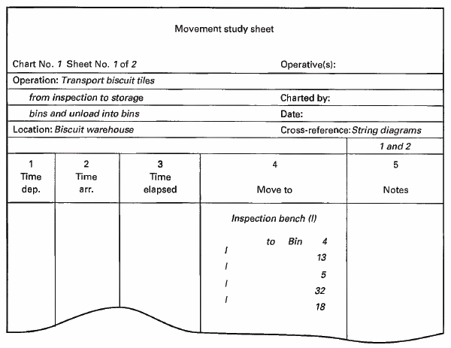
Figure 1:movement study sheet
4.3 Materials
Pieces of cork (50cm*50cm) or bigger
Pinpoints
Piece of string
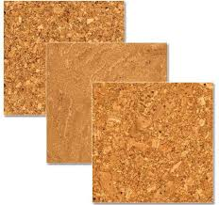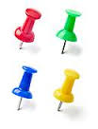
Figure 2:Pieces of cork Figure 3:Pinpoints

Figure 4: Piece of string

4.4 Experiment Procedures
Each group has to construct 2 string diagrams using the tools given:
- Participants are given a brief introduction to the experiment. They are provided with instructions and advised on how to construct a string diagram
- Using the data presented in the submitted movement study sheet. The students required to put the pinpoints on the cork as the work layout and make connection between the pinpoint using the string step by step. After that they need to determine the length of the string used in the process.
- The students will construct another string diagram by using another piece of cork and pin points but they need to make a change in the position of pinpoints to make the string used shorter than before by the same way of connections. In other words, the second diagram shows the proposed improvement in layout.

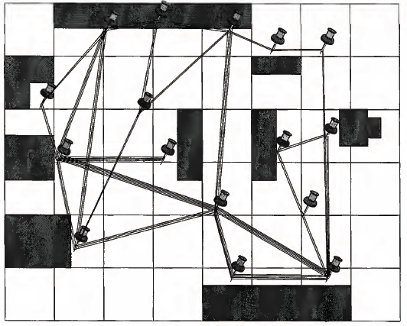
Figure 5: work layout

4.5 Requirements
- Construct a string diagram for the work layout given in the class by using the material described above.
- Construct a string diagram for the work developed (improved) layout by using similar set of material.

Mechanical and Industrial Engineering Department

Experiment(5) | Motion Study (Therbligs Technique)

Student Name : | ID: | Section No.:
Supervisor:Dr. Chandra Mouli | Submission Date: | SLO:
Academic Year: 2017-2018 | Semester: First

5.1 Theory
Motion study is an analysis of the basic hand, arm, and body movements of workers as they perform work. Frank Gilbreth was the first to analyze and classify the basic motion elements. He called each hand motion a therblig. Therbligs is spelled backward except for “th”. Therbligs are Basic building blocks of virtually all manual work performed at a single location (so the primary interest is the hand motions). Therbligs involved 17 letters symbols that are descriped the hands motion (right and left hands motion) of worker while perform a manual task (i.e. hand tasks). The list of 17 therbligs symbols are:

- Transport empty (TE) – reach for an object with empty hand – today we call it “reach”.
- Grasp (G) – grasp an object by contacting and closing the fingers until control has been achived.
- Transport loaded (TL) – move an object with hand and arm – today we call it “move”.
- Hold (H) – hold an object with one hand.
- Release load (RL) – release control of an object.
- Use (U) – manipulate/use a tool.
- Pre-position (PP) – position object for next operation.
- Position (P) – position object in defined location.
- Assemble (A) – join two parts
- Disassemble (DA) – separate multiple parts that were previously joined
- Search (Sh) – attempt to find an object using eyes or hand
- Select (St) – choose among several objects in a group (hand-eye coordination is involved)
- Plan (Pn) – decide on an action (a short pause or hesitation تردد in the motions)
- Inspect (I) – determine quality of object using the eyes
- Unavoidable delay (UD) – waiting due to factors beyond worker control
- Avoidable delay (AD) – worker waiting
- Rest (R) – resting to overcome fatigue.

The therbligs classified into two main sections; effective therbligs and ineffective therbligs and these classifications are:
Ineffective therbligs:
Physical Basic Motion Elements:
  - Hold
  - Pre-position
Physical and Mental Basic Motion Elements:
  - Position
  - Search
  - Select
Mental Basic Elements:
  - Plan
Delay elements:
  - Unavoidable delay
  - Avoidable delay
Effective therbligs:
Physical Basic Motion Elements:
  - Transport empty
  - Grasp
  - Transport loaded
  - Release load
  - Use
  - Assemble
  - Disassemble
Mental BasicElements:
  - Inspect
Delay Elements:
  - Rest

In general, Therbligs include physical elements such as transport, grasp assembly and it refers to any activity that needs physical hands movements. Also, therbligs include mental elements such as position, search and select and it refers to any activity that needs to information process and visual effort rather than physical effort.

Micromotion Analysis is analysis of therbligs that make up a repetitive task and the standard form of therbligs showed in Figure 1. The objectives of therbligs analysis are:

  - Eliminate ineffective therbligs if possible; for example, eliminate the need to search for parts or tools by positioning them in a known & fixed location in the workplace.
  - Avoid holding objects with hand – Use workholder
  - Combine therbligs – Perform right-hand and left-hand motions simultaneously
  - Simplify overall method resequence of therbligs in the cycle
- Reduce time for a motion, e.g., shorten distance of therbligs such as transport loaded

 | Seq. of activities | Left hand | Therbligs |  | Right hand | Cumulative Time

Figure 1: Standard Form of Therblig Analysis Sheet

5.2 Objectives
The objectives of this laboratory experiment are as follows:
- To understand and use the therblig analysis technique for hands motion while manual assembly task and create the present therbligs list of right and lift hands while perform a simple assembly task.
- To learn the various symbols of therbligs that used to analysis the hands motion activities.
- Understand how can make improve in the therbligs symbols in order to improve the hands motion activities and create the proposed list of therbligs chart for an improved activities of right and left hands activties.

5.3 Instrument

Roeder Board Manipulative Aptitude Test (Model 32026; Lafayette Inst. Company; see Figure 2) is the test that uses to measure hand, arm, finger dexterity, and speed. The board of the roeder board has four receptacles for holding washers, rods, caps, and nuts. The performance board also is comprised of a horizontal T-bar and 40 inserts arranged in a predetermined pattern.

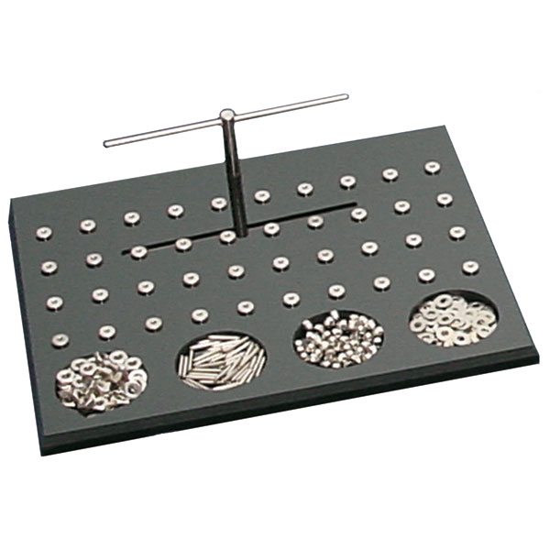
A digital stopwatch (Dad-7141, China) also records the time to complete a task. The stop watch has these features: 10-500 laps and split memory with 1/100sec memory recall during operation, calendar and time (12/24 hour format), 5 daily alarms, countdown and repeat (9h 59m 59s) and water resistance (See Figure 3).
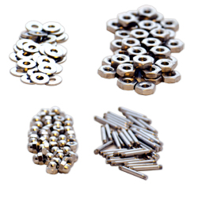

Figure 2: Roeder Board (Model 32026; Lafayette Inst. Company) and four receptacles for holding washers, rods, caps, and nuts.

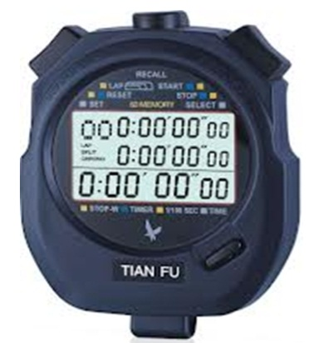

Figure 3: Digital stopwatch. (Dad-7141, Japan)

5.4 Experiment Procedures (Cutting saw machine task)
The experiment procedures are as follows (group work):

1. Participants are given a brief introduction to the experiment in order to familiarize themselves with the procedure. They are provided with instructions and advised on how to insert the pegs inside the holes.

- In the first part of the experiment (present method), one student in the group needs to assemble all four parts washers, rods, caps, and nuts together and insert into the hole in the board after pick-up these parts from pin that placed in the front of the student. Note: In the current method all the four parts washers, rods, caps, and nuts are placed in one pin together.

- The student requires to repeat this activity for 8 times which means that he needs to complete 8 assembly tasks and assemble only 8 holes in the board.

- A second student records the order of hand motions (right and left hands) of the student activities (e.g., reach, search, grasp, transport loaded, position, assemble and etc.) as mentioned previously. At the same time a third student records only the cumulative time of each complete assembly cycle that means he needs to records the cumulative time for 8 cycles.

- The group need to complete all the hands motions data of both hands as well as the cumulative time in the form of Therblig Analysis Sheet.

- As the group repeats the assembly task and similar procedures, but in second part of experiment (proposed method) the students need to arrange and separate the four parts washers, rods, caps, and nuts and place each part the identified location on the board and also, they can combine the washers and nut together and put both on the T-bars to reduce the time and effort of search and assemble.

5.5 Results of the Experiment

