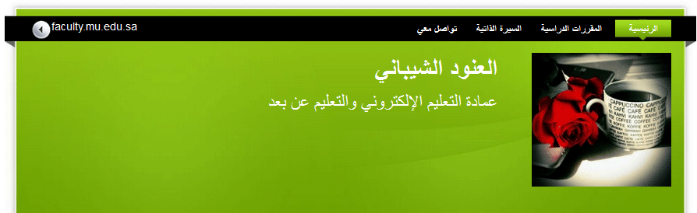
http://faculty.mu.edu.sa/aalshaibani

